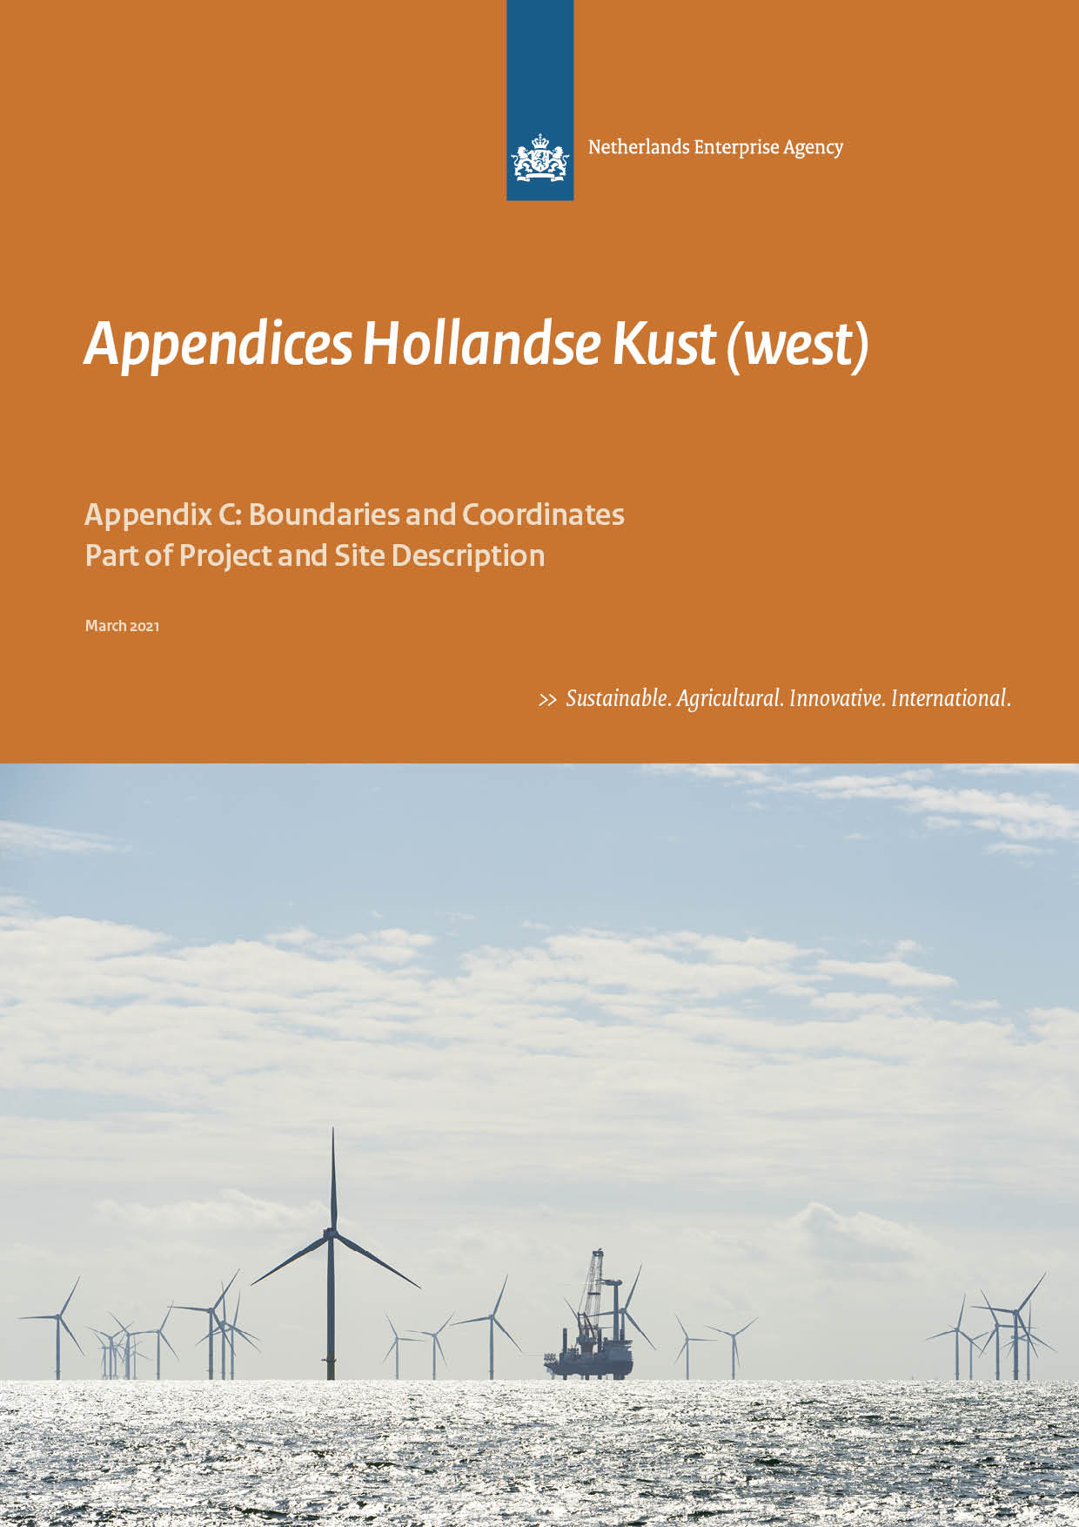

Colophon
Project name | Site Studies Hollandse Kust (west) Wind Farm Zone
Version | 22 March 2021, HKW appendix
File name | HKW_20210322_PSD_Appendix C_Boundaries and Coordinates –  Version March 2021
Project manager | Peter-Paul Lebbink (RVO)
Annex(es)  Note | HKW_20210322_RVO_Appendix C_Coordinates (.xlsx)  Please note the coordinates in this document are complete and final  and will be published in updated draft Wind Farm Site Decisions for  HKWWFS VI and VII
Authors | Stijn Wijdeven (RHDHV-NL)  Tom Moekotte (RHDHV-NL)  Geert van Oorschot (RHDHV-NL)
Reviewed | Camiel van der Hout (EZK)  Thomas Collette (RWS)  Rick van der Heijden (RVO)  Matté Brijder (RVO)  Peter-Paul Lebbink (RVO)  Alfred Dekkers (TenneT)  Kees Vlak (RWS)
Approved | Matté Brijder (RVO)

Only the coordinates and boundaries in the final Wind Farm Site Decisions are legally binding. The coordinates in the final Wind Farm Site Decisions HKWWFS VI and VII are aligned with this memo. Please note this memo confers no rights and is provided for convenience only.

Contents

1 Introduction 4
2 Hollandse Kust (west) Wind Farm Sites VI and VII (HKWWFS VI and VII) 6
3 Planned TenneT infrastructure 16
4 Existing infrastructure 18

Introduction

Purpose
The purpose of this memo is to establish the exact boundaries and coordinates for the Hollandse Kust (west) Wind Farm Sites VI and VII (HKWWFS VI and VII) (in Dutch: kavel VI en VII). The geographical information is based on the data available in January 2021.

Only the coordinates and boundaries in the final Wind Farm Site Decisions (WFSD) are legally binding. The coordinates in the final WFSDs are aligned with this Appendix. Please note this memo confers no rights and is provided for convenience only.

Horizontal datum
The geodetic system used for horizontal projections is European Terrestrial Reference System 1989 (ETRS89).

All coordinates are given in UTM projection, for which the following applies:
- Local datum European Datum (ETRS89)
- Central Meridian 3° E (Zone 31N)

The corresponding EPSG code to this horizontal datum is:
- EPSG 25831

GIS Information
All coordinates given in this document correspond to GIS data that is made available by the Netherlands Enterprise Agency (RVO) through the MPK file of the HKWWFZ at https://offshorewind.rvo.nl/generalw.

Coordinate numbering
The coordinates given in this document are numbered according to the system below. Coordinate groups that exceed 100 samples have been added to the accompanying Excel file: HKW_20210322_RVO_Appendix C_Coordinates
- Coordinates that determine the outer boundaries of the HKWWFZ start with the letter code WFZ (Wind Farm Zone) followed by an underscore and a number (WFZ_01, WFZ_02, …);
- Coordinates that determine the outer boundaries of the HKWWFS start with the letter code S (Site) followed by an underscore and a number (S_01, S_02, …);
- Coordinates that determine the maintenance zones of pipes and cables in the HKWWFZ start with the letter code MZ (Maintenance Zone) followed by an underscore and a number (MZ_01, MZ_02, …). These coordinates are in the separate Excel appendix with coordinates;
- Coordinates of objects which might have archaeological value start with the letter code AV (Archaeological Value) followed by an underscore and a number (AV_01, AV_02, …);
- Coordinates of objects are marked as wrecks start with the letter code W (Wreck) followed by an underscore and a number (W_01, W_02, …);
- Coordinates of magnetic anomalies possibly indicating UXO objects or objects with archaeological value start with the letter code MA (Magnetic Anomaly) followed by an underscore and a number (MA_01, MA_02, …). These coordinates are in the separate Excel appendix with coordinates;
- Coordinates that determine the location of the existing cables and pipelines in the HKWWFZ start with the letter code CP (Cables and Pipes) followed by an underscore and a number (CP_001, CP_002, …). The following number is derived from the GIS dataset (field: ObjectID). These coordinates are in the separate Excel appendix with coordinates;
- Coordinates of objects are marked as platform start with the letter code Q (Platform) followed by an underscore and a number (Q_01, Q_02, …);
- Coordinates of objects are marked as borehole start with the letter code BH (Borehole) followed by an underscore and a number (BH_01, BH_02, …);

Orientation figures
All figures included in this document are presented with the north direction facing upwards.

Hollandse Kust (west) Wind Farm Sites VI and VII (HKWWFS VI and VII)
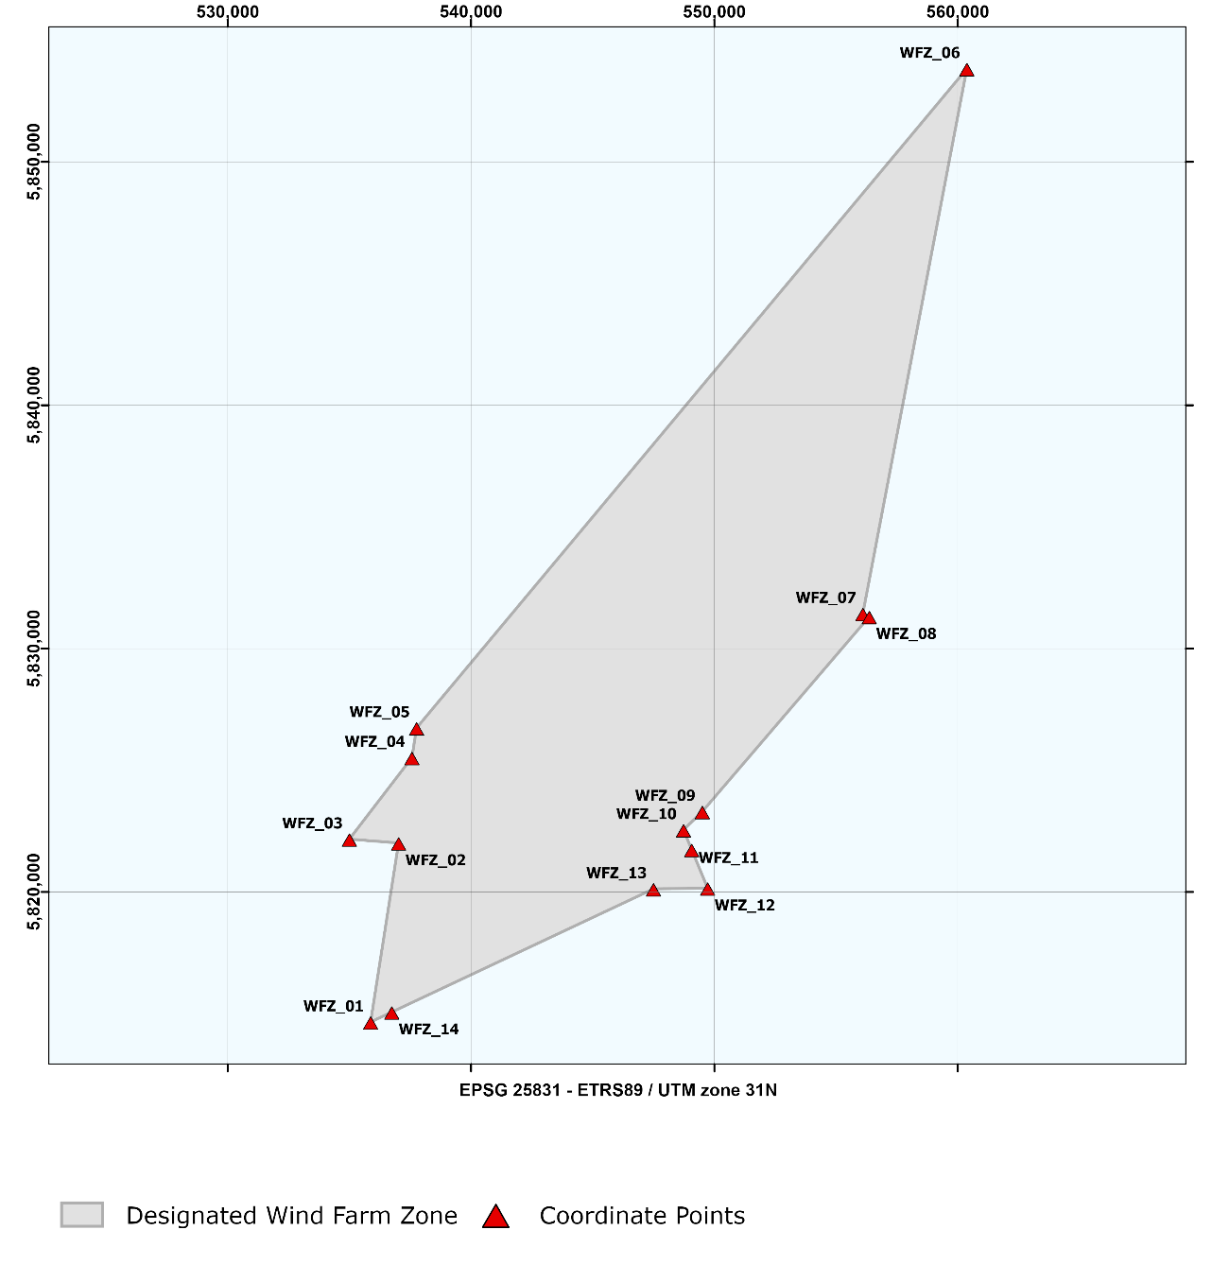
Figure 2.1 Overview of the HKWWFZ – Zone
Table 2.1 Coordinates of the HKWWFZ – Wind Farm Zone
Wind Farm Zone of HKWWFZ
ETRS 1989 UTM Zone 31N
EPSG 25831
Point No. | Easting | Northing |  | Point No. | Easting | Northing
WFZ_01 | 535,872.2 | 5,814,654.0 |  | WFZ_08 | 556,364.1 | 5,831,312.2
WFZ_02 | 537,022.3 | 5,822,012.5 |  | WFZ_09 | 549,503.4 | 5,823,303.3
WFZ_03 | 534,999.3 | 5,822,170.2 |  | WFZ_10 | 548,730.0 | 5,822,551.6
WFZ_04 | 537,570.7 | 5,825,520.7 |  | WFZ_11 | 549,065.8 | 5,821,741.1
WFZ_05 | 537,761.1 | 5,826,738.8 |  | WFZ_12 | 549,721.8 | 5,820,157.5
WFZ_06 | 560,375.0 | 5,853,830.4 |  | WFZ_13 | 547,496.6 | 5,820,125.9
WFZ_07 | 556,100.8 | 5,831,438.1 |  | WFZ_14 | 536,741.8 | 5,815,063.4

Wind Farm Sites VI and VII

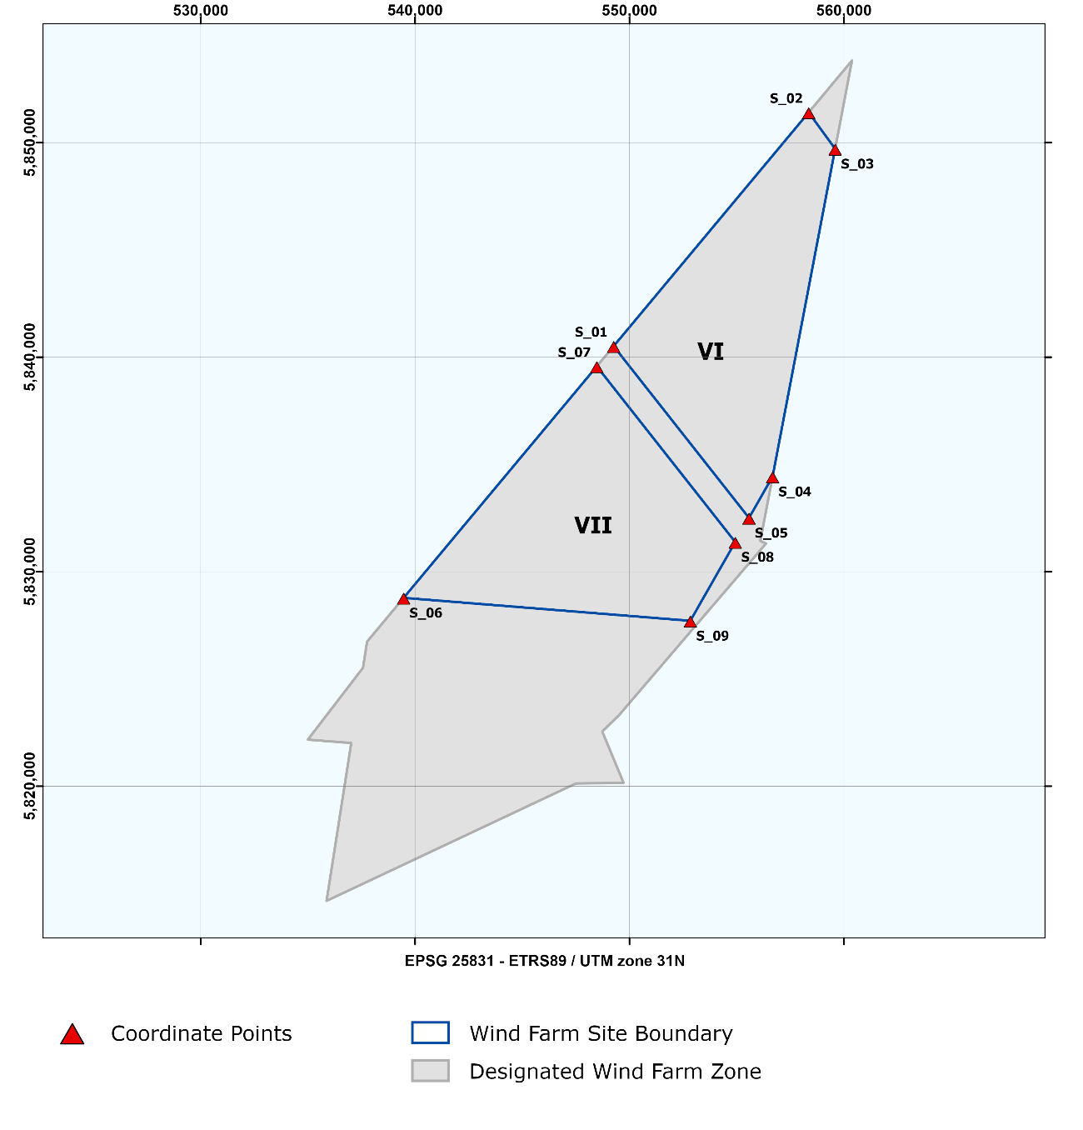
Figure 2.2 Overview of the HKWWFS – Site
Table 2.2 Coordinates of the HKWWFS – Wind Farm Site VI
Wind Farm Site VI of HKWWF
ETRS 1989 UTM Zone 31N
EPSG 25831
Point No. | Easting | Northing |  | Point No. | Easting | Northing
S_01 | 549,259.1 | 5,840,513.5 |  | S_04 | 556,672.6 | 5,834,433.9
S_02 | 558,353.9 | 5,851,409.2 |  | S_05 | 555,572.5 | 5,832,506.4
S_03 | 559,589.1 | 5,849,713.0

Table 2.3 Coordinates of the HKWWFS – Wind Farm Site VII
Wind Farm Site VII of HKWWFZ
ETRS 1989 UTM Zone 31N
EPSG 25831
Point No. | Easting | Northing |  | Point No. | Easting | Northing
S_06 | 539,465.9 | 5,828,781.1 |  | S_08 | 554,930.8 | 5,831,382.2
S_07 | 548,473.2 | 5,839,572.0 |  | S_09 | 552,835.3 | 5,827,710.8

Maintenance Zone and Coordinates
Site VI and VII have their own maintenance zones and coordinates. Therefore two overview maps are presented, one for each site. Additional zoomed in cut-outs are presented to further clarify the position of coordinates. Site VI is presented in Figure 2.3a, Site VII in Figure 2.3b. The coordinates of the Maintenance zones are in the Excel file: HKW_20210322_RVO_Appendix C_Coordinates
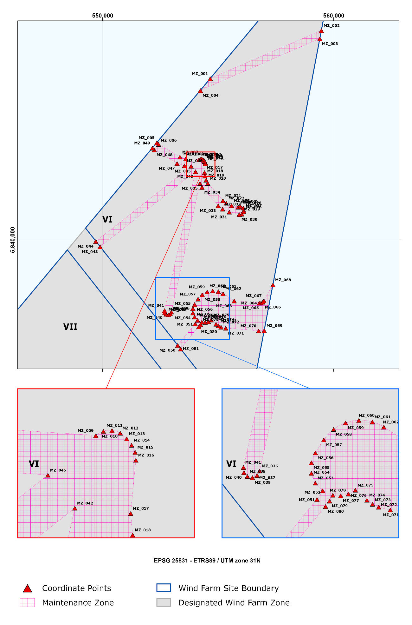
Figure 2.3a Overview of the Maintenance zone of the HKWWFS – Site VI

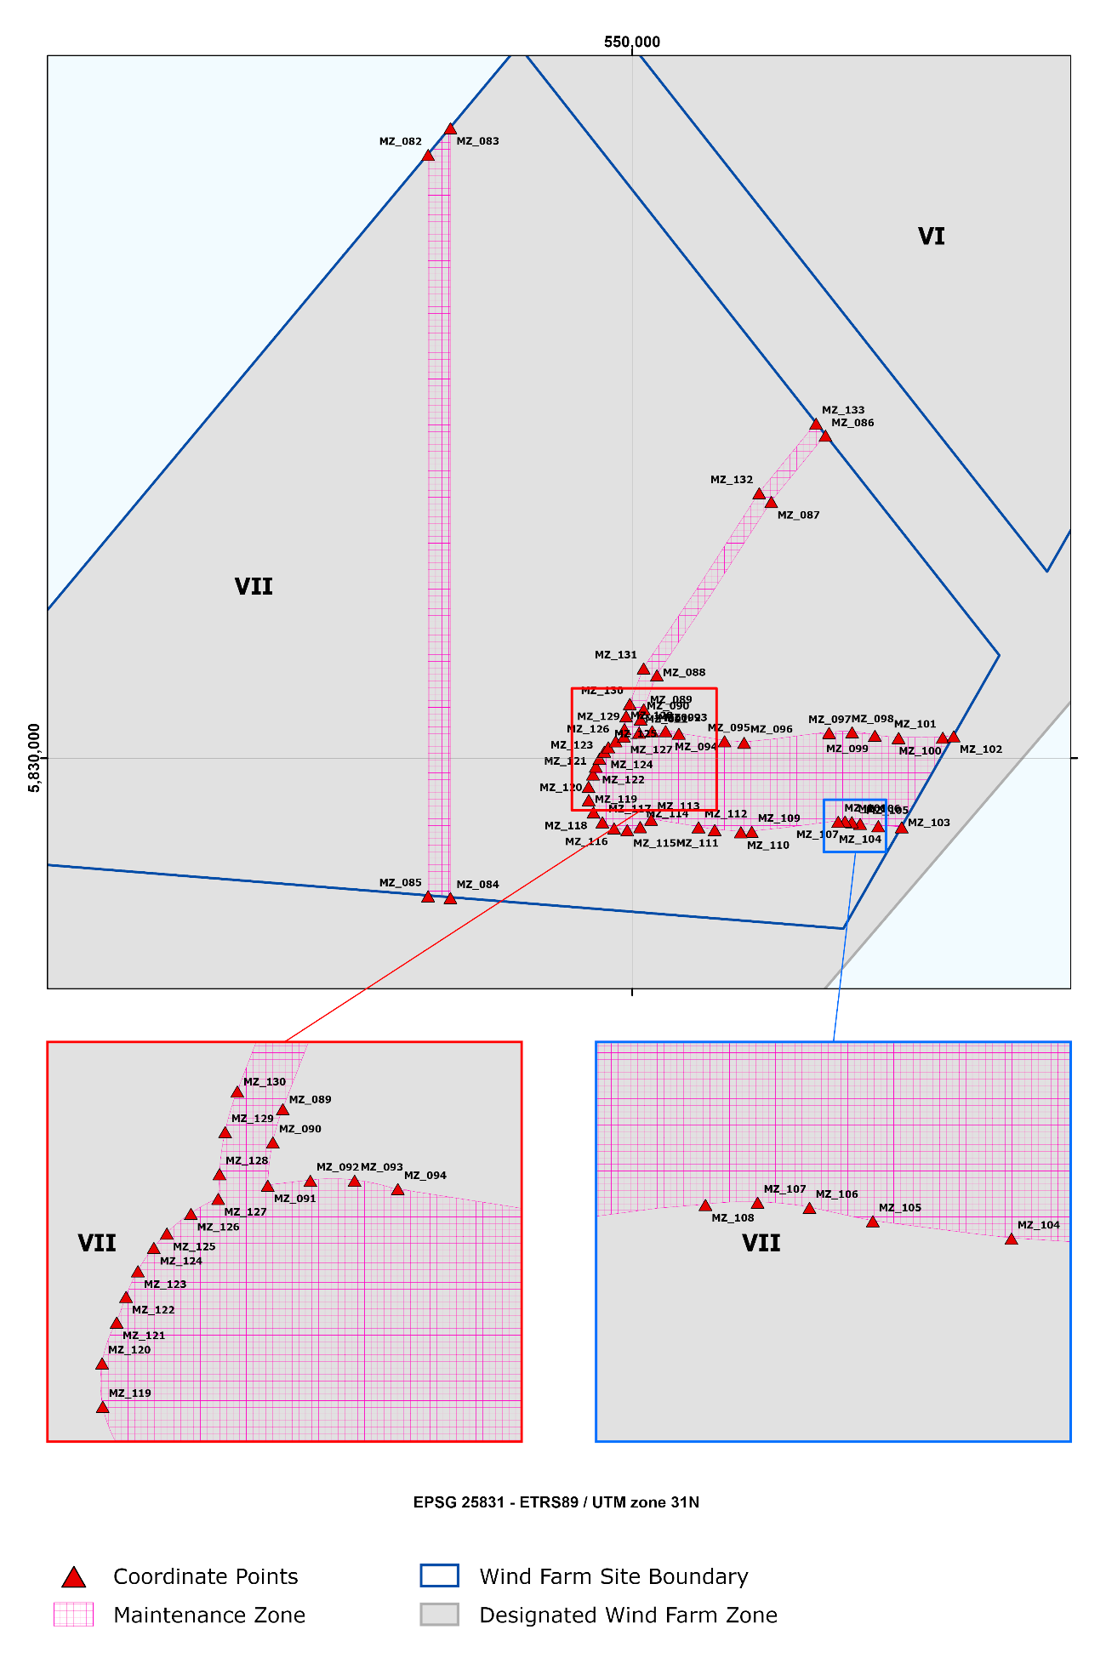
Figure 2.3b Overview of the Maintenance zone of the HKWWFS – Site VII

Possible Archaeological Objects and Coordinates

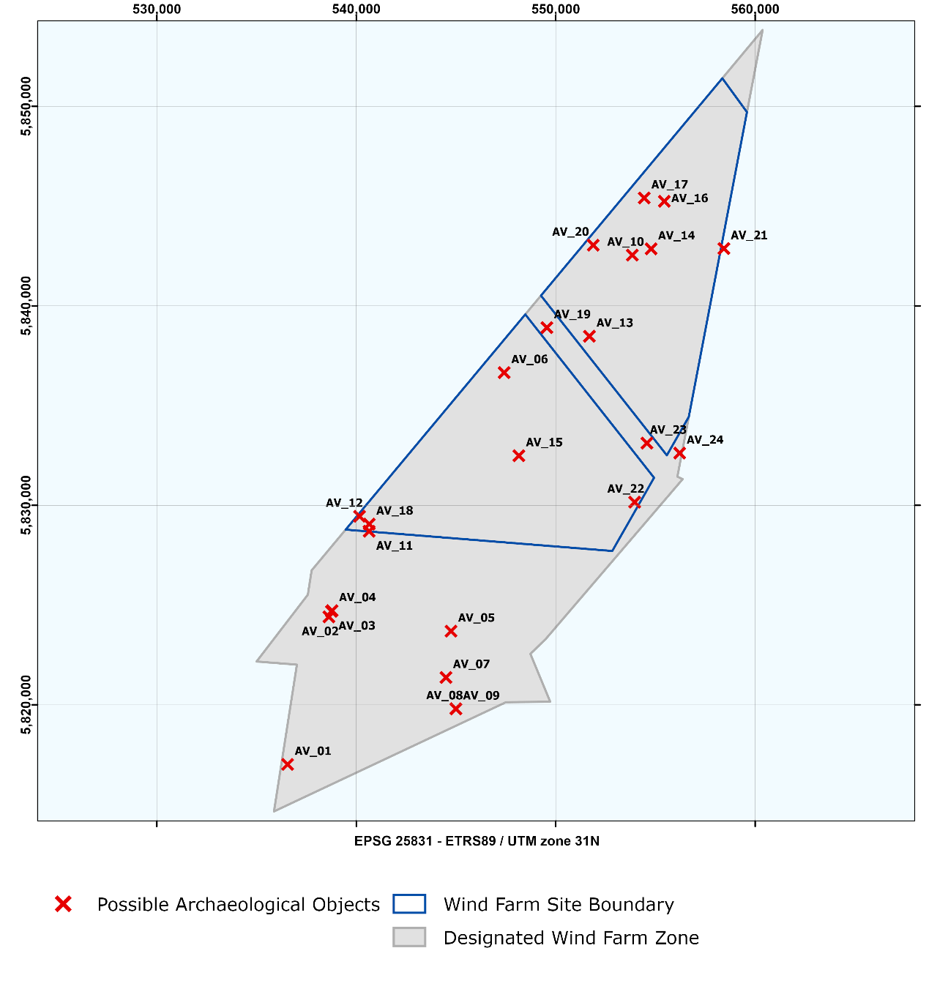
Figure 2.4 Overview of the HKWWFZ – Possible Archaeological Objects

Table 2.4 Coordinates of possible Archaeological Objects in HKWWFZ
Archaeological objects in HKWWFZ
ETRS 1989 UTM Zone 31N
EPSG 25831
Point No. | Description | Classification | Code | Easting | Northing
AV_01 | elongated to rectangular hard reflective object | Possible wreck | S_0039 | 536,556.0 | 5,817,013.0
AV_02 | spherical object amidst a scour 13 x 11 m with 118 nT magnetic anomaly | Possible wreck | S_0093 | 538,628.0 | 5,824,408.0
AV_03 | two elongated objects | Possible wreck site | S_0095 | 538,755.0 | 5,824,686.0
AV_04 | two elongated objects | Possible wreck site | S_0096 | 538,786.0 | 5,824,717.0
AV_05 | high reflective exposure | Possible buried wreck | S_0336 | 544,748.0 | 5,823,694.0
AV_06 | high reflective exposure | Possible buried wreck | S_0353 | 547,417.0 | 5,836,653.0
AV_07 | contours of a ship-like object | Buried ship wreck | S_0401 | 544,499.0 | 5,821,369.0
AV_08 | cluster of contacts | Possible wreck site | S_0412 | 544,989.0 | 5,819,800.0
AV_09 | cluster of contacts | Possible wreck site | S_0413 | 544,995.0 | 5,819,792.0
AV_10 | linear contact amidst cluster of contacts | Possible buried wreck | S_0679 | 553,839.0 | 5,842,543.0
AV_11 | Wreck DHY 2247. Duikteam Zeester: Biarritz, sunk 1940 | Wreck Biarritz | NCN2056 | 540,645.0 | 5,828,700.0
AV_12 | Wreck DHY 2256. Duikteam Zeester: SS Paris, sunk 1939 | Wreck SS Paris | NCN2064 | 540,162.0 | 5,829,452.0
AV_13 | Distributed remains of wreck DHY 2284 | Wreck | NCN2091 | 551,689.0 | 5,838,477.0
AV_14 | Wreck DHY 2292. Duikteam Zeester: Boezemwrak close to platform | No visible contacts, sandwave, mag. anomaly 2031 nT | NCN2098 | 554,783.0 | 5,842,860.0
AV_15 | Wreck DHY 2468. Unknown wreck reported 1984 | Wreck | NCN2250 | 548,149.0 | 5,832,487.0
AV_16 | Wreck debris | Wreck, partly buried | NCN2469 | 555,444.0 | 5,845,242.0
AV_17 | Wreck DHY 3427. Unknown wreck reported with sonar 1997 | Possible wreck | NCN2809 | 554,440.0 | 5,845,409.0
AV_18 | Wreck DHY 2255, Unknown wreck found 1970 | No visible contacts | NCN2063 | 540,648.0 | 5,829,062.0
AV_19 | Wreck DHY 2283. Unknown wreck found 1946 | No visible contacts | NCN2090 | 549,558.0 | 5,838,909.0
AV_20 | Wreck DHY 2291 Unknown wreck found 1961 | No visible contacts | NCN2097 | 551,880.0 | 5,843,043.0
AV_21 | Wreck DHY 2294. Mast reported 1898, not confirmed since | No visible contacts | NCN2100 | 558,429.0 | 5,842,871.0
AV_22 | Wreck DHY 3498 | No visible contacts | NCN2844 | 553,958.0 | 5,830,158.0
AV_23 | Wreck DHY 3500. Wreck debris reported 2014 | No visible contacts | NCN2845 | 554,572.0 | 5,833,117.0
AV_24 | Wooden wreck remains, discovered in 2002. | No visible contacts | NCN9226 | 556,213.0 | 5,832,620.0

A buffer zone of 100 m should be applied around the few objects found which have yet to be determined to have no archaeological value, thereby prohibiting any activities in their locations. This also applies to cable trenching and anchorages of work vessels. Please note that the buffer zone may be reduced if it can be substantiated that the applied activity and disturbance has no effect on the (possible) archaeological object.

Wrecks with possible Archaeological Value in HKWWFZ

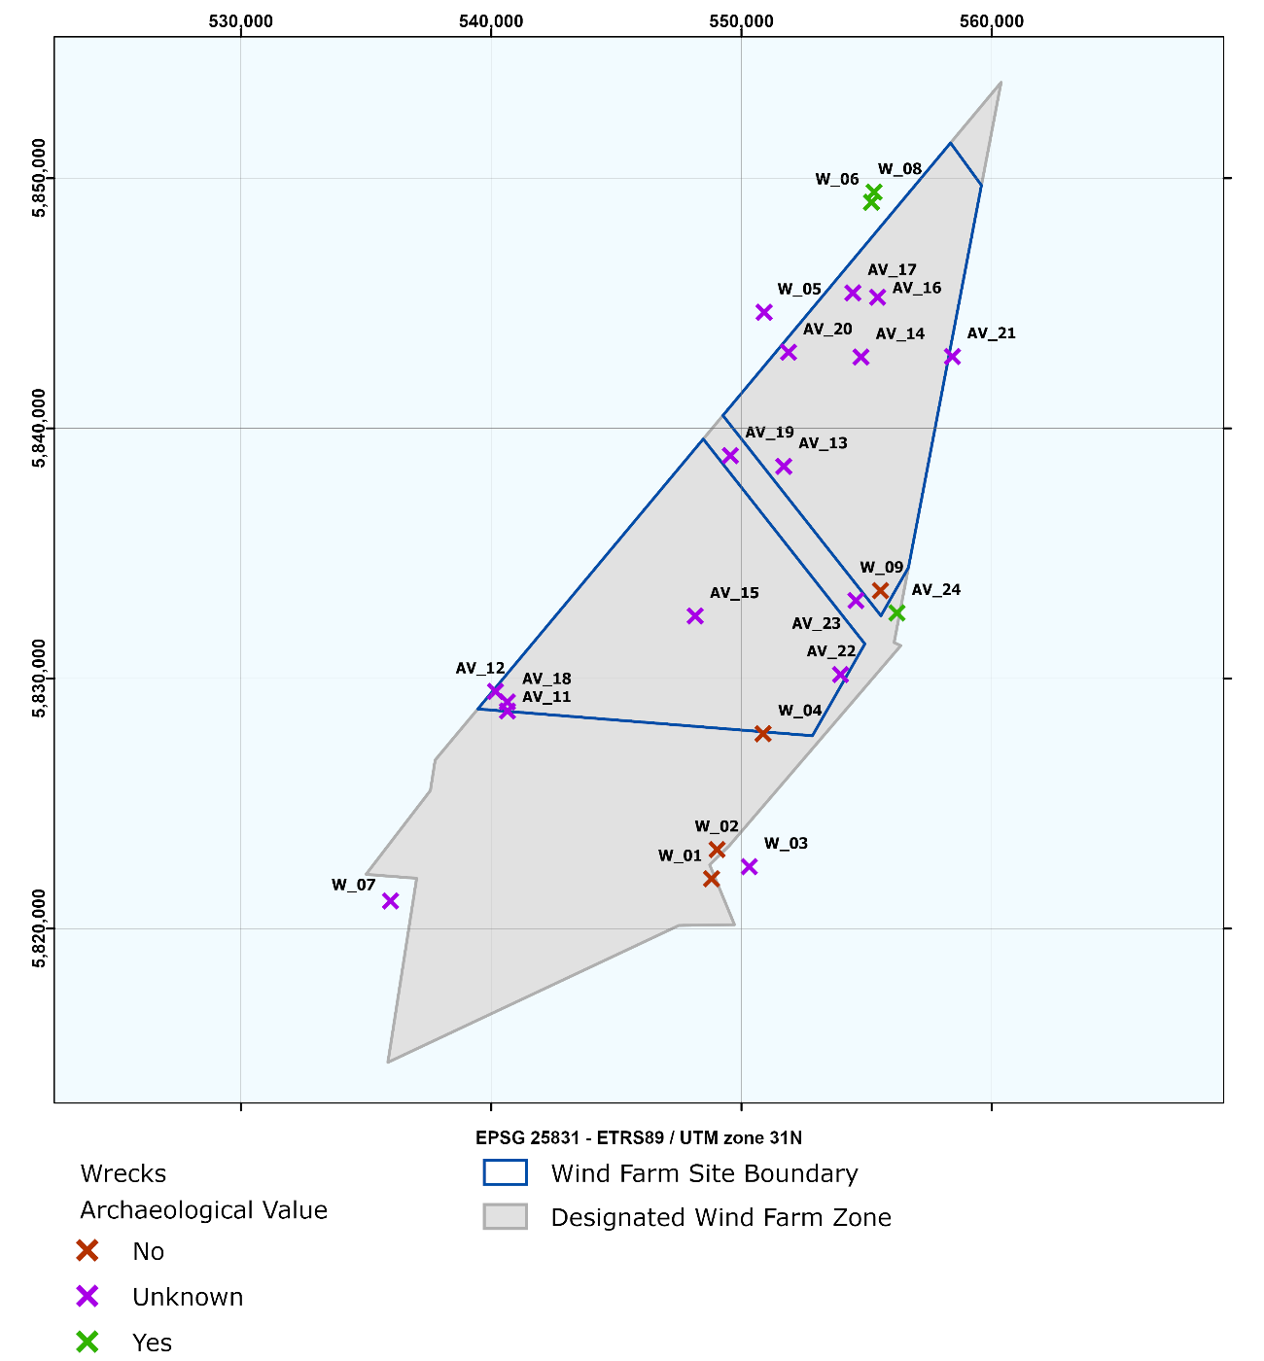
Figure 2.5 Overview of the Wrecks in the HKWWFZ

Table 2.5 Wrecks with possible archaeological value in HKWWFZ
Archaeological objects in HKWWFZ
ETRS 1989 UTM Zone 31N
EPSG 25831
Point No. | NCN | Type | Description | Easting | Northing
W_01 | 439 | Wreck | Wreck yacht Regina, 13x3x2 meter, sunk 01-05-2008 after collision | 548,806.0 | 5,821,993.0
W_02 | 522 | Wreck | Wreck DHY 522. Duikteam Zeester: Wreck of coast vessel, sunk 1980, standing right up, superstructure is gone, close by platform | 549,026.0 | 5,823,162.0
W_03 | 2035 | Wreck | Wreck DHY 2221. Unknown small wreck found 1959, not confirmed since | 550,310.0 | 5,822,477.0
AV_11 | 2056 | Wreck | Wreck DHY 2247. Duikteam Zeester: "Paaswrak 1", close to the Brown bank | 540,651.0 | 5,828,702.0
W_04 | 2057 | Wreck | Wreck DHY 2248. Duikteam Zeester: Wreck Dutsch fishing trawler Stellendam 4, sunk 1969 | 550,864.0 | 5,827,791.0
AV_18 | 2063 | Wreck | Wreck DHY 2255, Unknown wreck found 1970 | 540,648.0 | 5,829,062.0
AV_12 | 2064 | Wreck | Wreck DHY 2256. Duikteam Zeester: Norwegian cargo ship Biarritz from 1920, sunk 1940 | 540,173.0 | 5,829,482.0
AV_19 | 2090 | Wreck | Wreck DHY 2283. Unknown wreck found 1946 | 549,558.0 | 5,838,909.0
AV_13 | 2091 | Wreck | Distributed remains of wreck DHY 2284 | 551,689.0 | 5,838,477.0
AV_20 | 2097 | Wreck | Wreck DHY 2291 Unknown wreck found 1961 | 551,880.0 | 5,843,043.0
AV_14 | 2098 | Wreck | Wreck DHY 2292. Duikteam Zeester: Boezemwrak close to platform | 554,776.0 | 5,842,849.0
AV_21 | 2100 | Wreck | Wreck DHY 2294. Mast reported 1898, not confirmed since | 558,429.0 | 5,842,871.0
W_05 | 2110 | Wreck | Wreck DHY 2304. Wreck reported 1946, not confirmed since | 550,906.0 | 5,844,640.0
W_06 | 2120 | Wreck | Wreck DHY 2315. Duikteam Zeester: Submarine Doris | 555,194.0 | 5,849,035.0
AV_15 | 2250 | Wreck | Wreck DHY 2468. Unknown wreck reported 1984 | 548,152.0 | 5,832,498.0
AV_16 | 2469 | Wreck | Wreck debris | 555,440.0 | 5,845,241.0
AV_17 | 2809 | Wreck | Wreck DHY 3427. Unknown wreck reported with sonar 1997 | 554,452.0 | 5,845,413.0
W_07 | 2810 | Wreck | Distributed remains of wreck | 535,978.0 | 5,821,107.0
AV_22 | 2844 | Wreck | Wreck DHY 3498 | 553,958.0 | 5,830,158.0
AV_23 | 2845 | Wreck | Wreck DHY 3500. Wreck debris reported 2014 | 554,572.0 | 5,833,117.0
AV_24 | 9226 | Wreck | Wooden wreck remains, discovered in 2002. ARCHIS wng 47163 | 556,213.0 | 5,832,620.0
W_08 | 9299 | Submarine | French submarine Doris, sunk mei 1940, cannon salvaged in 2003. ARCHIS wng 48181 | 555,298.0 | 5,849,442.0
W_09 | 15219 | Wreck | Norwegian cargo vessel Nordfrakt, sunk 25-10-1992, dimensions 76x12x2m. RWS SR 11968 | 555,554.0 | 5,833,512.0

Whilst installing wind turbines and the various infield and export cables, developers are advised to avoid areas where wrecks have been identified, by implementing a 100 m buffer zone.

Magnetic Anomalies

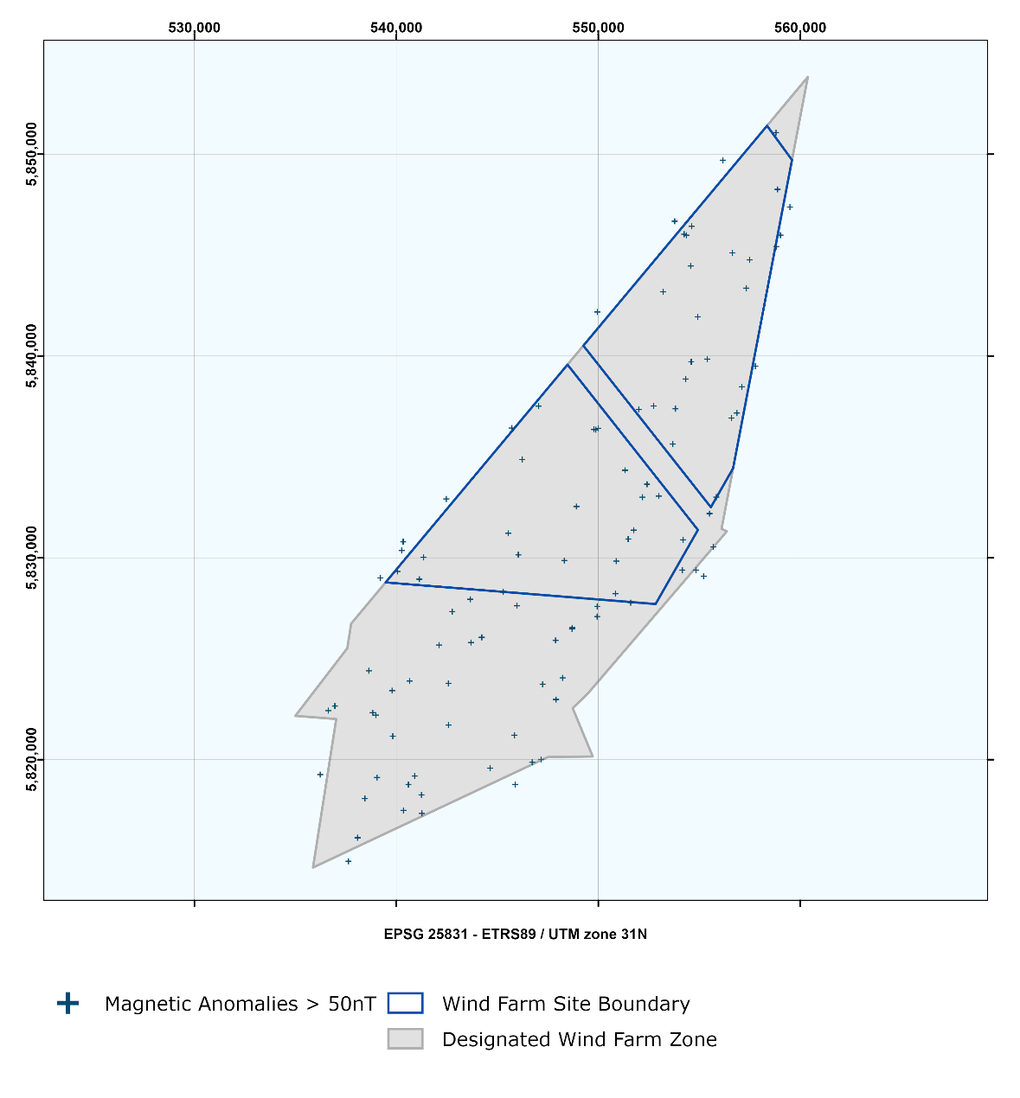
Figure 2.6 Overview of the HKWWFZ – Magnetic Anomalies (possible buried ferrous objects)

Whilst installing wind turbines and the various infield and export cables, developers are advised to avoid areas where magnetic anomalies have been identified, again by implementing a 100 m buffer zone. The coordinates of the magnetic anomalies is in the Excel file : HKW_20210322_RVO_Appendix C_Coordinates

Planned TenneT infrastructure

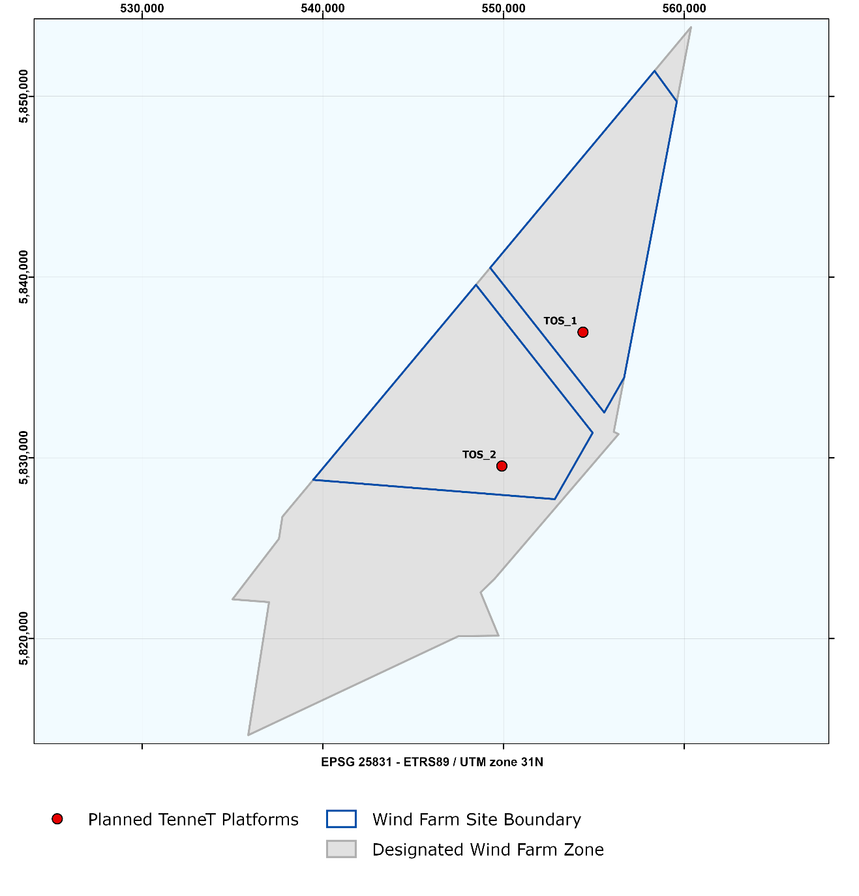
Figure 3.1 Planned TenneT Platform and Cables, the export and redundancy cable routes and the infield cable corridors in the HKWWFZ. The labels correspond with the planned TenneT Cables.
The positioning of the jacket (and thereby the J-tubes) is dependent on the design of the platform. Currently, the contractor of the platform, and therefore the exact design is not yet known. Therefore the infield cable corridor in the safety zone (500m) should be regarded as a guideline. In accordance with TenneT and the OWF developers the exact routes of these infield cables will be planned.

The cables to the platforms are currently not yet planned but will be positioned within the Maintenance Zones (see Figure 2.2 and 2.3).

TenneT Planned Substations
Table 3.1 Coordinates of the Planned TenneT Platforms HKW in the HKWWFZ
Planned TenneT Platform HKW
ETRS 1989 UTM Zone 31N
EPSG 25831
Point No. | Easting | Northing
TOS_1 | 554,395.1 | 5,836,951.8
TOS_2 | 549,905.6 | 5,829,544.0

Existing infrastructure

Cables and pipelines
Due to ocean currents cables and pipes might gradually move on the sea bed or get covered by sand. Therefore the ‘as laid’ cables and pipes are not always the same as the ‘as found’ cables and pipes by the survey. It is advised to consult both datasets in the planning of future wind turbines. Figures 4.1a and 4.1b depict the as found and as laid cable information. The coordinates of the as found cables and pipes is in the Excel file : HKW_20210322_RVO_Appendix C_Coordinates

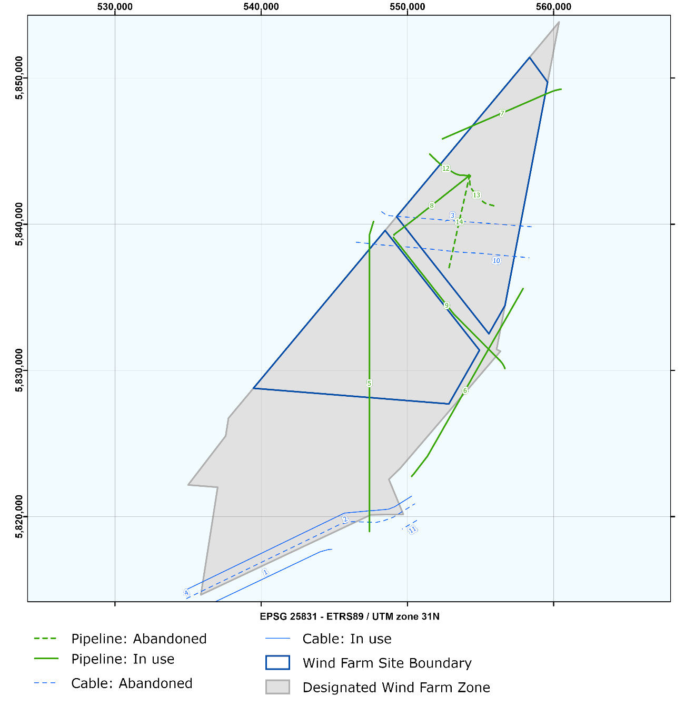
Figure 4.1a Active and inactive cables and pipelines (as laid) in and near the HKWWFZ. The labels correspond with the cables and pipes in tables 4.1a and 4.1b.

There are several existing cables and pipelines (both active and abandoned) crossing the HKWWFZ.

Table 4.1a Existing cables in the HKWWFZ
Cables in use
No. | Name | Route | Type | Status
1 | Atlantic Crossing 1 Segment B1 | Castricum (NL) naar Whitesand (GB) | Telecom | In use
2 | PANGEA Segment 2 | Lowesoft (GB) naar Egmond (NL) | Telecom | In use
3 | UK – NL 14 | Egmond (NL) naar Winterton (GB) | Telecom | Abandoned
4 | Rembrandt 1 | Beverwijk (NL) Lowesoft (GB) | Telecom | Abandoned
10 | UK – NL 10 | Egmond (NL) naar Lowesoft (GB) | Telecom | Abandoned
11 | Rioja 3 | Veurne (B) naar Egmond (NL) | Telecom | Abandoned

Table 4.1b Existing pipelines in the HKWWFZ
Pipelines in use
No. | Route | Type | Status
5 | P12-SW to P6-A | Glycol | Active
6 | P9-Horizon-A to Q1-Helder-AW | Oil | Active
7 | Q4-A to P6-A | Gas | Active
8 | P6-D to P6-B | Gas | Active
9 | P9-B to P6-D | Gas | Active
12 | P6-B to P6-A | Gas | Active
13 | P6-C to P6-B | Glycol | Abandoned
14 | P6-S to P6-B | Gas | Abandoned

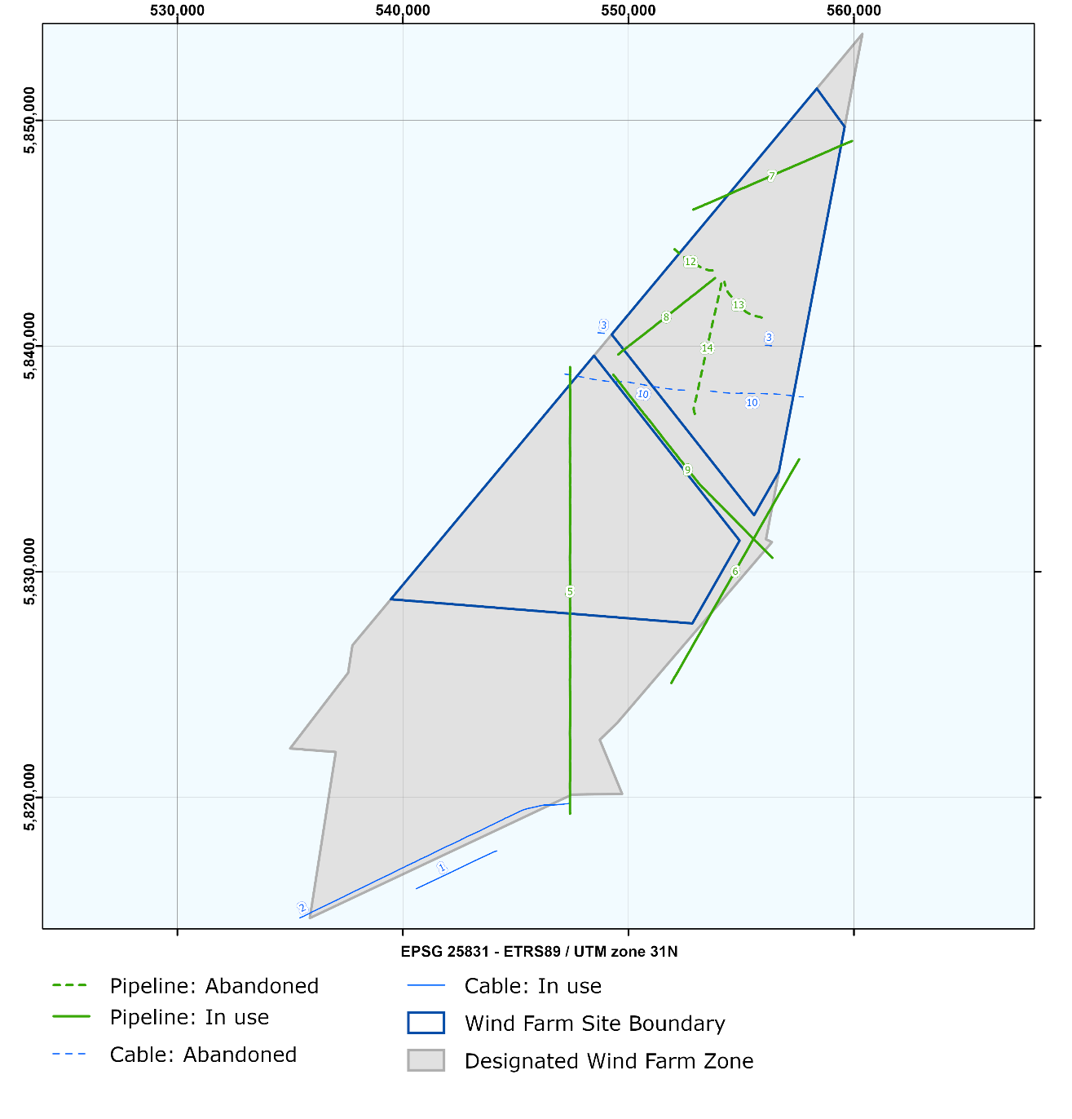
Figure 4.1b Active and inactive cables and pipelines (as found) in and near the HKWWFZ. The labels correspond with the cables and pipes in tables 4.1a and 4.1b.

Existing Platforms and boreholes

There are several existing platforms and boreholes (both active and inactive) in or around the HKWWFZ. Boreholes have been grouped when sharing the same coordinates. The coordinates of the existing platforms can be found in Table 4.2c, the coordinates boreholes in Table 4.2d.

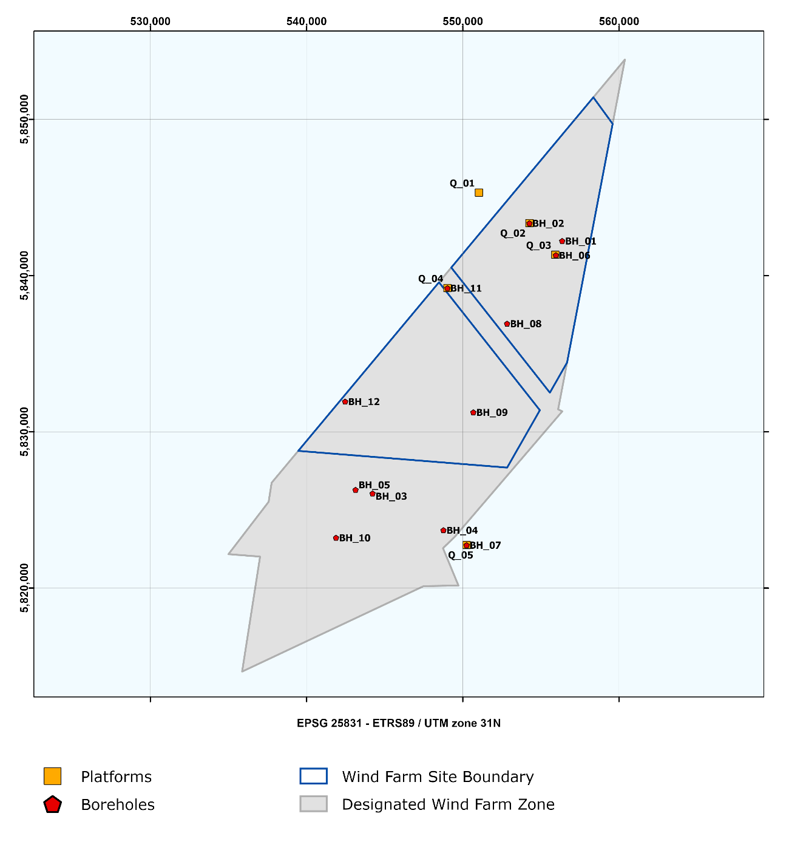
Figure 4.2 Existing platforms and boreholes in and near the HKWWFS

Table 4.2a Existing Platforms
Existing Platforms
Point No. | Name | Type | Status
Q_01 | P6-A | Platform | Existing
Q_02 | P6-B | Platform | Existing
Q_03 | P6-C | Platform | Removed
Q_04 | P6-D | Platform | Existing
Q_05 | P09-HORIZON | Platform | Existing

Table 4.2b Boreholes
Existing Boreholes
 | UWI | Borehole code | NITG number | Owner | Client | Status
BH_01 | 7417 | P06-01 | BP060183 | Wintershall | Mobil | Suspended
BH_02 | 7419 | P06-03 | BP060172 | Wintershall | Mobil | Producing/Injecting
 | 7619 | P06-B-01 | BP060171 | Wintershall | Mobil | Closed-in
 | 7777 | P06-B-03 | BP060173 | Wintershall | Mobil | Closed-in
 | 8339 | P06-B-04 | BP060174 | Wintershall | Clyde | Suspended
BH_03 | 7431 | P08-02 | BP080048 | Mobil | Mobil | Abandoned
 | 9131 | P08-03 | BP080088 | Mobil | Mobil | Failure/sidetracked
 | 9132 | P08-03-S1 | BP080089 | Mobil | Mobil | Failure/sidetracked
 | 7432 | P08-03-S2 | BP080049 | Mobil | Mobil | Abandoned
BH_04 | 7434 | P09-02 | BP090238 | TAQA | Amoco | Closed-in
 | 7544 | P09-04 | BP090240 | TAQA | Amoco | Abandoned
 | 7655 | P09-05 | BP090241 | TAQA | Amoco | Closed-in
BH_05 | 7535 | P08-05 | BP080051 | Mobil | Mobil | Abandoned
 | 7527 | P08-05-S1 | BP080052 | Mobil | Mobil | Abandoned
 | 7528 | P08-05-S2 | BP080053 | Mobil | Mobil | Abandoned
BH_06 | 8531 | P06-C-01 | BP060175 | Wintershall | Mobil | Failure/sidetracked
 | 8529 | P06-C-01-S1 | BP060177 | Wintershall | Mobil | Failure/sidetracked
 | 7694 | P06-C-01-S2 | BP060176 | Wintershall | Mobil | Closed-in
 | 7736 | P06-C-02 | BP060178 | Wintershall | Mobil | Closed-in
BH_07 | 7781 | P09-HORIZON-A-01 | BP090245 | Chevron | Unocal | Failure/sidetracked
 | 8452 | P09-HORIZON-A-01-S1 | BP090246 | Chevron | Unocal | Closed-in
 | 8152 | P09-HORIZON-A-02 | BP090247 | Chevron | Unocal | Producing/Injecting
 | 8153 | P09-HORIZON-A-03 | BP090248 | Chevron | Unocal | Plugged back and sidetracked
 | 8166 | P09-HORIZON-A-03-S1 | BP090257 | Chevron | Unocal | Producing/Injecting
 | 8154 | P09-HORIZON-A-04 | BP090249 | Chevron | Unocal | Producing/Injecting
 | 8155 | P09-HORIZON-A-05 | BP090250 | Chevron | Unocal | Plugged back and sidetracked
 | 8162 | P09-HORIZON-A-05-S1 | BP090251 | Chevron | Unocal | Producing/Injecting
 | 8167 | P09-HORIZON-A-06 | BP090252 | Chevron | Unocal | Producing/Injecting
 | 8204 | P09-HORIZON-A-07 | BP090253 | Chevron | Unocal | Plugged back and sidetracked
 | 8450 | P09-HORIZON-A-07-S1 | BP090254 | Chevron | Unocal | Producing/Injecting
 | 8201 | P09-HORIZON-A-08 | BP090255 | Chevron | Unocal | Plugged back and sidetracked
 | 8451 | P09-HORIZON-A-08-S1 | BP090256 | Chevron | Unocal | Closed-in
BH_08 | 8490 | P06-10 | BP060181 | Wintershall | Clyde | Abandoned
 | 7997 | P06-S-01 | BP060180 | Wintershall | Mobil | Abandoned
BH_09 | 8069 | P09-07 | BP090242 | Chevron | Unocal | Abandoned
BH_10 | 8245 | P08-06 | BP080054 | ENGIE E&P Nederland B.V. | Occidental | Abandoned
BH_11 | 8465 | P06-D-01 | BP060179 | Wintershall | Clyde | Producing/Injecting
BH_12 | 9044 | P08-07 | BP080084 | Wintershall | Wintershall | Abandoned

Table 4.2c Coordinates for existing Platforms
Existing Platforms
ETRS 1989 UTM Zone 31N
EPSG 25831
Point No. | Easting | Northing |  | Point No. | Easting | Northing
Q_01 | 551,031.4 | 5,845,314.0 |  | Q_04 | 549,013.4 | 5,839,204.0
Q_02 | 554,262.4 | 5,843,360.0 |  | Q_05 | 550,242.0 | 5,822,755.0
Q_03 | Removed | Removed

Table 4.2d Coordinates for Boreholes
Existing Boreholes
ETRS 1989 UTM Zone 31N
EPSG 25831
Point No. | Easting | Northing |  | Point No. | Easting | Northing
BH_01 | 556,359.0 | 5,842,226.0 |  | BH_07 | 550,242.0 | 5,822,755.0
BH_02 | 554,264.0 | 5,843,361.0 |  | BH_08 | 552,833.0 | 5,836,933.0
BH_03 | 544,221.0 | 5,826,065.0 |  | BH_09 | 550,671.0 | 5,831,258.0
BH_04 | 548,758.0 | 5,823,713.0 |  | BH_10 | 541,883.0 | 5,823,229.0
BH_05 | 543,133.0 | 5,826,296.0 |  | BH_11 | 549,015.0 | 5,839,204.0
BH_06 | 555,958.0 | 5,841,313.0 |  | BH_12 | 542,467.0 | 5,831,946.0

