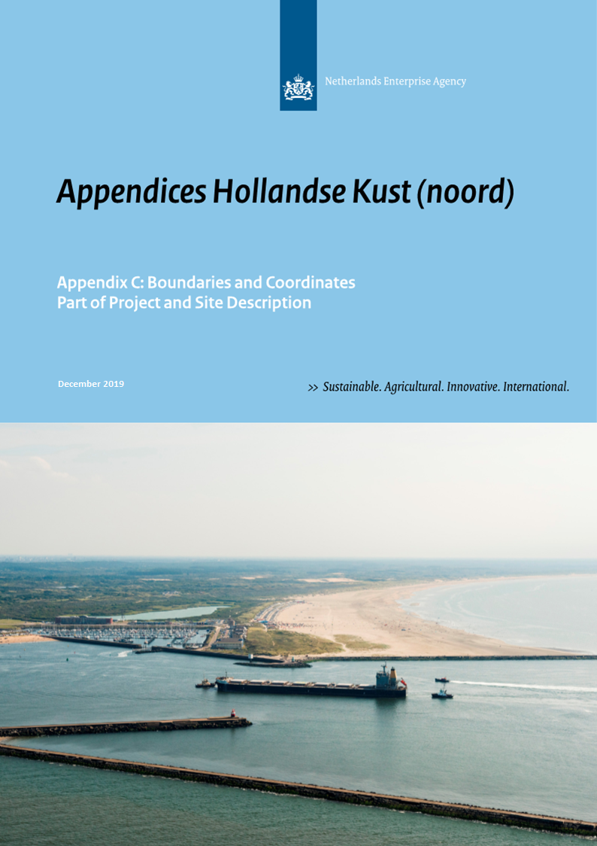

Colophon
Project name | Site Studies Hollandse Kust (noord) Wind Farm Zone
Version | December 17, 2019, HKN memo_F1.6
Project manager | C.A. (Cynthia) Mors (RVO)
Annex(es) | -
Authors | Ronald van Lanen (RHDHV-NL)  Georgina Cutler (RHDHV-UK)  Tom Moekotte (RHDHV-NL)
Reviewed | Cynthia Mors (RVO)  Rick van der Heijden (RVO)  Arjen Crince (RVO)  Thomas Collette (RWS)  René van ’t Hart (RWS)  Camiel van der Hout (EZK)  Martijn Haman (Tennet)  Jeroen Achterberg (Tennet)
Approved  Revisions:  2019-08-08  2019-08-15  2019-12-17 | Camiel van der Hout (EZK)  Thomas Collette (RWS)  Correction of the coordinates for wreck locations  AV_01 and AV_03  Correction status cable UK-Netherlands 14 in table 4.1 into “In use”  Correction in table 5.1:  Hub height Amalia 59m (LAT) into 60m (MSL)

Only the coordinates and boundaries in the final Wind Farm Site Decision are legally binding. The coordinates in the final Wind Farm Site Decision HKNWFS are aligned with this memo. Please note this memo confers no rights and is provided for convenience only.

Contents

1 Introduction 4
2 Hollandse Kust (noord) Wind Farm Site (HKNWFS) 6
3 Planned TenneT infrastructure 17
4 Existing infrastructure 18
5 Wind turbines in existing nearby wind farms 35

Introduction

Purpose
The purpose of this memo is to establish the exact boundaries and coordinates for the Hollandse Kust (noord) Wind Farm Site (HKNWFS) (in Dutch: kavel). The geographical information is based on the data available in August 2018.

The coordinates in TenneT's permit application for the export cables for HKNWFS and the export cables for Hollandse Kust (west) alpha aligned with the coordinates in the HKN Wind Farm Site Decision (WFSD) and the coordinates in this memo.
Please note this memo confers no rights and is provided for convenience only.
Only the coordinates and boundaries in the final WFSD are legally binding. This appendix is aligned with the coordinates in the final WFSD (url). Available on this website under Kavelbesluit V.

Horizontal datum
The geodetic system used for horizontal projections is European Terrestrial Reference System 1989 (ETRS89).

All coordinates are given in UTM projection, for which the following applies:
- Local datum European Datum (ETRS89)
- Central Meridian 3° E (Zone 31N)

The corresponding EPSG code to this horizontal datum is:
- EPSG 25831

GIS Information
All coordinates given in this document correspond to GIS data made available by the Netherlands Enterprise Agency (RVO.nl) through the MPK file of the Hollandse Kust (noord) Wind Farm Zone (HKNWFZ) at https://offshorewind.rvo.nl/generalnh.

Coordinate numbering
The coordinates given in this document are numbered according to the following system:
- Coordinates that determine the boundaries of the HKNWFZ start with the letter code WFZ (Wind Farm Zone) followed by an underscore and a number (WFZ_01, WFZ_02, …);
- Coordinates that determine the outer boundaries of the HKNWFS start with the letter code S (Site) followed by an underscore and a number (S_01, S_02, …);
- Coordinates that determine the maintenance zones of pipes and cables in the HKNWFZ start with the letter code MZ (Maintenance Zone) followed by an underscore and a number (MZ_01, MZ_02, …);
- Coordinates that determine the entry zone for the connection of the infield cables to the TenneT platforms start with the letter code CE (Cable Entry zone) followed by an underscore and a number (CE_01, CE_02, …);
- Coordinates of objects which might have archaeological value start with the letter code AV (Archaeological Value) followed by an underscore and a number (AV_01, AV_02, …);
- Coordinates of objects marked as wrecks start with the letter code W (Wreck) followed by an underscore and a number (W_01, W_02, …);
- Coordinates of magnetic anomalies possibly indicating UXO objects or objects with archaeological value start with the letter code MA (Magnetic Anomaly) followed by an underscore and a number (MA_01, MA_02, …);
- Coordinates that determine the downtime measure in the HKNWFZ start with the letter code DM (Downtime Measure zone) followed by an underscore and a number (DM_01, DM_02, …);
- Coordinates that determine the 12 Nautical Mile Border in the HKNWFZ start with the letter code NM (Nautical Mile) followed by an underscore and a number number (NM_01, NM_02, …);
- Coordinates of the centre of the TenneT OHVS platform (Substation HKN) in the HKNWFZ start with the letter code TOS (TenneT Offshore high voltage Substation) followed by an underscore and a number (TOS_1);
- Coordinates that determine the location of the existing cables and pipelines in the HKNWFZ start with the letter code CP (Cables and Pipes) followed by an underscore and a number (CP_001, CP_002, …). The following number is derived from the GIS dataset (field: ObjectID);
- Coordinates that determine the locations of the wind turbines at existing nearby wind farms start with the letter code NW (Nearby Wind farm) followed by an underscore and a number (NW_001, NW_002, …).

Orientation figures
All figures included in this document are presented with the north direction facing upwards.

Hollandse Kust (noord) Wind Farm Site (HKNWFS)

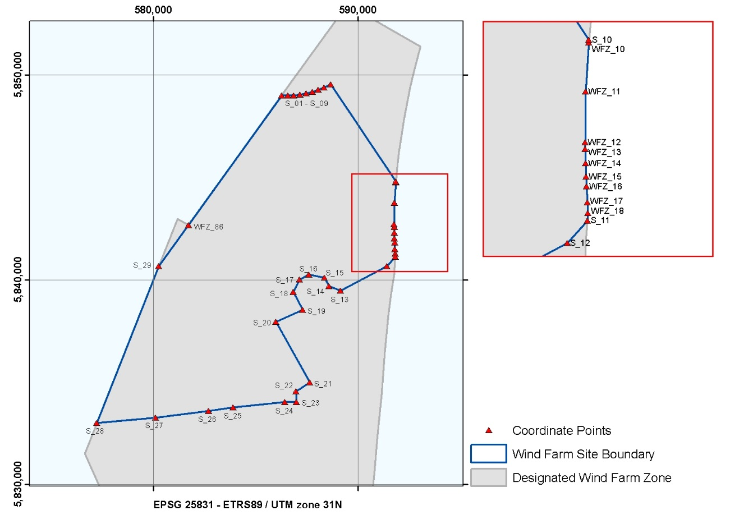
Figure 2.1 Overview of the HKNWFS – Site
Table 2.1 Coordinates of the HKNWFS
HKNWFS
ETRS 1989 UTM Zone 31N
EPSG 25831
Point No. | Easting | Northing |  | Point No. | Easting | Northing
S_01 | 586,261.3 | 5,849,008.4 |  | S_12 | 591,406.8 | 5,840,673.5
S_02 | 586,565.5 | 5,849,004.8 |  | S_13 | 589,144.7 | 5,839,468.5
S_03 | 586,869.3 | 5,849,021.2 |  | S_14 | 588,576.8 | 5,839,685.5
S_04 | 587,171.3 | 5,849,057.4 |  | S_15 | 588,352.6 | 5,840,106.4
S_05 | 587,470.3 | 5,849,113.4 |  | S_16 | 587,607.0 | 5,840,248.8
S_06 | 587,764.9 | 5,849,188.9 |  | S_17 | 587,151.6 | 5,840,006.2
S_07 | 588,054.0 | 5,849,283.6 |  | S_18 | 586,829.0 | 5,839,414.7
S_08 | 588,336.3 | 5,849,397.1 |  | S_19 | 587,298.2 | 5,838,533.8
S_09 | 588,664.2 | 5,849,557.3 |  | S_20 | 585,998.0 | 5,837,944.0
S_10 | 591,846.7 | 5,844,809.2 |  | S_21 | 587,651.1 | 5,834,988.4
WFZ_10 | 591,841.5 | 5,844,754.0 |  | S_22 | 586,973.5 | 5,834,559.4
WFZ_11 | 591,780.8 | 5,843,758.8 |  | S_23 | 586,993.9 | 5,834,035.5
WFZ_12 | 591,768.5 | 5,842,720.7 |  | S_24 | 586,430.2 | 5,834,028.7
WFZ_13 | 591,770.2 | 5,842,586.6 |  | S_25 | 583,893.5 | 5,833,768.8
WFZ_14 | 591,776.6 | 5,842,300.0 |  | S_26 | 582,705.2 | 5,833,582.7
WFZ_15 | 591,785.7 | 5,842,028.4 |  | S_27 | 580,117.3 | 5,833,266.0
WFZ_16 | 591,794.6 | 5,841,826.7 |  | S_28 | 577,231.0 | 5,833,001.2
WFZ_17 | 591,812.1 | 5,841,503.1 |  | S_29 | 580,254.0 | 5,840,662.8
WFZ_18 | 591,828.6 | 5,841,283.3 |  | WFZ_86 | 581,708.5 | 5,842,683.4
S_11 | 591,816.9 | 5,841,132.6

Maintenance Zone and Coordinates

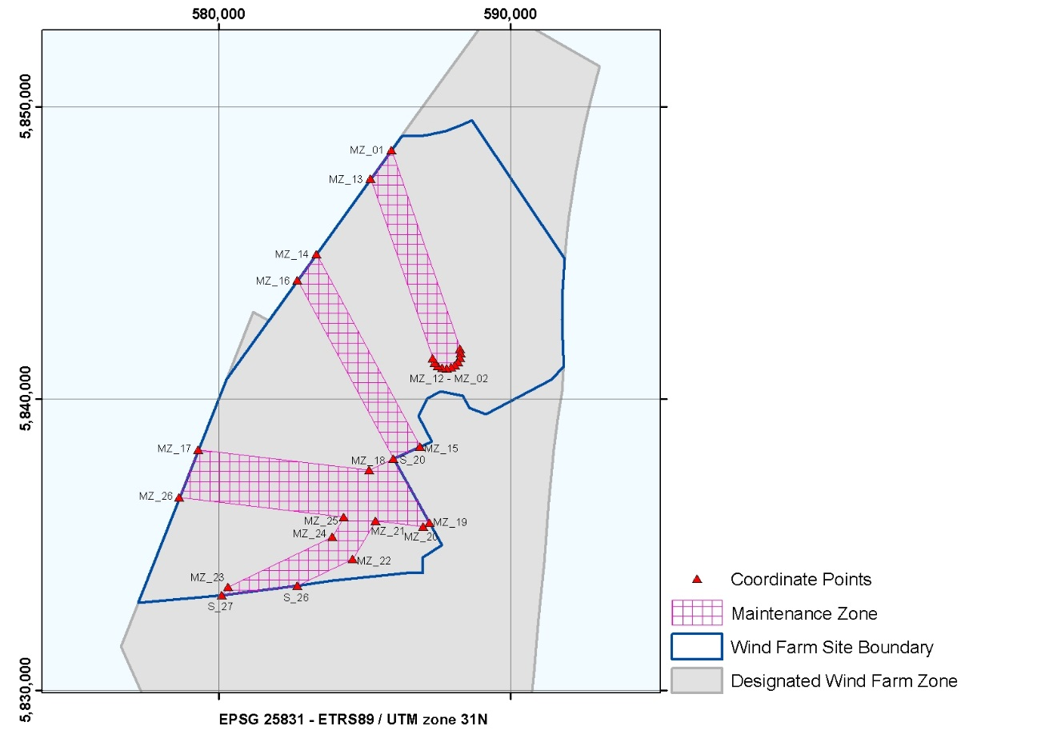
Figure 2.2 Overview of the HKNWFS – Maintenance Zone

Table 2.2 Coordinates of Maintenance Zone I
Maintenance Zone I in HKNWFS
ETRS 1989 UTM Zone 31N
EPSG 25831
Point No. | Easting | Northing |  | Point No. | Easting | Northing
MZ_01 | 585,920.4 | 5,848,534.7 |  | MZ_08 | 587,813.3 | 5,841,045.1
MZ_02 | 588,276.8 | 5,841,708.2 |  | MZ_09 | 587,658.3 | 5,841,066.8
MZ_03 | 588,304.1 | 5,841,554.1 |  | MZ_10 | 587,517.7 | 5,841,135.2
MZ_04 | 588,282.4 | 5,841,399.2 |  | MZ_11 | 587,405.1 | 5,841,243.8
MZ_05 | 588,214.0 | 5,841,258.5 |  | MZ_12 | 587,331.5 | 5,841,381.9
MZ_06 | 588,105.4 | 5,841,145.9 |  | MZ_13 | 585,205.4 | 5,847,541.4
MZ_07 | 587,967.3 | 5,841,072.4

Table 2.3 Coordinates of Maintenance Zone II
Maintenance Zone II in HKNWFS
ETRS 1989 UTM Zone 31N
EPSG 25831
Point No. | Easting | Northing |  | Point No. | Easting | Northing
MZ_14 | 583,348.5 | 5,844,961.7 |  | S_20 | 585,998.0 | 5,837,944.0
MZ_15 | 586,912.4 | 5,838,358.8 |  | MZ_16 | 582,699.0 | 5,844,059.5

Table 2.4 Coordinates of Maintenance Zone III
Maintenance Zone III in HKNWFS
ETRS 1989 UTM Zone 31N
EPSG 25831
Point No. | Easting | Northing |  | Point No. | Easting | Northing
MZ_17 | 579,301.9 | 5,838,249.8 |  | S_26 | 582,705.2 | 5,833,582.7
MZ_18 | 585,162.3 | 5,837,551.1 |  | S_27 | 580,117.3 | 5,833,266.0
S_20 | 585,998.0 | 5,837,944.0 |  | MZ_23 | 580,331.4 | 5,833,541.0
MZ_19 | 587,230.7 | 5,835,748.5 |  | MZ_24 | 583,894.5 | 5,835,272.4
MZ_20 | 587,017.6 | 5,835,622.2 |  | MZ_25 | 584,290.5 | 5,835,944.0
MZ_21 | 585,375.5 | 5,835,815.3 |  | MZ_26 | 578,656.7 | 5,836,614.6
MZ_22 | 584,602.7 | 5,834,504.7

Cable Entry Zone and Coordinates
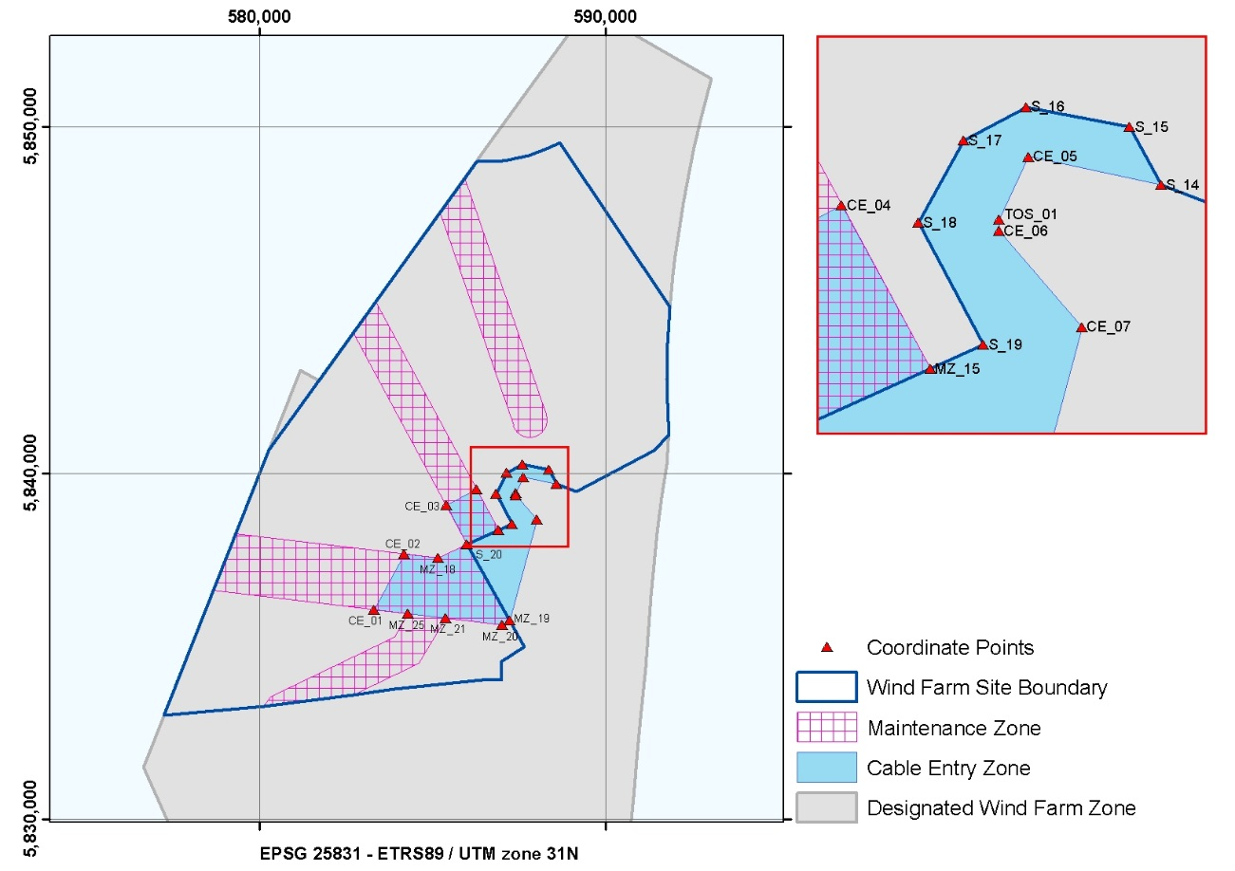
Figure 2.3 Overview of the HKNWFS – Cable Entry Zone

The positioning of the jacket (and thereby the J-tubes) is dependent on the design of the platform. Currently the contractor of the platform and therefore the exact design is not yet known. Therefore the infield cable corridor in the safety zone (500 m) should be regarded as a guideline. In partnership with TenneT and the OWFs, the exact routes of these infield cables will be planned.

Table 2.5 Coordinates of the infield Cable Entry Zone HKNWFS
Cable Entry Zone in HKNWFS
ETRS 1989 UTM Zone 31N
EPSG 25831
Point No. | Easting | Northing |  | Point No. | Easting | Northing
CE_01 | 583,297.5 | 5,836,062.2 |  | S_15 | 588,352.6 | 5,840,106.4
CE_02 | 584,169.3 | 5,837,669.5 |  | S_14 | 588,576.8 | 5,839,685.5
MZ_18 | 585,162.3 | 5,837,551.1 |  | CE_05 | 587,621.8 | 5,839,890.2
S_20 | 585,998.0 | 5,837,944.0 |  | TOS_01 | 587,410.1 | 5,839,436.2
CE_03 | 585,392.5 | 5,839,069.3 |  | CE_06 | 587,411.2 | 5,839,353.2
CE_04 | 586,275.1 | 5,839,539.4 |  | CE_07 | 588,009.3 | 5,838,660.7
MZ_15 | 586,912.4 | 5,838,358.8 |  | MZ_19 | 587,230.7 | 5,835,748.5
S_19 | 587,298.2 | 5,838,533.8 |  | MZ_20 | 587,017.6 | 5,835,622.2
S_18 | 586,829.0 | 5,839,414.7 |  | MZ_21 | 585,375.5 | 5,835,815.3
S_17 | 587,151.6 | 5,840,006.2 |  | MZ_25 | 584,290.5 | 5,835,944.0
S_16 | 587,607.0 | 5,840,248.8

Possible Archaeological Objects and Coordinates
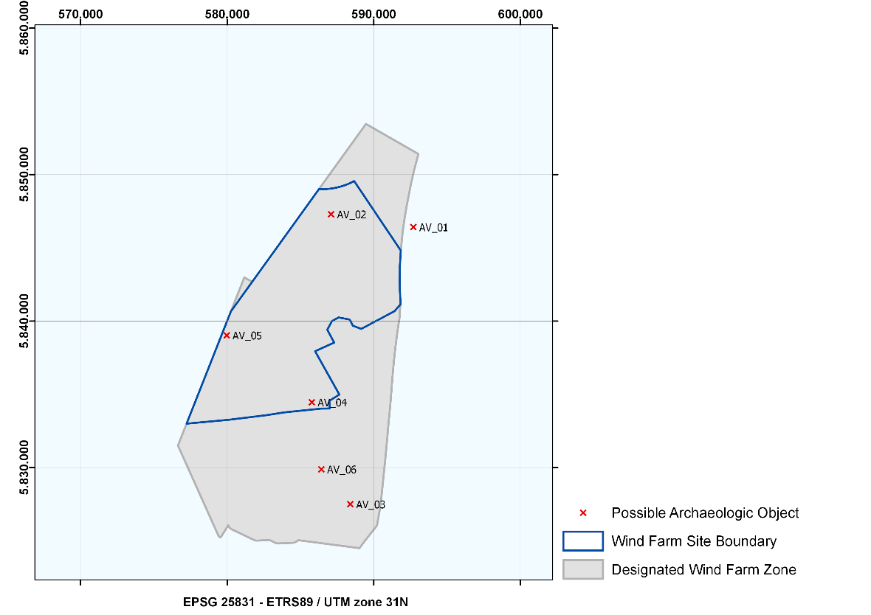
Figure 2.4 Overview of the HKNWFZ – Possible Archaeological Objects

Table 2.6 Coordinates of possible Archaeological Objects in the HKNWFZ
Wrecks in HKNWFZ
No. | Description | NCN | Easting | Northing
AV_01 | Possible wreck | 2118/16651 | 592,699.7 | 5,846,422.0
AV_02 | Debris, strong contact with shadow, clear object, partially buried | - | 587,093.6 | 5,847,292.0
AV_03 | Wreck; broken, partially covered with sand | 2060 | 588,396.1 | 5,827,503.0
AV_04 | Debris, clear object | - | 585,770.2 | 5,834,462.0
AV_05 | Debris, clear object | - | 579,971.4 | 5,839,026.0
AV_06 | Debris, linear object perpendicular to current ripples | - | 586,423.6 | 5,829,880.0

A buffer zone of 100 m should be applied around the few objects found which have yet to be determined to have no archaeological value, thereby prohibiting any activities in their locations. This also applies to cable trenching and anchorages of work vessels. Please note the buffer zone may be reduced if it can be substantiated that the applied activity and disturbance has no effect on the (possible) archaeological object.

Some of the archaeological objects have a corresponding NCN. For AV_01 this is NCN2118/16651, and for AV_03 this is NCN2060

Wrecks with possible archaeological value in the HKNWFZ

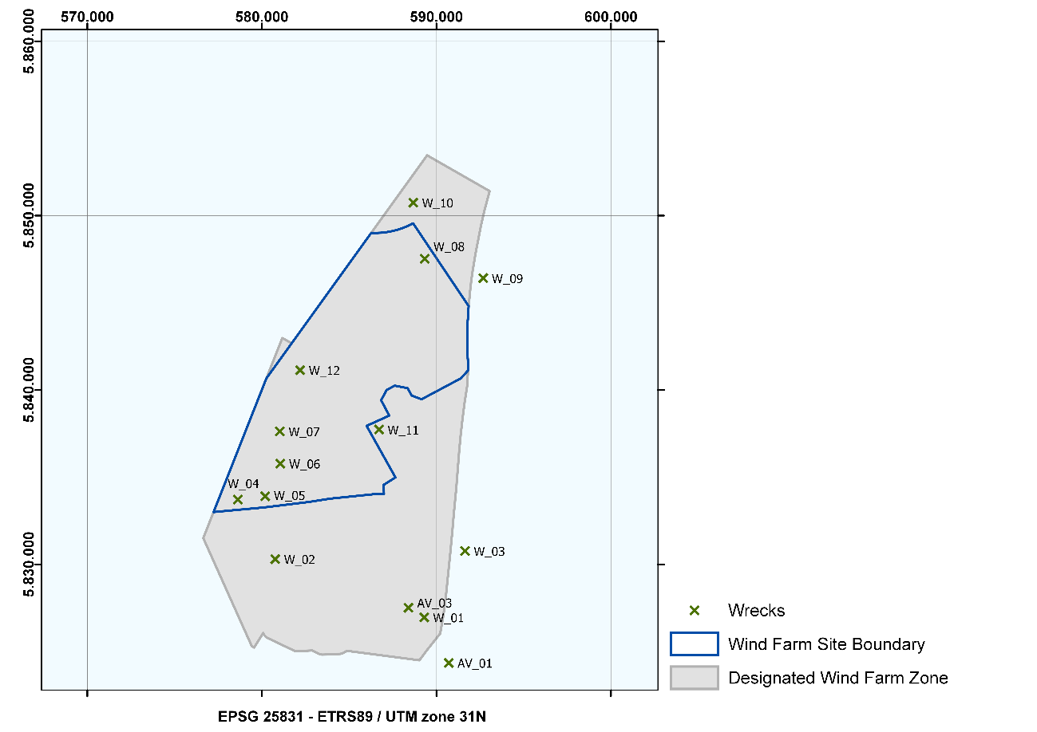
Figure 2.5 Overview of the wrecks with possible archaeological value in the HKNWFZ

Whilst installing wind turbines and infield and export cables, developers are advised to avoid areas where wrecks have been identified, by implementing a 100 m buffer zone.

Table 2.7 Wrecks with possible archaeological value in HKNWFZ
Wrecks in HKNWFZ
No. | NCN | Description | Easting | Northing
AV_01 | 2043 | unknown; BDS 1452/2004 | 590,712.0 | 5,824,349.0
W_01 | 2051 | Eton; Buyskes HY01129; British cargo ship built 1890 sunk 25-08-1912 | 589,301.0 | 5,826,959.0
AV_03 | 2060 | unknown; HY 09223 is broken; partially covered with sand | 588,397.0 | 5,827,512.0
W_02 | 2065 | TX 24, posacc 20m, HY11320 | 580,767.0 | 5,830,306.0
W_03 | 2066 | unknown; posacc 20m; Buyskes HY01129 | 591,639.0 | 5,830,773.0
W_04 | 2077 | unknown, posacc 20m, 42.2x7.6m. Marhis: of Salland, Dutch cargo vessel, sunk february 1953 | 578,616.0 | 5,833,718.0
W_05 | 2078 | unknown; posacc 1000m; Buyskes HY00087 not found | 580,189.0 | 5,833,909.0
W_06 | 2082 | unknown; posacc 1000m; Buyskes HY00087 not found | 581,060.0 | 5,835,778.0
W_07 | 2086 | unknown; posacc 1000m; Buyskes HY00087 not found | 581,029.0 | 5,837,632.0
W_08 | 2117 | Sirabuen; Norwegian cargo vessel, built 1921, sunk 1956 after colission posacc 20m; 43x11m;HY12322 | 589,328.0 | 5,847,520.0
W_09 | 2118 | posacc 20m, 60x15m;HY12322 | 592,677.0 | 5,846,416.0
W_10 | 2126 | unknown; posacc 20m;HY10322 | 588,678.0 | 5,850,747.0
W_11 | 2545 | unknown; 67.9m | 586,708.0 | 5,837,737.0
W_12 | 25000 | Former Kugelbake SH 23 sunk 19-09-1989, raised | 582,190.5 | 5,841,144.2

Magnetic Anomalies

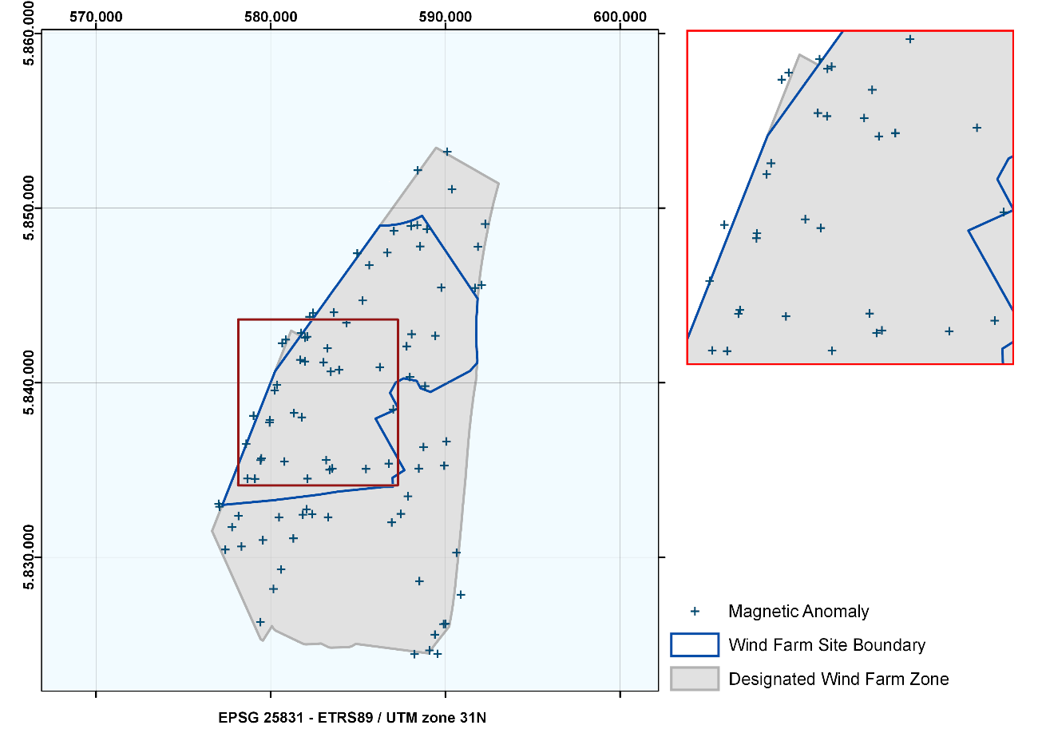
Figure 2.6 Overview of the HKNWFZ – Magnetic Anomalies (possible buried ferrous objects)

Table 2.8 Coordinates of Magnetic Anomalies (possible buried ferrous objects)
Magnetic Anomalies in HKNWFZ
ETRS 1989 UTM Zone 31N
EPSG 25831
Point No. | Easting | Northing |  | Point No. | Easting | Northing
MA_01 | 589,934.3 | 5,835,255.0 |  | MA_46 | 582,099.3 | 5,834,504.0
MA_02 | 588,509.9 | 5,828,634.0 |  | MA_47 | 583,910.9 | 5,840,736.0
MA_03 | 590,639.6 | 5,830,265.0 |  | MA_48 | 587,050.4 | 5,848,692.0
MA_04 | 588,228.7 | 5,824,457.0 |  | MA_49 | 588,416.9 | 5,852,167.0
MA_05 | 589,087.6 | 5,824,672.0 |  | MA_50 | 585,263.4 | 5,844,710.0
MA_06 | 589,895.8 | 5,826,175.0 |  | MA_51 | 586,671.8 | 5,847,452.0
MA_07 | 589,999.1 | 5,826,190.0 |  | MA_52 | 583,439.6 | 5,840,642.0
MA_08 | 589,549.0 | 5,824,470.0 |  | MA_53 | 580,474.5 | 5,832,291.0
MA_09 | 590,885.3 | 5,827,859.0 |  | MA_54 | 584,332.7 | 5,843,428.0
MA_10 | 590,058.4 | 5,836,636.0 |  | MA_55 | 585,640.5 | 5,846,731.0
MA_11 | 586,925.3 | 5,832,002.0 |  | MA_56 | 579,548.8 | 5,830,987.0
MA_12 | 588,476.7 | 5,835,085.0 |  | MA_57 | 580,780.2 | 5,835,487.0
MA_13 | 587,853.6 | 5,833,497.0 |  | MA_58 | 581,776.3 | 5,838,018.0
MA_14 | 587,448.9 | 5,832,488.0 |  | MA_59 | 583,018.1 | 5,841,167.0
MA_15 | 592,073.8 | 5,845,596.0 |  | MA_60 | 583,247.2 | 5,841,974.0
MA_16 | 588,743.6 | 5,836,317.0 |  | MA_61 | 584,955.3 | 5,847,410.0
MA_17 | 591,693.4 | 5,845,425.0 |  | MA_62 | 583,615.6 | 5,844,030.0
MA_18 | 591,863.5 | 5,847,792.0 |  | MA_63 | 581,332.7 | 5,838,267.0
MA_19 | 586,755.8 | 5,835,366.0 |  | MA_64 | 578,324.0 | 5,830,623.0
MA_20 | 588,836.3 | 5,839,805.0 |  | MA_65 | 581,954.5 | 5,841,219.0
MA_21 | 589,418.9 | 5,842,686.0 |  | MA_66 | 579,097.9 | 5,834,494.0
MA_22 | 592,280.5 | 5,849,090.0 |  | MA_67 | 577,784.6 | 5,831,735.0
MA_23 | 587,962.7 | 5,840,328.0 |  | MA_68 | 582,085.5 | 5,842,637.0
MA_24 | 589,766.2 | 5,845,451.0 |  | MA_69 | 578,669.8 | 5,834,512.0
MA_25 | 587,013.2 | 5,838,471.0 |  | MA_70 | 579,934.8 | 5,837,724.0
MA_26 | 585,452.5 | 5,835,062.0 |  | MA_71 | 582,422.8 | 5,844,005.0
MA_27 | 588,066.9 | 5,842,782.0 |  | MA_72 | 581,691.1 | 5,841,310.0
MA_28 | 587,779.3 | 5,842,086.0 |  | MA_73 | 579,462.9 | 5,835,670.0
MA_29 | 590,375.6 | 5,851,080.0 |  | MA_74 | 579,421.6 | 5,835,563.0
MA_30 | 583,282.7 | 5,832,298.0 |  | MA_75 | 578,158.5 | 5,832,369.0
MA_31 | 586,247.1 | 5,840,889.0 |  | MA_76 | 577,399.2 | 5,830,443.0
MA_32 | 582,371.0 | 5,832,475.0 |  | MA_77 | 581,741.6 | 5,842,852.0
MA_33 | 583,374.1 | 5,835,012.0 |  | MA_78 | 581,966.9 | 5,842,577.0
MA_34 | 588,939.4 | 5,848,797.0 |  | MA_79 | 580,225.7 | 5,839,557.0
MA_35 | 588,552.1 | 5,847,807.0 |  | MA_80 | 580,353.5 | 5,839,872.0
MA_36 | 583,524.6 | 5,835,084.0 |  | MA_81 | 582,226.2 | 5,843,779.0
MA_37 | 582,048.1 | 5,832,750.0 |  | MA_82 | 578,595.3 | 5,836,503.0
MA_38 | 583,173.2 | 5,835,570.0 |  | MA_83 | 577,015.7 | 5,833,063.0
MA_39 | 588,032.8 | 5,848,973.0 |  | MA_84 | 579,015.8 | 5,838,108.0
MA_40 | 588,386.7 | 5,849,031.0 |  | MA_85 | 580,658.4 | 5,842,268.0
MA_41 | 581,836.6 | 5,832,441.0 |  | MA_86 | 580,858.2 | 5,842,465.0
MA_42 | 581,294.1 | 5,831,085.0 |  | MA_87 | 577,067.2 | 5,832,900.0
MA_43 | 580,592.4 | 5,829,307.0 |  | MA_88 | 590,106.5 | 5,853,230.0
MA_44 | 580,155.7 | 5,828,190.0 |  | MA_89 | 579,948.9 | 5,837,865.0
MA_45 | 579,407.5 | 5,826,289.0 |  | MA_90 | 589,396.1 | 5,825,571.0

Whilst installing wind turbines and infield and export cables, developers are advised to avoid areas where magnetic anomalies have been identified, again by implementing a 100 m buffer zone.

Downtime Measure zone
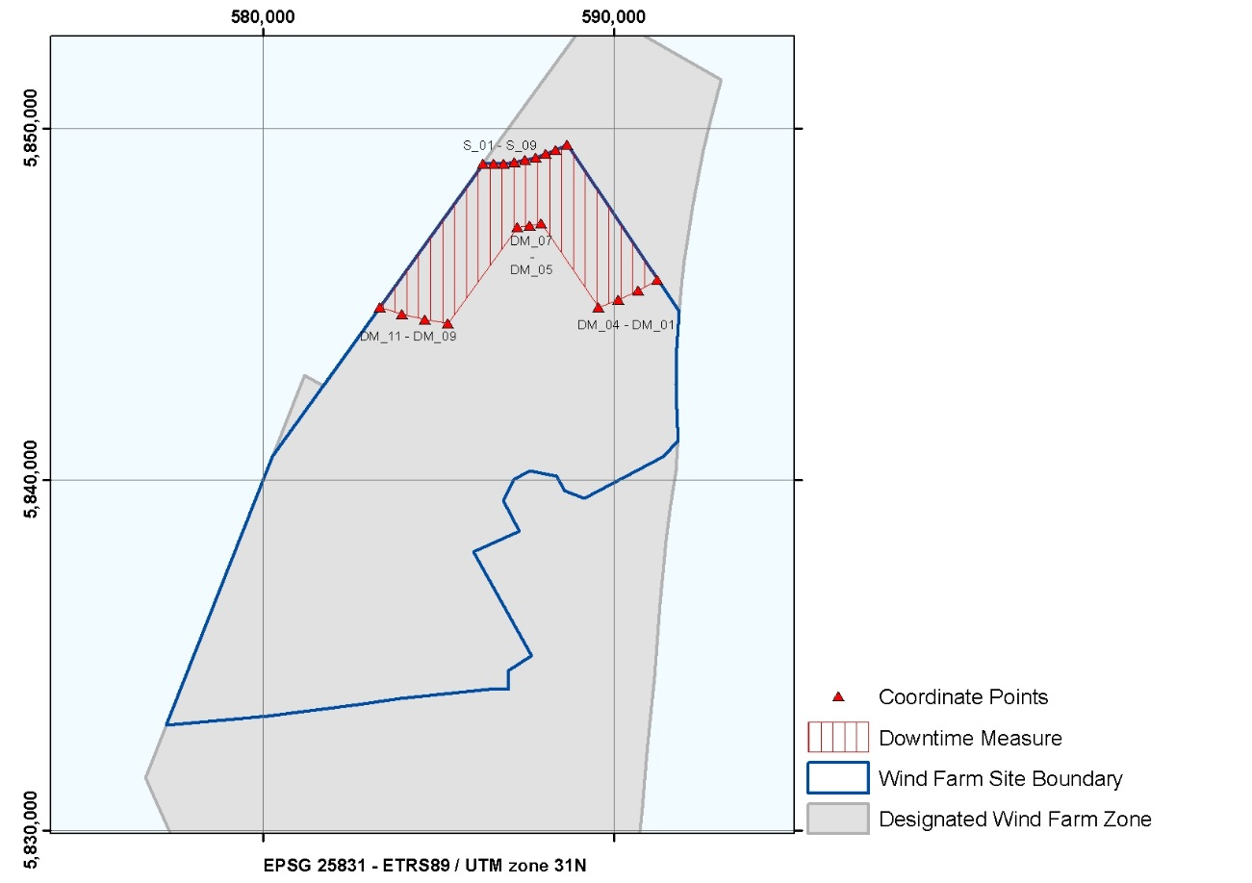
Figure 2.7 Overview of the HKNWFS – Downtime Measure zone

In the WFSD, a standstill facility for turbines located within 5 nautical miles of the mining platform Q4C and also within 1 nautical mile of the boundary of the lot is included in regulation 4, paragraph 9.

Table 2.9 Coordinates of the Downtime Measure zone
Downtime Measure zone in HKNWFS
ETRS 1989 UTM Zone 31N
EPSG 25831
Point No. | Easting | Northing |  | Point No. | Easting | Northing
S_01 | 586,261.3 | 5,849,008.4 |  | DM_02 | 590,700.2 | 5,845,400.6
S_02 | 586,565.5 | 5,849,004.8 |  | DM_03 | 590,134.7 | 5,845,133.7
S_03 | 586,869.3 | 5,849,021.2 |  | DM_04 | 589,552.5 | 5,844,905.7
S_04 | 587,171.3 | 5,849,057.4 |  | DM_05 | 587,932.6 | 5,847,322.5
S_05 | 587,470.3 | 5,849,113.4 |  | DM_06 | 587,589.2 | 5,847,252.6
S_06 | 587,764.9 | 5,849,188.9 |  | DM_07 | 587,242.5 | 5,847,201.4
S_07 | 588,054.0 | 5,849,283.6 |  | DM_08 | 585,265.9 | 5,844,455.3
S_08 | 588,336.3 | 5,849,397.1 |  | DM_09 | 584,607.7 | 5,844,565.8
S_09 | 588,664.2 | 5,849,557.3 |  | DM_10 | 583,959.1 | 5,844,723.3
DM_01 | 591,246.3 | 5,845,704.9 |  | DM_11 | 583,323.6 | 5,844,927.2

Territorial sea
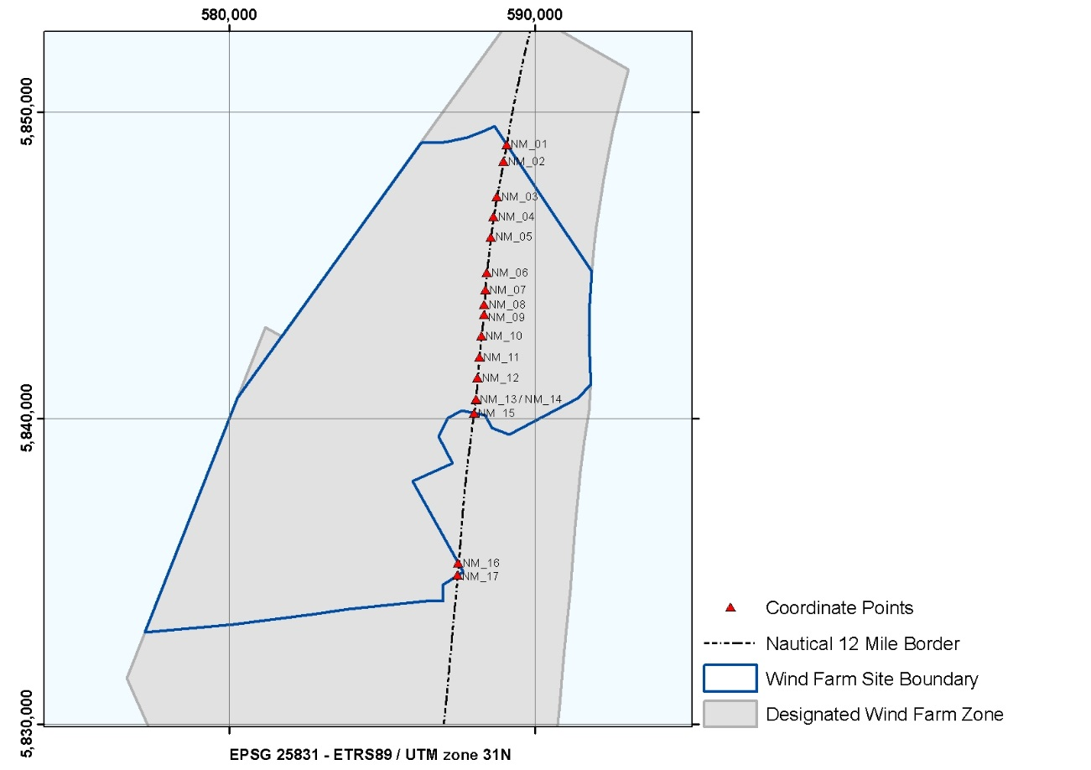

Figure 2.8 Overview of the HKNWFS – 12 Nautical Mile border

A part of the wind farm plot is located in the Dutch territorial sea. Figure 2.8 shows which area is within 12 NM zone.

Table 2.10 Coordinates of the Nautical 12 Mile Border
12 Nautical Mile Border in HKNWFS
ETRS 1989 UTM Zone 31N
EPSG 25831
Point No. | Easting | Northing |  | Point No. | Easting | Northing
NM_01 | 589,069.2 | 5,848,953.2 |  | NM_10 | 588,246.9 | 5,842,695.6
NM_02 | 588,973.0 | 5,848,392.1 |  | NM_11 | 588,178.8 | 5,841,999.3
NM_03 | 588,752.9 | 5,847,238.4 |  | NM_12 | 588,120.5 | 5,841,327.0
NM_04 | 588,647.1 | 5,846,597.2 |  | NM_13 | 588,070.1 | 5,840,629.1
NM_05 | 588,554.7 | 5,845,928.9 |  | NM_14 | 588,071.3 | 5,840,604.1
NM_06 | 588,422.7 | 5,844,761.6 |  | NM_15 | 588,004.5 | 5,840,172.9
NM_07 | 588,372.7 | 5,844,189.2 |  | NM_16 | 587,499.2 | 5,835,260.0
NM_08 | 588,342.5 | 5,843,715.2 |  | NM_17 | 587,466.1 | 5,834,871.3
NM_09 | 588,329.4 | 5,843,390.8

Planned TenneT infrastructure
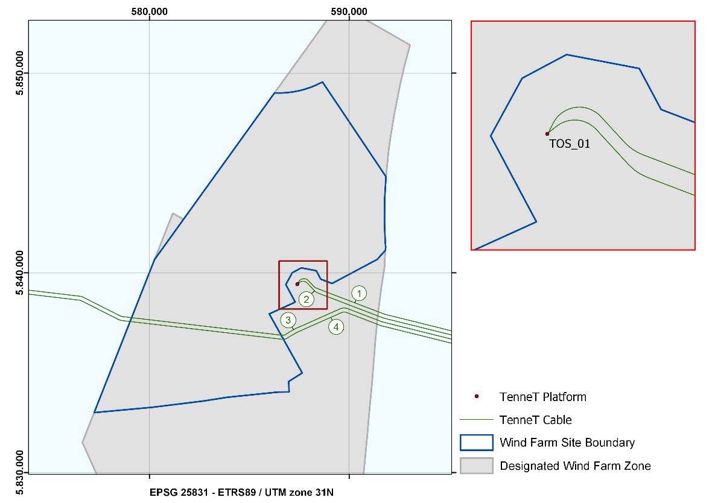
Figure 3.1 Planned TenneT Platform and Cables, the export and redundancy cable routes, and the infield cable corridors in the HKNWFZ. The labels correspond with the planned TenneT Cables.
The positioning of the jacket (and thereby the J-tubes) is dependent on the design of the platform. The contractor of the platform, and therefore the exact design, is not yet known. Therefore the infield cable corridor in the safety zone (500 m) should be regarded as a guideline. In partnership with TenneT and the OWFs, the exact routes of these infield cables will be planned.

TenneT Planned Substations
Table 3.1 Coordinates of the Planned TenneT Platform HKN in the HKNWFZ
Planned TenneT Platform HKN
ETRS 1989 UTM Zone 31N
EPSG 25831
Point No. | Easting | Northing
TOS_1 | 587,410.1 | 5,839,436.2

TenneT Planned Cables
Table 3.2 Planned TenneT Cables in the HKNWFZ
Planned TenneT Cables
Cable No. | Name | Route | Type | Status
1 | HKN 1 | Wijk aan Zee – HKN Platform | Electra | Planned
2 | HKN 2 | Wijk aan Zee – HKN Platform | Electra | Planned
3 | HKWa 1 | Wijk aan Zee – HKW Alpha Platform | Electra | Planned
4 | HKWa 2 | Wijk aan Zee – HKW Alpha Platform | Electra | Planned

Existing infrastructure

Cables and pipelines
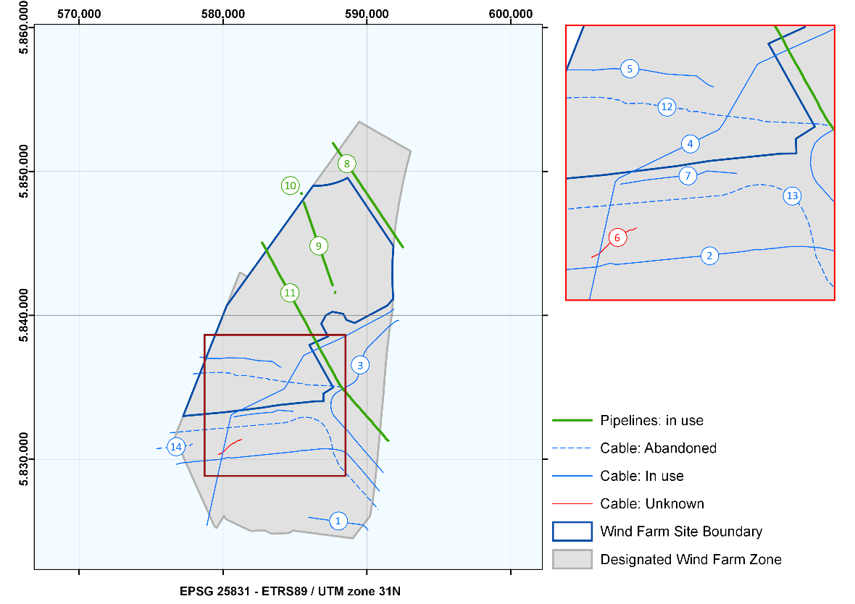
Figure 4.1 Active and inactive cables and pipelines in and near the HKNWFZ. The labels correspond with the cables and pipes in the upcoming tables below.

There are several existing and planned cables and pipelines (both active and abandoned) crossing the HKNWFZ. Those for all other cables and pipelines listed in the other tables below are based on data which has been verified on the basis of the results from the geophysical survey of the HKNWFZ completed in 2017. (Please see: https://offshorewind.rvo.nl/soilnh.

Table 4.1 Existing active cables in the HKNWFZ
Cables in use
No. | Name | Route | Material | Type | Status
1 | Amalia Windfarm Export Cable | Windfarm Q7-WP_Zuid to Wijk aan Zee (NL) | Copper | Electra | In Use
2 | Atlantic Crossing Seg B1 | Castricum (NL) to Sylt (DE) | Fiber Optic | Telecom | In use
3 | Atlantic Crossing Seg B2 | Castricum (NL) to Sylt (DE) | Fiber Optic | Telecom | In use
4 | TAT 14 (Seg J) | Katwijk (NL) to Norden (DE) | Fiber Optic | Telecom | In use
5 | UK-Netherlands 14 | Winterton (UK) to Egmond (NL) | Fiber Optic | Telecom | In use
6 | Unknown possible cable | Unknown | Unknown | Unknown | Unknown
7 | Pangea South | Lowestoft (UK) to Egmond (NL) | Fibre Optic | Telecom | In use

Table 4.2 Existing active pipelines in the HKNWFZ
Pipelines in use
No. | Route | Material | Type | Status
8 | Q4-C to Q8-A | Pipeline | Gas | In use
9 | Q4-B to Q4-A | Pipeline | Gas | In use
10 | Q4-A to P6-A | Pipeline | Gas | In use
11 | Q1-Helm-AP to IJmuiden (NL) | Pipeline | Oil | In use

Table 4.3 Existing abandoned cables in the HKNWFZ
Cables abandoned
No. | Name | Route | Material | Type | Status
12 | UK-Netherlands 10 | Lowesoft (UK) to Egmond (NL) | Coaxial | Telecom | Abandoned
13 | Rembrandt 1 | Pakefield (UK) to Bakkum (NL) | Fiber Optic | Telecom | Abandoned
14 | RIOJA-3 | Veurne (BE) to Egmond (NL) | Fibre Optic | Telecom | Abandoned

Coordinates of active cables
The following tables describe the coordinates of the cables and pipelines in the proximity of the HKNWFZ. The numbers in brackets in the table headline (i.e. (1) Amalia Wind farm Export Cable) correspond with the numbers in the labels on the map in Figure 4.1.

Table 4.4 Coordinates for the Amalia Windfarm Export Cable
(1) Amalia Wind Farm Export Cable
ETRS 1989 UTM Zone 31N
EPSG 25831
Point No. | Easting | Northing |  | Point No. | Easting | Northing
CP_263 | 585,938.9 | 5,825,961.7 |  | CP_275 | 589,402.4 | 5,825,479.8
CP_264 | 586,850.7 | 5,825,831.7 |  | CP_276 | 589,475.1 | 5,825,470.7
CP_265 | 587,375.0 | 5,825,761.2 |  | CP_277 | 589,528.7 | 5,825,462.7
CP_266 | 587,525.3 | 5,825,742.8 |  | CP_278 | 589,596.2 | 5,825,450.2
CP_267 | 588,013.4 | 5,825,670.9 |  | CP_279 | 589,654.4 | 5,825,435.6
CP_268 | 588,669.7 | 5,825,574.3 |  | CP_280 | 589,696.6 | 5,825,424.0
CP_269 | 588,800.5 | 5,825,556.1 |  | CP_281 | 589,732.4 | 5,825,409.1
CP_270 | 589,002.0 | 5,825,530.8 |  | CP_282 | 589,792.6 | 5,825,380.5
CP_271 | 589,090.0 | 5,825,520.5 |  | CP_283 | 589,842.1 | 5,825,337.5
CP_272 | 589,123.2 | 5,825,516.3 |  | CP_284 | 589,897.7 | 5,825,279.0
CP_273 | 589,205.3 | 5,825,505.6 |  | CP_285 | 589,989.4 | 5,825,176.2
CP_274 | 589,281.7 | 5,825,494.8 |  | CP_286 | 590,078.0 | 5,825,071.5

Table 4.5 Coordinates for the Atlantic Crossing Seg B1 Cable
(2) Atlantic Crossing Seg B1
ETRS 1989 UTM Zone 31N
EPSG 25831
Point No. | Easting | Northing |  | Point No. | Easting | Northing
CP_029 | 576,747.7 | 5,829,646.7 |  | CP_065 | 585,957.3 | 5,830,637.4
CP_030 | 577,118.2 | 5,829,746.1 |  | CP_066 | 586,091.6 | 5,830,654.3
CP_031 | 577,219.1 | 5,829,752.8 |  | CP_067 | 586,177.3 | 5,830,656.5
CP_032 | 577,337.2 | 5,829,765.1 |  | CP_068 | 586,299.3 | 5,830,672.8
CP_033 | 577,443.5 | 5,829,776.0 |  | CP_069 | 586,401.1 | 5,830,682.4
CP_034 | 577,552.3 | 5,829,770.1 |  | CP_070 | 586,627.5 | 5,830,709.7
CP_035 | 577,679.8 | 5,829,798.5 |  | CP_071 | 586,851.9 | 5,830,724.8
CP_036 | 577,789.8 | 5,829,807.0 |  | CP_072 | 586,961.6 | 5,830,726.0
CP_037 | 577,904.4 | 5,829,843.9 |  | CP_073 | 587,060.5 | 5,830,727.8
CP_038 | 578,123.7 | 5,829,841.1 |  | CP_074 | 587,224.4 | 5,830,726.5
CP_039 | 578,235.8 | 5,829,854.2 |  | CP_075 | 587,289.5 | 5,830,727.6
CP_040 | 578,343.0 | 5,829,865.6 |  | CP_076 | 587,394.7 | 5,830,715.3
CP_041 | 578,414.5 | 5,829,875.2 |  | CP_077 | 587,812.2 | 5,830,682.4
CP_042 | 578,471.7 | 5,829,877.4 |  | CP_078 | 588,288.2 | 5,830,583.4
CP_043 | 579,885.3 | 5,829,997.0 |  | CP_079 | 588,648.0 | 5,830,367.9
CP_044 | 580,374.7 | 5,830,131.1 |  | CP_080 | 588,936.9 | 5,830,043.1
CP_045 | 580,579.4 | 5,830,083.2 |  | CP_081 | 589,029.8 | 5,829,938.6
CP_046 | 581,472.7 | 5,830,171.4 |  | CP_082 | 589,095.5 | 5,829,856.4
CP_047 | 581,824.0 | 5,830,208.7 |  | CP_083 | 589,168.1 | 5,829,771.5
CP_048 | 582,036.3 | 5,830,231.1 |  | CP_084 | 589,243.8 | 5,829,697.0
CP_049 | 582,143.4 | 5,830,239.9 |  | CP_085 | 589,317.2 | 5,829,615.8
CP_050 | 582,706.6 | 5,830,296.7 |  | CP_086 | 589,832.0 | 5,829,030.0
CP_051 | 582,812.7 | 5,830,308.6 |  | CP_087 | 589,913.8 | 5,828,923.3
CP_052 | 582,953.9 | 5,830,323.6 |  | CP_088 | 590,049.0 | 5,828,763.9
CP_053 | 583,157.5 | 5,830,344.3 |  | CP_089 | 590,118.8 | 5,828,688.7
CP_054 | 583,256.7 | 5,830,350.4 |  | CP_090 | 590,197.1 | 5,828,586.9
CP_055 | 583,386.7 | 5,830,364.8 |  | CP_091 | 590,262.7 | 5,828,503.9
CP_056 | 583,483.0 | 5,830,370.5 |  | CP_092 | 590,349.4 | 5,828,405.8
CP_057 | 583,603.7 | 5,830,388.1 |  | CP_093 | 590,414.4 | 5,828,326.2
CP_058 | 584,838.8 | 5,830,516.9 |  | CP_094 | 590,477.4 | 5,828,242.6
CP_059 | 584,967.1 | 5,830,531.9 |  | CP_095 | 590,561.9 | 5,828,148.6
CP_060 | 585,059.2 | 5,830,543.0 |  | CP_096 | 590,639.8 | 5,828,064.8
CP_061 | 585,191.4 | 5,830,560.2 |  | CP_097 | 590,714.9 | 5,827,965.4
CP_062 | 585,516.9 | 5,830,616.4 |  | CP_098 | 590,780.8 | 5,827,889.6
CP_063 | 585,717.2 | 5,830,611.3 |  | CP_099 | 590,860.4 | 5,827,795.2
CP_064 | 585,854.1 | 5,830,621.4

Table 4.6 Coordinates for the Atlantic Crossing Seg B2 Cable
(3) Atlantic Crossing Seg B2
ETRS 1989 UTM Zone 31N
EPSG 25831
Point No. | Easting | Northing |  | Point No. | Easting | Northing
CP_381 | 591,133.7 | 5,829,061.1 |  | CP_418 | 587,521.3 | 5,833,496.5
CP_382 | 591,071.5 | 5,829,156.3 |  | CP_419 | 587,492.4 | 5,833,695.5
CP_383 | 591,017.8 | 5,829,213.3 |  | CP_420 | 587,527.7 | 5,834,087.5
CP_384 | 590,991.8 | 5,829,251.8 |  | CP_421 | 587,607.7 | 5,834,285.3
CP_385 | 590,933.5 | 5,829,319.8 |  | CP_422 | 587,657.2 | 5,834,409.4
CP_386 | 590,844.1 | 5,829,424.2 |  | CP_423 | 587,840.4 | 5,834,588.7
CP_387 | 590,773.6 | 5,829,494.9 |  | CP_424 | 587,979.3 | 5,834,686.4
CP_388 | 590,692.5 | 5,829,585.2 |  | CP_425 | 587,987.1 | 5,834,692.6
CP_389 | 590,623.5 | 5,829,669.1 |  | CP_426 | 588,149.5 | 5,834,787.4
CP_390 | 590,541.4 | 5,829,756.7 |  | CP_427 | 588,295.6 | 5,834,872.8
CP_391 | 590,479.0 | 5,829,831.7 |  | CP_354 | 588,344.6 | 5,834,900.4
CP_392 | 590,390.5 | 5,829,933.3 |  | CP_355 | 588,425.3 | 5,834,945.1
CP_393 | 590,334.8 | 5,830,001.9 |  | CP_356 | 588,562.3 | 5,835,023.4
CP_394 | 590,252.1 | 5,830,099.2 |  | CP_357 | 588,692.0 | 5,835,094.1
CP_395 | 589,735.5 | 5,830,695.4 |  | CP_358 | 588,803.1 | 5,835,159.5
CP_396 | 589,670.0 | 5,830,769.1 |  | CP_359 | 588,976.7 | 5,835,251.2
CP_397 | 589,594.6 | 5,830,857.4 |  | CP_360 | 589,121.7 | 5,835,353.2
CP_398 | 589,452.5 | 5,831,023.1 |  | CP_361 | 589,310.0 | 5,835,562.8
CP_399 | 589,373.1 | 5,831,117.7 |  | CP_362 | 589,392.3 | 5,835,781.8
CP_400 | 589,300.5 | 5,831,205.3 |  | CP_363 | 589,492.0 | 5,836,264.6
CP_401 | 589,220.1 | 5,831,306.7 |  | CP_364 | 589,508.4 | 5,836,352.1
CP_402 | 589,079.7 | 5,831,454.6 |  | CP_365 | 589,621.3 | 5,836,876.8
CP_403 | 588,652.7 | 5,832,003.7 |  | CP_366 | 589,830.9 | 5,837,419.9
CP_404 | 588,486.6 | 5,832,131.7 |  | CP_367 | 590,042.7 | 5,837,759.2
CP_405 | 588,410.0 | 5,832,223.4 |  | CP_368 | 590,059.3 | 5,837,770.7
CP_406 | 588,350.6 | 5,832,296.3 |  | CP_369 | 590,248.5 | 5,837,947.0
CP_407 | 588,259.0 | 5,832,391.0 |  | CP_370 | 590,268.4 | 5,837,994.2
CP_408 | 588,175.2 | 5,832,490.7 |  | CP_371 | 590,397.4 | 5,838,095.0
CP_409 | 588,121.3 | 5,832,545.5 |  | CP_372 | 590,445.8 | 5,838,176.8
CP_410 | 588,041.5 | 5,832,635.0 |  | CP_373 | 590,594.9 | 5,838,302.7
CP_411 | 587,976.2 | 5,832,712.9 |  | CP_374 | 590,805.2 | 5,838,514.4
CP_412 | 587,884.1 | 5,832,811.4 |  | CP_375 | 590,944.2 | 5,838,638.3
CP_413 | 587,823.6 | 5,832,887.0 |  | CP_376 | 591,261.2 | 5,838,951.3
CP_414 | 587,739.8 | 5,832,967.2 |  | CP_377 | 591,487.6 | 5,839,197.7
CP_415 | 587,679.7 | 5,833,062.1 |  | CP_378 | 591,650.6 | 5,839,320.9
CP_416 | 587,604.7 | 5,833,193.3 |  | CP_379 | 592,021.8 | 5,839,604.6
CP_417 | 587,567.0 | 5,833,304.3 |  | CP_380 | 592,206.1 | 5,839,644.8

Table 4.7 Coordinates for the TAT14 Segment J Cable
(4) TAT14 Segment J
ETRS 1989 UTM Zone 31N
EPSG 25831
Point no. | Easting | Northing |  | Point No. | Easting | Northing
CP_287 | 578,884.7 | 5,825,395.9 |  | CP_320 | 584,227.7 | 5,834,875.6
CP_288 | 578,924.0 | 5,825,597.2 |  | CP_321 | 584,391.9 | 5,835,097.0
CP_289 | 579,061.9 | 5,826,241.2 |  | CP_322 | 584,664.7 | 5,835,576.8
CP_290 | 579,191.1 | 5,826,814.6 |  | CP_323 | 585,081.3 | 5,836,304.1
CP_291 | 579,307.4 | 5,827,357.7 |  | CP_324 | 585,595.5 | 5,837,196.9
CP_292 | 579,348.6 | 5,827,539.6 |  | CP_325 | 585,672.7 | 5,837,245.1
CP_293 | 579,455.6 | 5,828,047.2 |  | CP_326 | 585,823.4 | 5,837,324.2
CP_294 | 579,588.6 | 5,828,644.1 |  | CP_327 | 585,916.8 | 5,837,360.1
CP_295 | 579,727.2 | 5,829,270.5 |  | CP_328 | 586,037.9 | 5,837,415.9
CP_296 | 579,885.3 | 5,829,997.0 |  | CP_329 | 586,199.5 | 5,837,496.0
CP_297 | 579,988.3 | 5,830,474.0 |  | CP_330 | 586,313.2 | 5,837,553.6
CP_298 | 580,148.4 | 5,831,202.2 |  | CP_331 | 586,407.1 | 5,837,599.2
CP_299 | 580,279.5 | 5,831,796.1 |  | CP_332 | 586,685.9 | 5,837,723.5
CP_300 | 580,395.8 | 5,832,329.9 |  | CP_333 | 586,717.3 | 5,837,737.5
CP_301 | 580,520.6 | 5,832,881.3 |  | CP_334 | 587,625.8 | 5,838,142.7
CP_302 | 580,541.6 | 5,833,008.9 |  | CP_335 | 587,894.6 | 5,838,261.0
CP_303 | 580,662.3 | 5,833,149.4 |  | CP_336 | 588,029.1 | 5,838,318.3
CP_304 | 580,978.8 | 5,833,301.5 |  | CP_337 | 588,311.8 | 5,838,463.1
CP_305 | 581,124.7 | 5,833,370.2 |  | CP_338 | 588,413.0 | 5,838,511.1
CP_306 | 581,242.4 | 5,833,427.8 |  | CP_339 | 589,105.7 | 5,838,876.9
CP_307 | 581,659.4 | 5,833,631.7 |  | CP_340 | 589,648.2 | 5,839,177.3
CP_308 | 581,772.9 | 5,833,685.1 |  | CP_341 | 589,784.6 | 5,839,246.4
CP_309 | 582,059.8 | 5,833,826.2 |  | CP_342 | 590,046.4 | 5,839,386.7
CP_310 | 582,197.9 | 5,833,893.5 |  | CP_343 | 590,336.4 | 5,839,543.7
CP_311 | 582,313.8 | 5,833,954.6 |  | CP_344 | 590,477.1 | 5,839,614.4
CP_312 | 582,459.5 | 5,834,020.9 |  | CP_345 | 590,877.9 | 5,839,828.3
CP_313 | 582,983.5 | 5,834,272.7 |  | CP_346 | 591,007.8 | 5,839,895.7
CP_314 | 583,104.0 | 5,834,328.5 |  | CP_347 | 591,130.4 | 5,839,956.4
CP_315 | 583,276.4 | 5,834,419.4 |  | CP_348 | 591,276.1 | 5,840,038.5
CP_316 | 583,382.7 | 5,834,469.6 |  | CP_349 | 591,448.3 | 5,840,136.6
CP_317 | 583,645.5 | 5,834,596.6 |  | CP_350 | 591,566.7 | 5,840,195.8
CP_318 | 583,789.9 | 5,834,668.4 |  | CP_351 | 591,877.0 | 5,840,450.5
CP_319 | 583,903.4 | 5,834,722.5

Table 4.8 Coordinates for the UK-Netherlands 14 Cable
(5) UK-Netherlands 14
ETRS 1989 UTM Zone 31N
EPSG 25831
Point No. | Easting | Northing |  | Point No. | Easting | Northing
CP_001 | 578,398.4 | 5,837,089.7 |  | CP_007 | 581,493.0 | 5,837,021.1
CP_002 | 578,506.2 | 5,837,098.2 |  | CP_008 | 582,385.4 | 5,836,860.8
CP_003 | 578,793.2 | 5,837,011.1 |  | CP_009 | 583,434.5 | 5,836,795.7
CP_004 | 579,650.3 | 5,837,010.1 |  | CP_010 | 583,855.9 | 5,836,476.9
CP_005 | 579,765.0 | 5,836,998.1 |  | CP_011 | 584,036.1 | 5,836,403.1
CP_006 | 580,423.1 | 5,837,055.1

Table 4.9 Coordinates for the Unknown Possible Cable
(6) Unknown Possible Cable
ETRS 1989 UTM Zone 31N
EPSG 25831
Point No. | Easting | Northing |  | Point No. | Easting | Northing
CP_012 | 579,706.0 | 5,830,336.3 |  | CP_017 | 580,934.9 | 5,831,236.7
CP_013 | 579,988.3 | 5,830,474.0 |  | CP_018 | 581,058.7 | 5,831,305.4
CP_014 | 580,358.2 | 5,830,851.9 |  | CP_019 | 581,182.2 | 5,831,323.0
CP_015 | 580,655.3 | 5,831,098.1 |  | CP_020 | 581,295.5 | 5,831,384.1
CP_016 | 580,772.2 | 5,831,120.5

Table 4.10 Coordinates for the Pangea South Cable
(7) Pangea South
ETRS 1989 UTM Zone 31N
EPSG 25831
Point No. | Easting | Northing |  | Point No. | Easting | Northing
CP_226 | 580,732.0 | 5,832,942.6 |  | CP_229 | 583,452.6 | 5,833,272.4
CP_227 | 581,666.1 | 5,833,094.5 |  | CP_230 | 583,821.1 | 5,833,411.5
CP_228 | 582,658.5 | 5,833,207.4 |  | CP_231 | 584,869.9 | 5,833,328.4

Coordinates of pipelines
Table 4.11 Coordinates of Q4-C to Q8-A
(8) Q4-C to Q8-A
ETRS 1989 UTM Zone 31N
EPSG 25831
Point No. | Easting | Northing |  | Point No. | Easting | Northing
CP_610 | 587,643.6 | 5,851,969.4 |  | CP_460 | 589,794.4 | 5,848,768.6
CP_428 | 587,679.8 | 5,851,918.6 |  | CP_461 | 589,926.9 | 5,848,571.5
CP_611 | 587,679.8 | 5,851,918.6 |  | CP_462 | 589,990.1 | 5,848,477.3
CP_429 | 587,762.5 | 5,851,783.5 |  | CP_463 | 590,061.4 | 5,848,370.2
CP_430 | 587,818.2 | 5,851,716.6 |  | CP_464 | 590,120.1 | 5,848,275.7
CP_431 | 587,890.1 | 5,851,603.0 |  | CP_465 | 590,193.9 | 5,848,170.4
CP_432 | 587,948.8 | 5,851,510.4 |  | CP_466 | 590,255.6 | 5,848,074.3
CP_433 | 588,029.5 | 5,851,395.1 |  | CP_467 | 590,329.5 | 5,847,967.9
CP_434 | 588,084.8 | 5,851,309.5 |  | CP_468 | 590,390.4 | 5,847,887.5
CP_435 | 588,154.8 | 5,851,220.1 |  | CP_469 | 590,470.1 | 5,847,766.7
CP_436 | 588,226.9 | 5,851,111.2 |  | CP_470 | 590,528.9 | 5,847,672.7
CP_437 | 588,294.5 | 5,850,987.4 |  | CP_471 | 590,600.7 | 5,847,572.0
CP_438 | 588,351.6 | 5,850,912.5 |  | CP_472 | 590,664.9 | 5,847,473.9
CP_439 | 588,436.4 | 5,850,786.9 |  | CP_473 | 590,739.8 | 5,847,359.3
CP_440 | 588,493.7 | 5,850,703.2 |  | CP_474 | 590,806.7 | 5,847,255.4
CP_441 | 588,563.7 | 5,850,604.2 |  | CP_475 | 590,875.2 | 5,847,159.3
CP_442 | 588,634.9 | 5,850,497.1 |  | CP_476 | 591,011.1 | 5,846,959.2
CP_443 | 588,701.6 | 5,850,394.6 |  | CP_477 | 591,069.5 | 5,846,858.7
CP_444 | 588,758.2 | 5,850,308.1 |  | CP_478 | 591,145.4 | 5,846,752.2
CP_445 | 588,840.5 | 5,850,188.7 |  | CP_479 | 591,213.2 | 5,846,647.8
CP_446 | 588,906.7 | 5,850,106.4 |  | CP_480 | 591,281.2 | 5,846,551.9
CP_447 | 588,972.3 | 5,849,998.6 |  | CP_481 | 591,423.0 | 5,846,345.5
CP_448 | 589,040.9 | 5,849,897.2 |  | CP_482 | 591,466.3 | 5,846,270.6
CP_449 | 589,112.9 | 5,849,786.8 |  | CP_483 | 591,552.0 | 5,846,150.0
CP_450 | 589,163.3 | 5,849,709.9 |  | CP_484 | 591,609.7 | 5,846,061.7
CP_451 | 589,249.6 | 5,849,580.7 |  | CP_485 | 591,742.8 | 5,845,862.5
CP_452 | 589,314.6 | 5,849,480.8 |  | CP_486 | 591,814.1 | 5,845,757.0
CP_453 | 589,384.2 | 5,849,375.9 |  | CP_487 | 591,959.4 | 5,845,550.4
CP_454 | 589,442.8 | 5,849,292.2 |  | CP_488 | 592,019.2 | 5,845,451.1
CP_455 | 589,501.6 | 5,849,187.4 |  | CP_489 | 592,154.2 | 5,845,242.6
CP_456 | 589,519.5 | 5,849,179.8 |  | CP_490 | 592,282.9 | 5,845,052.6
CP_457 | 589,586.5 | 5,849,072.0 |  | CP_491 | 592,421.3 | 5,844,854.3
CP_458 | 589,651.1 | 5,848,971.3 |  | CP_492 | 592,497.0 | 5,844,744.5
CP_459 | 589,711.3 | 5,848,860.9

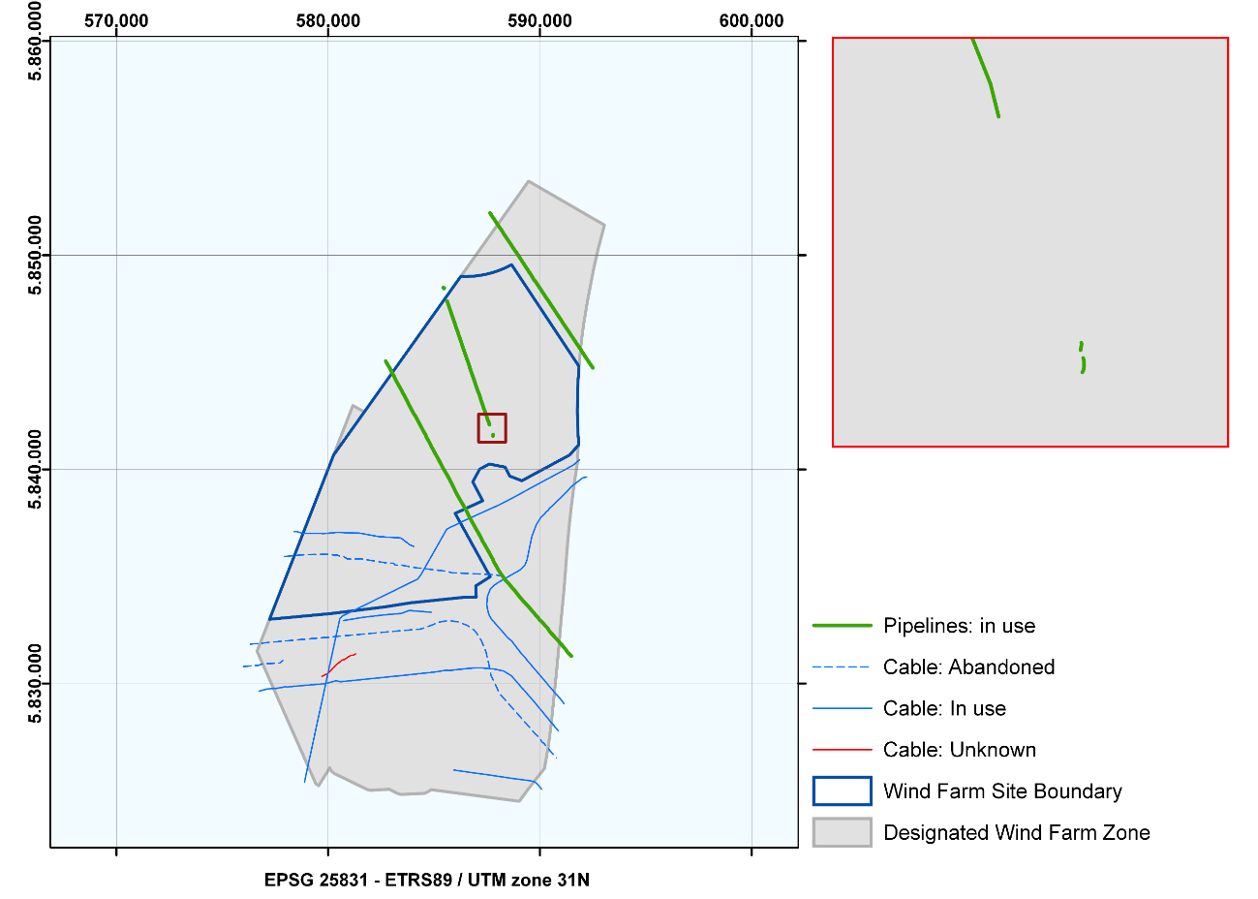
Figure 4.2 Pipeline Q4-B to Q4-A has been identified in three separate parts within HKNWFZ. Coordinates of the three different parts are written in table 4.12 and separated by the word gap.

Pipeline Q4-B tot Q4-A has been found in three different parts. These parts are separated by the word 'gap' in the coordinate tables. Figure 4.2 shows how the three different parts are located within the HKNWFZ

Table 4.12 Coordinates of Q4-B to Q4-A
(9) Q4-B to Q4-A
ETRS 1989 UTM Zone 31N
EPSG 25831
Point No. | Easting | Northing |  | Point No. | Easting | Northing
CP_493 | 585,623.6 | 5,847,850.8 |  | CP_525 | 587,150.6 | 5,843,463.9
CP_494 | 585,629.3 | 5,847,809.0 |  | CP_526 | 587,194.2 | 5,843,301.7
CP_495 | 585,691.4 | 5,847,652.4 |  | CP_527 | 587,237.8 | 5,843,173.2
CP_496 | 585,735.5 | 5,847,517.4 |  | CP_528 | 587,295.1 | 5,843,013.7
CP_497 | 585,793.2 | 5,847,356.3 |  | CP_529 | 587,336.9 | 5,842,879.1
CP_498 | 585,831.7 | 5,847,233.9 |  | CP_530 | 587,401.1 | 5,842,715.6
CP_499 | 585,896.0 | 5,847,060.0 |  | CP_531 | 587,440.6 | 5,842,595.4
CP_500 | 585,933.6 | 5,846,945.4 |  | CP_532 | 587,498.4 | 5,842,429.9
CP_501 | 585,992.1 | 5,846,786.7 |  | CP_533 | 587,524.6 | 5,842,346.2
CP_502 | 586,029.9 | 5,846,653.6 |  | CP_534 | 587,547.0 | 5,842,287.6
CP_503 | 586,085.5 | 5,846,510.9 |  | CP_535 | 587,599.2 | 5,842,158.1
CP_504 | 586,134.7 | 5,846,367.4 |  | CP_536 | 587,616.1 | 5,842,091.3
CP_505 | 586,178.1 | 5,846,225.0 |  | gap
CP_506 | 586,188.2 | 5,846,222.4 |  | CP_614 | 587,787.8 | 5,841,627.1
CP_507 | 586,236.2 | 5,846,072.4 |  | CP_615 | 587,788.2 | 5,841,625.8
CP_508 | 586,292.7 | 5,845,908.9 |  | CP_616 | 587,788.3 | 5,841,623.5
CP_509 | 586,333.7 | 5,845,777.7 |  | CP_617 | 587,787.8 | 5,841,620.1
CP_510 | 586,387.7 | 5,845,621.1 |  | CP_618 | 587,787.6 | 5,841,618.8
CP_511 | 586,429.9 | 5,845,500.1 |  | CP_619 | 587,787.3 | 5,841,617.5
CP_512 | 586,489.7 | 5,845,337.4 |  | CP_620 | 587,787.0 | 5,841,616.6
CP_513 | 586,537.3 | 5,845,200.6 |  | CP_621 | 587,786.7 | 5,841,615.3
CP_514 | 586,592.0 | 5,845,042.2 |  | CP_622 | 587,786.5 | 5,841,614.1
CP_515 | 586,637.6 | 5,844,918.8 |  | CP_623 | 587,786.4 | 5,841,613.3
CP_516 | 586,696.3 | 5,844,724.8 |  | CP_624 | 587,786.4 | 5,841,612.5
CP_517 | 586,734.6 | 5,844,611.5 |  | CP_625 | 587,786.3 | 5,841,611.6
CP_518 | 586,839.6 | 5,844,320.8 |  | gap
CP_519 | 586,894.0 | 5,844,173.3 |  | CP_663 | 587,791.7 | 5,841,595.8
CP_520 | 586,941.5 | 5,844,022.2 |  | CP_664 | 587,793.1 | 5,841,589.0
CP_521 | 586,994.8 | 5,843,865.1 |  | CP_665 | 587,793.5 | 5,841,581.1
CP_522 | 587,041.6 | 5,843,737.4 |  | CP_666 | 587,793.0 | 5,841,575.4
CP_523 | 587,052.6 | 5,843,698.6 |  | CP_667 | 587,792.1 | 5,841,570.6
CP_524 | 587,095.1 | 5,843,592.0 |  | CP_668 | 587,789.9 | 5,841,566.1

Table 4.13 Coordinates of Q4-A to P6-A
(10) Q4-A to P6-A
ETRS 1989 UTM Zone 31N
EPSG 25831
Point No. | Easting | Northing |  | Point No. | Easting | Northing
CP_626 | 585,464.5 | 5,848,446.0 |  | CP_645 | 585,473.6 | 5,848,474.6
CP_627 | 585,465.8 | 5,848,447.5 |  | CP_646 | 585,472.8 | 5,848,475.6
CP_628 | 585,467.5 | 5,848,448.8 |  | CP_647 | 585,470.4 | 5,848,476.4
CP_629 | 585,469.1 | 5,848,450.0 |  | CP_648 | 585,467.5 | 5,848,477.3
CP_630 | 585,470.8 | 5,848,450.9 |  | CP_649 | 585,463.2 | 5,848,478.4
CP_631 | 585,472.4 | 5,848,451.8 |  | CP_650 | 585,460.7 | 5,848,479.0
CP_632 | 585,475.0 | 5,848,452.8 |  | CP_651 | 585,458.5 | 5,848,479.5
CP_633 | 585,477.1 | 5,848,453.7 |  | CP_652 | 585,455.7 | 5,848,479.8
CP_634 | 585,478.9 | 5,848,454.7 |  | CP_653 | 585,454.1 | 5,848,480.2
CP_635 | 585,480.6 | 5,848,455.9 |  | CP_654 | 585,451.2 | 5,848,481.0
CP_636 | 585,482.7 | 5,848,457.6 |  | CP_655 | 585,448.4 | 5,848,481.5
CP_637 | 585,483.2 | 5,848,459.1 |  | CP_656 | 585,446.2 | 5,848,482.1
CP_638 | 585,482.8 | 5,848,461.1 |  | CP_657 | 585,444.0 | 5,848,482.8
CP_639 | 585,482.1 | 5,848,463.5 |  | CP_658 | 585,441.2 | 5,848,483.6
CP_640 | 585,481.0 | 5,848,465.4 |  | CP_659 | 585,438.9 | 5,848,484.2
CP_641 | 585,479.9 | 5,848,467.7 |  | CP_660 | 585,436.9 | 5,848,484.8
CP_642 | 585,477.1 | 5,848,471.0 |  | CP_661 | 585,435.1 | 5,848,485.2
CP_643 | 585,476.0 | 5,848,472.3 |  | CP_662 | 585,433.7 | 5,848,485.5
CP_644 | 585,475.0 | 5,848,473.5

Table 4.14 Coordinates of Q1-Helm-AP to IJmuiden (NL)
(11) Q1-Helm-AP to Ijmuiden (NL)
ETRS 1989 UTM Zone 31N
EPSG 25831
Point No. | Easting | Northing |  | Point No. | Easting | Northing
CP_537 | 582,717.7 | 5,845,051.5 |  | CP_613 | 586,705.2 | 5,837,720.6
CP_538 | 582,783.1 | 5,844,933.8 |  | CP_713 | 586,720.6 | 5,837,691.4
CP_539 | 582,852.5 | 5,844,825.3 |  | CP_612 | 586,720.6 | 5,837,691.4
CP_540 | 582,912.3 | 5,844,725.2 |  | CP_714 | 586,760.2 | 5,837,611.2
CP_541 | 582,980.6 | 5,844,582.7 |  | CP_598 | 586,776.8 | 5,837,590.3
CP_542 | 583,035.2 | 5,844,479.3 |  | CP_715 | 586,776.8 | 5,837,590.3
CP_543 | 583,103.2 | 5,844,371.6 |  | CP_599 | 586,782.8 | 5,837,578.5
CP_544 | 583,151.0 | 5,844,260.6 |  | CP_600 | 586,790.4 | 5,837,564.6
CP_545 | 583,221.1 | 5,844,119.9 |  | CP_601 | 586,799.1 | 5,837,548.6
CP_546 | 583,283.5 | 5,844,011.8 |  | CP_716 | 586,799.1 | 5,837,548.6
CP_547 | 583,350.0 | 5,843,891.0 |  | CP_602 | 586,813.3 | 5,837,521.7
CP_548 | 583,405.7 | 5,843,801.4 |  | CP_717 | 586,813.3 | 5,837,521.7
CP_549 | 583,479.0 | 5,843,667.9 |  | CP_603 | 586,825.2 | 5,837,499.2
CP_550 | 583,532.7 | 5,843,549.7 |  | CP_718 | 586,825.2 | 5,837,499.2
CP_551 | 583,601.4 | 5,843,444.0 |  | CP_719 | 586,841.0 | 5,837,471.9
CP_552 | 583,655.8 | 5,843,330.2 |  | CP_597 | 586,893.4 | 5,837,379.9
CP_553 | 583,729.4 | 5,843,196.5 |  | CP_720 | 586,893.4 | 5,837,379.9
CP_554 | 583,777.2 | 5,843,097.1 |  | CP_596 | 586,896.5 | 5,837,374.6
CP_555 | 583,845.2 | 5,842,958.8 |  | CP_721 | 586,896.5 | 5,837,374.6
CP_556 | 583,898.3 | 5,842,870.2 |  | CP_722 | 586,898.5 | 5,837,370.3
CP_557 | 583,941.6 | 5,842,779.6 |  | CP_723 | 586,951.6 | 5,837,268.3
CP_558 | 583,973.2 | 5,842,726.7 |  | CP_724 | 586,964.3 | 5,837,248.0
CP_559 | 584,018.2 | 5,842,638.5 |  | CP_725 | 587,092.2 | 5,837,036.9
CP_560 | 584,100.5 | 5,842,519.1 |  | CP_726 | 587,145.6 | 5,836,939.8
CP_561 | 584,148.0 | 5,842,440.9 |  | CP_727 | 587,220.5 | 5,836,804.4
CP_562 | 584,223.1 | 5,842,297.2 |  | CP_728 | 587,275.6 | 5,836,683.3
CP_563 | 584,273.1 | 5,842,208.5 |  | CP_729 | 587,342.7 | 5,836,561.4
CP_564 | 584,341.6 | 5,842,075.4 |  | CP_730 | 587,398.3 | 5,836,475.8
CP_565 | 584,399.0 | 5,841,969.6 |  | CP_731 | 587,526.0 | 5,836,249.5
CP_566 | 584,466.3 | 5,841,846.8 |  | CP_732 | 587,633.2 | 5,836,067.0
CP_567 | 584,523.1 | 5,841,734.6 |  | CP_593 | 587,678.0 | 5,835,975.2
CP_568 | 584,599.8 | 5,841,619.3 |  | CP_733 | 587,678.0 | 5,835,975.2
CP_569 | 584,643.2 | 5,841,492.1 |  | CP_594 | 587,683.4 | 5,835,964.4
CP_570 | 584,712.9 | 5,841,383.8 |  | CP_595 | 587,692.5 | 5,835,949.8
CP_571 | 584,771.0 | 5,841,279.1 |  | CP_669 | 587,692.5 | 5,835,949.8
CP_572 | 584,836.4 | 5,841,149.6 |  | CP_670 | 587,763.2 | 5,835,828.3
CP_573 | 584,896.6 | 5,841,022.5 |  | CP_671 | 587,835.5 | 5,835,657.6
CP_574 | 584,963.1 | 5,840,911.3 |  | CP_672 | 587,893.1 | 5,835,561.3
CP_575 | 585,016.7 | 5,840,808.1 |  | CP_673 | 587,975.5 | 5,835,425.1
CP_576 | 585,088.2 | 5,840,682.1 |  | CP_674 | 588,022.8 | 5,835,331.4
CP_577 | 585,138.3 | 5,840,595.8 |  | CP_675 | 588,095.2 | 5,835,219.3
CP_578 | 585,272.9 | 5,840,352.5 |  | CP_676 | 588,156.8 | 5,835,127.1
CP_579 | 585,337.5 | 5,840,233.5 |  | CP_677 | 588,376.2 | 5,834,823.1
CP_580 | 585,390.7 | 5,840,120.9 |  | CP_678 | 588,447.0 | 5,834,744.3
CP_581 | 585,421.6 | 5,840,057.3 |  | CP_679 | 588,516.2 | 5,834,679.4
CP_582 | 585,466.2 | 5,839,992.7 |  | CP_680 | 588,582.6 | 5,834,602.3
CP_583 | 585,524.0 | 5,839,894.9 |  | CP_681 | 588,684.0 | 5,834,478.8
CP_584 | 585,591.7 | 5,839,780.7 |  | CP_682 | 588,747.5 | 5,834,410.0
CP_585 | 585,651.2 | 5,839,678.9 |  | CP_683 | 588,775.9 | 5,834,380.8
CP_586 | 585,722.1 | 5,839,554.8 |  | CP_684 | 588,822.3 | 5,834,326.7
CP_587 | 585,774.0 | 5,839,449.7 |  | CP_685 | 588,960.2 | 5,834,153.4
CP_588 | 585,840.8 | 5,839,325.8 |  | CP_686 | 589,040.2 | 5,834,048.9
CP_589 | 585,896.7 | 5,839,206.7 |  | CP_687 | 589,105.4 | 5,833,978.3
CP_590 | 585,963.3 | 5,839,075.8 |  | CP_688 | 589,177.6 | 5,833,889.9
CP_591 | 586,002.7 | 5,838,987.3 |  | CP_689 | 589,259.4 | 5,833,802.8
CP_592 | 586,056.1 | 5,838,888.0 |  | CP_690 | 589,407.8 | 5,833,646.2
CP_609 | 586,056.1 | 5,838,888.0 |  | CP_691 | 589,489.4 | 5,833,564.7
CP_608 | 586,103.3 | 5,838,799.8 |  | CP_692 | 589,582.7 | 5,833,443.3
CP_734 | 586,103.3 | 5,838,799.8 |  | CP_693 | 589,710.0 | 5,833,307.3
CP_735 | 586,143.2 | 5,838,729.9 |  | CP_694 | 589,778.9 | 5,833,220.8
CP_736 | 586,209.0 | 5,838,615.6 |  | CP_695 | 589,919.0 | 5,833,068.0
CP_737 | 586,264.7 | 5,838,519.0 |  | CP_696 | 589,996.5 | 5,832,959.0
CP_738 | 586,334.2 | 5,838,406.2 |  | CP_697 | 590,068.9 | 5,832,902.0
CP_739 | 586,341.5 | 5,838,392.7 |  | CP_698 | 590,156.3 | 5,832,808.0
CP_606 | 586,341.5 | 5,838,392.9 |  | CP_699 | 590,223.4 | 5,832,735.4
CP_607 | 586,388.2 | 5,838,315.1 |  | CP_700 | 590,302.6 | 5,832,646.6
CP_740 | 586,388.2 | 5,838,315.1 |  | CP_701 | 590,373.6 | 5,832,573.6
CP_741 | 586,405.2 | 5,838,278.6 |  | CP_702 | 590,445.4 | 5,832,449.0
CP_742 | 586,467.7 | 5,838,173.2 |  | CP_703 | 590,954.8 | 5,831,891.6
CP_743 | 586,521.6 | 5,838,081.1 |  | CP_704 | 591,052.1 | 5,831,793.4
CP_744 | 586,545.7 | 5,838,028.4 |  | CP_705 | 591,098.9 | 5,831,724.8
CP_604 | 586,546.6 | 5,838,029.0 |  | CP_706 | 591,184.7 | 5,831,629.8
CP_605 | 586,596.1 | 5,837,930.3 |  | CP_707 | 591,249.0 | 5,831,542.3
CP_710 | 586,596.1 | 5,837,930.3 |  | CP_708 | 591,326.5 | 5,831,433.8
CP_711 | 586,642.9 | 5,837,828.3 |  | CP_709 | 591,487.0 | 5,831,283.2
CP_712 | 586,705.2 | 5,837,720.6

Coordinates of abandoned cables

Table 4.15 Coordinates for the UK-Netherlands 10 Cable
(12) UK-Netherlands 10
ETRS 1989 UTM Zone 31N
EPSG 25831
Point No. | Easting | Northing |  | Point No. | Easting | Northing
CP_232 | 577,941.0 | 5,835,935.3 |  | CP_248 | 581,246.3 | 5,835,814.1
CP_233 | 578,049.7 | 5,835,939.9 |  | CP_249 | 581,450.4 | 5,835,819.8
CP_234 | 578,167.6 | 5,835,950.9 |  | CP_250 | 581,545.7 | 5,835,825.7
CP_235 | 578,281.6 | 5,835,963.9 |  | CP_251 | 582,464.9 | 5,835,676.0
CP_236 | 578,514.4 | 5,835,984.5 |  | CP_252 | 582,668.6 | 5,835,644.9
CP_237 | 578,732.2 | 5,836,007.7 |  | CP_253 | 583,096.7 | 5,835,613.5
CP_238 | 578,832.6 | 5,836,010.7 |  | CP_254 | 583,158.9 | 5,835,535.8
CP_239 | 578,945.4 | 5,836,019.0 |  | CP_255 | 583,477.8 | 5,835,525.1
CP_240 | 579,261.5 | 5,836,027.9 |  | CP_256 | 584,086.4 | 5,835,414.5
CP_241 | 579,689.7 | 5,836,035.6 |  | CP_257 | 585,624.0 | 5,835,241.2
CP_242 | 580,016.6 | 5,836,033.7 |  | CP_258 | 585,817.6 | 5,835,174.7
CP_243 | 580,327.2 | 5,835,993.6 |  | CP_259 | 586,876.4 | 5,835,128.3
CP_244 | 580,439.3 | 5,835,996.3 |  | CP_260 | 586,983.8 | 5,835,122.2
CP_245 | 580,535.8 | 5,835,950.5 |  | CP_261 | 587,834.7 | 5,835,084.8
CP_246 | 580,729.7 | 5,835,931.3 |  | CP_262 | 588,229.4 | 5,835,010.2
CP_247 | 580,906.3 | 5,835,815.9

Table 4.17 Coordinates for the Rembrandt 1 Cable
(13) Rembrandt 1
ETRS 1989 UTM Zone 31N
EPSG 25831
Point No. | Easting | Northing |  | Point No. | Easting | Northing
CP_100 | 576,324.1 | 5,831,839.2 |  | CP_163 | 584,129.0 | 5,832,522.7
CP_101 | 576,431.8 | 5,831,848.9 |  | CP_164 | 584,235.6 | 5,832,530.7
CP_102 | 576,538.7 | 5,831,856.3 |  | CP_165 | 584,343.7 | 5,832,540.1
CP_103 | 576,661.5 | 5,831,866.6 |  | CP_166 | 584,464.7 | 5,832,574.0
CP_104 | 576,741.4 | 5,831,822.9 |  | CP_167 | 584,726.1 | 5,832,662.1
CP_105 | 576,892.1 | 5,831,886.3 |  | CP_168 | 584,837.4 | 5,832,707.7
CP_106 | 576,999.2 | 5,831,897.1 |  | CP_169 | 584,975.1 | 5,832,759.8
CP_107 | 577,110.2 | 5,831,914.6 |  | CP_170 | 585,230.8 | 5,832,865.6
CP_108 | 577,214.3 | 5,831,917.2 |  | CP_171 | 585,457.9 | 5,832,904.0
CP_109 | 577,332.2 | 5,831,929.6 |  | CP_172 | 585,561.5 | 5,832,916.9
CP_110 | 577,436.6 | 5,831,939.3 |  | CP_173 | 585,700.9 | 5,832,940.8
CP_111 | 577,566.0 | 5,831,952.2 |  | CP_174 | 585,790.0 | 5,832,925.7
CP_112 | 577,663.7 | 5,831,960.7 |  | CP_175 | 585,899.1 | 5,832,910.3
CP_113 | 577,773.3 | 5,831,970.0 |  | CP_176 | 585,989.3 | 5,832,898.0
CP_114 | 578,009.9 | 5,831,991.8 |  | CP_177 | 586,107.1 | 5,832,883.9
CP_115 | 578,120.4 | 5,831,999.5 |  | CP_178 | 586,185.4 | 5,832,864.3
CP_116 | 578,318.9 | 5,832,018.5 |  | CP_179 | 586,375.7 | 5,832,787.5
CP_117 | 578,447.2 | 5,832,028.8 |  | CP_180 | 586,554.6 | 5,832,719.8
CP_118 | 578,517.8 | 5,832,031.5 |  | CP_181 | 586,652.8 | 5,832,660.7
CP_119 | 578,564.2 | 5,832,043.0 |  | CP_182 | 586,830.2 | 5,832,542.5
CP_120 | 578,670.8 | 5,832,050.8 |  | CP_183 | 586,896.2 | 5,832,483.3
CP_121 | 578,768.6 | 5,832,058.3 |  | CP_184 | 586,981.4 | 5,832,394.4
CP_122 | 578,993.3 | 5,832,070.6 |  | CP_185 | 587,044.4 | 5,832,306.3
CP_123 | 579,126.5 | 5,832,085.4 |  | CP_186 | 587,176.1 | 5,832,100.4
CP_124 | 579,220.8 | 5,832,099.5 |  | CP_187 | 587,248.8 | 5,831,974.1
CP_125 | 579,448.7 | 5,832,113.6 |  | CP_188 | 587,296.9 | 5,831,854.0
CP_126 | 579,677.6 | 5,832,136.7 |  | CP_189 | 587,361.2 | 5,831,723.2
CP_127 | 579,798.7 | 5,832,148.5 |  | CP_190 | 587,403.9 | 5,831,607.4
CP_128 | 579,877.2 | 5,832,154.4 |  | CP_191 | 587,468.2 | 5,831,435.3
CP_129 | 580,002.3 | 5,832,148.5 |  | CP_192 | 587,502.4 | 5,831,263.9
CP_130 | 580,095.3 | 5,832,169.7 |  | CP_193 | 587,545.2 | 5,831,085.4
CP_131 | 580,334.3 | 5,832,192.9 |  | CP_194 | 587,580.9 | 5,830,948.1
CP_132 | 580,460.4 | 5,832,205.2 |  | CP_195 | 587,616.9 | 5,830,751.8
CP_133 | 580,542.0 | 5,832,212.2 |  | CP_196 | 587,657.9 | 5,830,556.5
CP_134 | 580,678.4 | 5,832,221.8 |  | CP_197 | 587,689.7 | 5,830,375.6
CP_135 | 580,770.0 | 5,832,232.1 |  | CP_198 | 587,858.0 | 5,830,041.0
CP_136 | 580,899.6 | 5,832,238.4 |  | CP_199 | 588,086.6 | 5,829,536.2
CP_137 | 581,118.1 | 5,832,263.4 |  | CP_200 | 588,389.4 | 5,829,205.8
CP_138 | 581,215.4 | 5,832,271.3 |  | CP_201 | 588,541.6 | 5,829,031.8
CP_139 | 581,348.8 | 5,832,281.3 |  | CP_202 | 588,626.8 | 5,828,936.8
CP_140 | 581,451.4 | 5,832,289.2 |  | CP_203 | 588,709.4 | 5,828,844.8
CP_141 | 581,665.3 | 5,832,311.0 |  | CP_204 | 588,778.8 | 5,828,775.6
CP_142 | 581,783.7 | 5,832,324.1 |  | CP_205 | 588,847.2 | 5,828,695.0
CP_143 | 581,877.5 | 5,832,327.1 |  | CP_206 | 589,437.1 | 5,828,032.0
CP_144 | 582,115.0 | 5,832,350.2 |  | CP_207 | 589,524.7 | 5,827,942.0
CP_145 | 582,235.5 | 5,832,361.6 |  | CP_208 | 589,578.8 | 5,827,874.1
CP_146 | 582,329.3 | 5,832,369.5 |  | CP_209 | 589,655.5 | 5,827,791.2
CP_147 | 582,449.5 | 5,832,379.2 |  | CP_210 | 589,730.1 | 5,827,701.1
CP_148 | 582,563.4 | 5,832,390.1 |  | CP_211 | 589,813.7 | 5,827,616.4
CP_149 | 582,690.1 | 5,832,400.4 |  | CP_212 | 589,874.1 | 5,827,568.8
CP_150 | 582,781.7 | 5,832,409.6 |  | CP_213 | 589,971.7 | 5,827,441.1
CP_151 | 582,898.9 | 5,832,418.0 |  | CP_214 | 590,038.2 | 5,827,365.8
CP_152 | 582,963.1 | 5,832,417.1 |  | CP_215 | 590,108.0 | 5,827,257.0
CP_153 | 583,005.5 | 5,832,424.8 |  | CP_216 | 590,187.1 | 5,827,209.6
CP_154 | 583,122.2 | 5,832,437.3 |  | CP_217 | 590,264.1 | 5,827,114.9
CP_155 | 583,233.7 | 5,832,448.9 |  | CP_218 | 590,342.1 | 5,827,040.2
CP_156 | 583,346.7 | 5,832,459.2 |  | CP_219 | 590,349.2 | 5,827,018.4
CP_157 | 583,445.6 | 5,832,466.0 |  | CP_220 | 590,411.5 | 5,826,944.9
CP_158 | 583,569.3 | 5,832,475.9 |  | CP_221 | 590,488.4 | 5,826,851.0
CP_159 | 583,680.1 | 5,832,480.3 |  | CP_222 | 590,568.8 | 5,826,766.1
CP_160 | 583,835.1 | 5,832,499.7 |  | CP_223 | 590,638.0 | 5,826,691.6
CP_161 | 583,897.8 | 5,832,507.1 |  | CP_224 | 590,714.6 | 5,826,601.7
CP_162 | 584,013.1 | 5,832,521.6 |  | CP_225 | 590,776.7 | 5,826,528.9

Table 4.18 Coordinates for the RIOJA-3 Cable
(14) RIOJA-3
ETRS 1989 UTM zone 31N
EPSG 25831
Point No. | Easting | Northing |  | Point No. | Easting | Northing
CP_021 | 575,998.5 | 5,830,792.4 |  | CP_025 | 576,689.3 | 5,830,841.1
CP_022 | 576,124.7 | 5,830,803.6 |  | CP_026 | 576,889.2 | 5,830,919.9
CP_023 | 576,483.7 | 5,830,838.5 |  | CP_027 | 577,711.2 | 5,830,955.6
CP_024 | 576,582.2 | 5,830,845.7 |  | CP_028 | 577,858.4 | 5,831,070.5

Existing platforms and boreholes

There are several existing platforms and boreholes (both active and inactive) in or around the HKNWFZ.

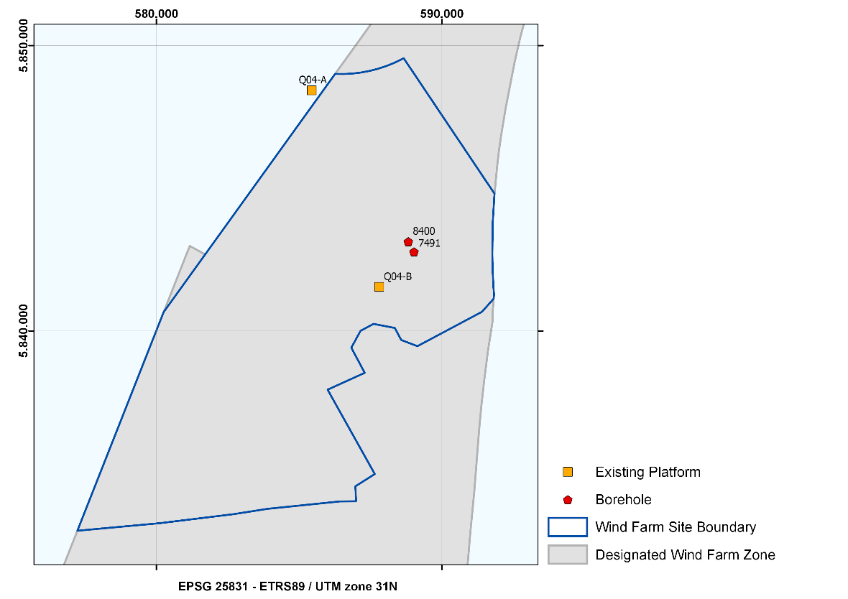
Figure 4.3 Existing platforms and boreholes in and near the HKNWFZ

Table 4.19 Existing platforms
Existing Platforms
 | Name | Type | Operator | Country | Status
1 | Q04-A | Production platform | WIN | NLD | In use
2 | Q04-B | Production platform | WIN | NLD | In use

Table 4.20 Boreholes
Existing Boreholes
 | UWI | Result | Borehole code | NITG number | Owner | Client | Status
1 | 7491 | Dry | Q04-03 | BQ040153 | Wintershall | BP Exploratie | Abandoned
2 | 8400 | Gas | Q04-08 | BQ040144 | Wintershall | Clyde | Suspended

Coordinates for existing platforms

Table 4.21 Coordinates for existing platforms
Existing Platforms
ETRS 1989 UTM Zone 31N
EPSG 25831
Point No. | Easting | Northing |  | Point No. | Easting | Northing
Q04-A | 585,440.0 | 5,848,432.0 |  | Q04-B | 587,804.0 | 5,841,545.0

Coordinates for boreholes

Table 4.22 Coordinates for boreholes
Existing Boreholes
ETRS 1989 UTM Zone 31N
EPSG 25831
Point No. | Easting | Northing |  | Point No. | Easting | Northing
7491 | 589,024.0 | 5,842,781.0 |  | 8400 | 588,825.0 | 5,843,139.0

Wind turbines in existing nearby wind farms

Three existing wind farms are located in the vicinity of the HKNWFZ. Offshore Wind Farm Prinses Amalia is located within the HKNWFZ, the Offshore Wind Farm Egmond aan Zee (OWEZ) is situated to the east of the HKNWFZ, and Offshore Wind Farm Luchterduinen is located within the Hollandse Kust (zuid) Wind Farm Zone (HKZWFZ) to the south of HKNWFZ. The coordinates and information of the wind turbines in these wind farms are presented in the tables in this section.

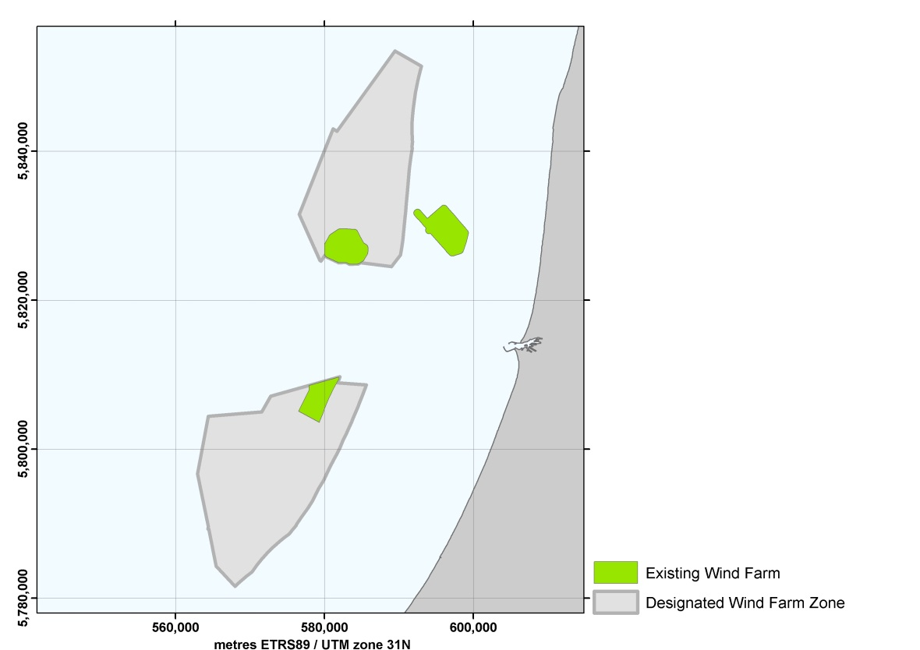
Figure 5.1 Existing nearby wind farms in the vicinity of HKNWFZ

Table 5.1 Coordinates of the wind turbines installed at the Prinses Amalia Wind Farm (60 Vestas 2 MW V80 turbines, hub height 60 m (MSL))
Princess Amalia Wind Farm
ETRS 1989 UTM Zone 31N
EPSG 25831
Point No. | Easting | Northing |  | Point No. | Easting | Northing
NW_044 | 584,022.0 | 5,829,007.0 |  | NW_074 | 584,887.0 | 5,826,200.0
NW_045 | 583,071.0 | 5,829,056.0 |  | NW_075 | 581,041.1 | 5,827,763.0
NW_046 | 583,532.0 | 5,828,757.0 |  | NW_076 | 581,523.0 | 5,827,499.0
NW_047 | 583,994.0 | 5,828,458.0 |  | NW_077 | 582,005.1 | 5,827,235.0
NW_048 | 584,455.0 | 5,828,159.0 |  | NW_078 | 582,488.1 | 5,826,971.0
NW_049 | 582,103.0 | 5,829,063.0 |  | NW_079 | 582,970.0 | 5,826,707.0
NW_050 | 582,570.0 | 5,828,772.0 |  | NW_080 | 583,452.0 | 5,826,443.0
NW_051 | 583,037.0 | 5,828,481.0 |  | NW_081 | 583,935.0 | 5,826,179.0
NW_052 | 583,503.0 | 5,828,191.0 |  | NW_082 | 584,417.0 | 5,825,915.0
NW_053 | 583,970.0 | 5,827,900.0 |  | NW_083 | 584,900.0 | 5,825,651.0
NW_054 | 584,437.0 | 5,827,608.0 |  | NW_084 | 580,531.1 | 5,827,405.0
NW_055 | 584,904.0 | 5,827,318.0 |  | NW_085 | 581,019.1 | 5,827,150.0
NW_056 | 585,371.0 | 5,827,027.0 |  | NW_086 | 581,506.1 | 5,826,895.0
NW_057 | 581,585.1 | 5,828,734.0 |  | NW_087 | 581,993.0 | 5,826,640.0
NW_058 | 582,057.0 | 5,828,452.0 |  | NW_088 | 582,481.0 | 5,826,385.0
NW_059 | 582,529.0 | 5,828,170.0 |  | NW_089 | 582,968.0 | 5,826,130.0
NW_060 | 583,002.0 | 5,827,888.0 |  | NW_090 | 583,455.0 | 5,825,875.0
NW_061 | 583,474.0 | 5,827,606.0 |  | NW_091 | 583,942.0 | 5,825,620.0
NW_062 | 583,946.0 | 5,827,323.0 |  | NW_092 | 584,430.0 | 5,825,365.0
NW_063 | 584,418.0 | 5,827,041.0 |  | NW_093 | 580,527.1 | 5,826,802.0
NW_064 | 584,890.0 | 5,826,759.0 |  | NW_094 | 581,019.1 | 5,826,556.0
NW_065 | 585,362.0 | 5,826,477.0 |  | NW_095 | 581,511.0 | 5,826,310.0
NW_066 | 581,068.1 | 5,828,385.0 |  | NW_096 | 582,002.1 | 5,826,064.0
NW_067 | 581,545.0 | 5,828,111.0 |  | NW_097 | 582,494.0 | 5,825,818.0
NW_068 | 582,024.0 | 5,827,839.0 |  | NW_098 | 582,986.0 | 5,825,571.0
NW_069 | 582,500.0 | 5,827,566.0 |  | NW_099 | 583,478.0 | 5,825,325.0
NW_070 | 582,978.0 | 5,827,293.0 |  | NW_100 | 580,547.1 | 5,826,228.0
NW_071 | 583,455.0 | 5,827,020.0 |  | NW_101 | 581,043.1 | 5,825,990.0
NW_072 | 583,932.0 | 5,826,747.0 |  | NW_102 | 581,539.1 | 5,825,752.0
NW_073 | 584,410.0 | 5,826,473.0 |  | NW_103 | 582,035.1 | 5,825,515.0

Table 5.2 Coordinates of the wind turbines installed at the Offshore Wind Farm Egmond aan Zee (36 Vestas 3 MW V90 turbines, hub height 70 m (MSL))
Offshore Wind Farm Egmond aan Zee (OWEZ)
ETRS 1989 UTM Zone 31N
EPSG 25831
Point No. | Easting | Northing |  | Point No. | Easting | Northing
NW_104 | 597,181.1 | 5,826,380.1 |  | NW_122 | 595,384.1 | 5,829,940.1
NW_105 | 596,756.1 | 5,826,863.1 |  | NW_123 | 594,959.1 | 5,830,424.1
NW_106 | 596,339.1 | 5,827,338.1 |  | NW_124 | 594,534.1 | 5,830,908.1
NW_107 | 595,914.1 | 5,827,822.1 |  | NW_125 | 598,548.1 | 5,827,853.1
NW_108 | 595,490.1 | 5,828,305.1 |  | NW_126 | 598,119.1 | 5,828,338.1
NW_109 | 595,065.1 | 5,828,789.1 |  | NW_127 | 597,695.1 | 5,828,826.1
NW_110 | 594,633.1 | 5,829,281.1 |  | NW_128 | 597,038.1 | 5,829,572.1
NW_111 | 594,208.1 | 5,829,764.1 |  | NW_129 | 596,560.1 | 5,830,116.1
NW_112 | 593,783.1 | 5,830,248.1 |  | NW_130 | 596,135.1 | 5,830,600.1
NW_113 | 593,366.1 | 5,830,739.1 |  | NW_131 | 595,710.1 | 5,831,084.1
NW_114 | 592,933.1 | 5,831,216.1 |  | NW_132 | 595,285.1 | 5,831,568.1
NW_115 | 592,508.1 | 5,831,700.1 |  | NW_133 | 598,868.1 | 5,828,998.1
NW_116 | 598,189.1 | 5,826,748.1 |  | NW_134 | 598,446.1 | 5,829,486.1
NW_117 | 597,764.1 | 5,827,232.1 |  | NW_135 | 597,796.1 | 5,830,224.1
NW_118 | 597,339.1 | 5,827,715.1 |  | NW_136 | 597,312.1 | 5,830,776.1
NW_119 | 596,914.1 | 5,828,199.1 |  | NW_137 | 596,887.1 | 5,831,260.1
NW_120 | 596,234.1 | 5,828,973.1 |  | NW_138 | 596,462.1 | 5,831,744.1
NW_121 | 595,809.1 | 5,829,457.1 |  | NW_139 | 596,037.1 | 5,832,228.1

Table 5.3 Coordinates of the wind turbines installed at the Luchterduinen Wind Farm (43 Vestas 3 MW V112 turbines, hub height 81 m (LAT))
Offshore Wind Farm Luchterduinen
ETRS 1989 UTM Zone 31N
EPSG 25831
Point No. | Easting | Northing |  | Point No. | Easting | Northing
NW_01 | 579,282.2 | 5,803,658.3 |  | NW_23 | 578,169.2 | 5,807,039.2
NW_02 | 578,737.2 | 5,803,948.3 |  | NW_24 | 577,666.2 | 5,807,306.2
NW_03 | 578,191.2 | 5,804,238.3 |  | NW_25 | 580,524.2 | 5,806,709.2
NW_04 | 577,645.2 | 5,804,529.3 |  | NW_26 | 580,037.2 | 5,806,968.2
NW_05 | 577,100.2 | 5,804,819.3 |  | NW_27 | 579,550.2 | 5,807,227.2
NW_06 | 576,554.2 | 5,805,110.3 |  | NW_28 | 579,063.2 | 5,807,486.2
NW_07 | 579,584.2 | 5,804,435.3 |  | NW_29 | 578,575.2 | 5,807,745.2
NW_08 | 579,053.2 | 5,804,718.3 |  | NW_30 | 578,088.2 | 5,808,005.2
NW_09 | 578,521.2 | 5,805,000.3 |  | NW_31 | 580,867.2 | 5,807,450.2
NW_10 | 577,990.2 | 5,805,283.3 |  | NW_32 | 580,392.2 | 5,807,703.2
NW_11 | 577,458.2 | 5,805,566.3 |  | NW_33 | 579,917.2 | 5,807,955.2
NW_12 | 576,927.2 | 5,805,849.3 |  | NW_34 | 579,442.2 | 5,808,207.2
NW_13 | 579,889.2 | 5,805,212.3 |  | NW_35 | 578,968.2 | 5,808,460.2
NW_14 | 579,372.2 | 5,805,487.2 |  | NW_36 | 578,493.2 | 5,808,712.2
NW_15 | 578,855.2 | 5,805,762.3 |  | NW_37 | 581,237.2 | 5,808,169.2
NW_16 | 578,337.2 | 5,806,037.2 |  | NW_38 | 580,640.2 | 5,808,486.2
NW_17 | 577,820.2 | 5,806,312.2 |  | NW_39 | 580,144.2 | 5,808,749.2
NW_18 | 577,303.2 | 5,806,588.2 |  | NW_40 | 579,648.2 | 5,809,013.2
NW_19 | 580,182.2 | 5,805,968.3 |  | NW_41 | 581,601.5 | 5,808,840.7
NW_20 | 579,678.2 | 5,806,236.2 |  | NW_42 | 580,591.4 | 5,809,287.2
NW_21 | 579,175.2 | 5,806,503.3 |  | NW_43 | 581,920.2 | 5,809,650.2
NW_22 | 578,672.2 | 5,806,771.2

