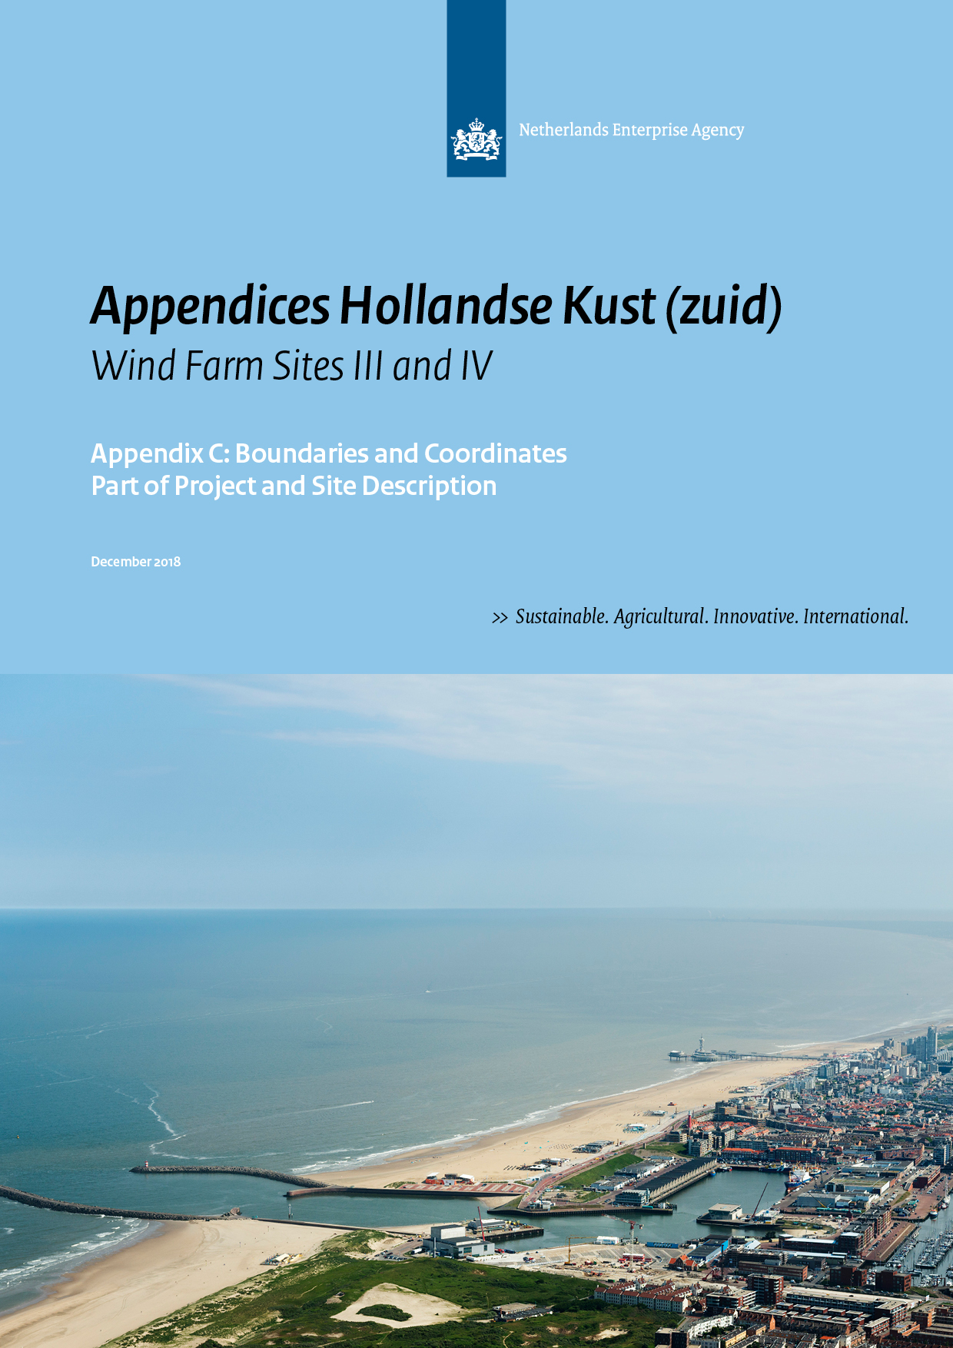
Colophon
Project name | Site Studies Hollandse Kust (zuid) Wind Farm Zone
Version | December 2018
File name | HKZ_20180412_Memo boundaries and coordinates_F
Project manager | Ruud de Bruijne
Annex(es) | -
Authors | Rick van der Heijden (RVO.nl); Danny Meus (RVO.nl)
Reviewed | Ruud de Bruijne (RVO.nl);  Frank van Erp (RVO.nl); Matté Brijder (RVO.nl);
Approved | Thomas Collette (RWS); Bert Wilbrink (EZK)

Only the coordinates and boundaries in the final Wind Farm Site Decisions are legally binding. Please note this memo confers no rights and is provided for convenience only.

Contents

1 Introduction 4
2 The Hollandse Kust (zuid) Wind Farm Zone (HKZWFZ) 6
3 Hollandse Kust (zuid) Wind Farm Sites (HKZWFS) 8
4 TenneT infrastructure 30
5 Existing infrastructure - cables and pipelines 31
6 Wind turbines in existing nearby wind farms 34

Introduction

Purpose
The purpose of this memo is to establish the exact definition for the Hollandse Kust (zuid) Wind Farm Sites (HKZWFS) (in Dutch: kavels). The geographical information is based on the data available in January 2018.

Only the coordinates and boundaries in the final Wind Farm Site Decisions (WFSD) are legally binding. The coordinates in the final WFSD Sites l - lV are aligned with this Appendix. Please note this memo confers no rights and is provided for convenience only.

Revisions

Horizontal datum
The geodetic system used for horizontal projections is European Terrestrial Reference System 1989 (ETRS89).

All coordinates are given in UTM projection, for which the following applies:
- Local datum European Datum (ETRS89)
- Central Meridian 3° E (Zone 31)

GIS Information
All coordinates given in this document correspond to GIS data that is made available by the Netherlands Enterprise Agency (RVO.nl) through the MPK file of the HKZWFZ at http://offshorewind.rvo.nl/mapszh.

Coordinate numbering
The coordinates given in this document are numbered according to the following system:
- Coordinates that determine the boundaries of the Hollandse Kust (zuid) Wind Farm Zone (HKZWFZ) start with the letter code WFZ followed by an underscore and a number (WFZ_1, WFZ_2, …);
- Coordinates that determine the outer boundaries of the HKZWFS start with the letter code S followed by an underscore and a number (S_1, S_2, …);
- Coordinates that determine the entry zone for the connection of the infield cables to the TenneT platforms Alpha and Beta start with the letter code CE followed by an underscore and a number (CE_1, CE_2, …);
- Coordinates that determine the maintenance zones of pipes and cables in the HKZWFZ start with the letter code MZ followed by an underscore and a number (MZ_1, MZ_2, …);
- Coordinates of objects which might have archaeological value start with the letter code AV followed by an underscore and a number (AV_1, AV_2, …); ;
- Coordinates of magnetic anomalies possibly indicating UXO objects or objects with archaeological value start with the letter code MA followed by an underscore and a number (MA_1, MA_2, …);
- Coordinates of the centre of the TenneT OHVS platforms (Substations HKZ Alpha and Beta) in the HKZWFZ start with the letter code TOS followed by an underscore and a number (TOS_1, TOS_2, …);
- Coordinates that determine the route of the TenneT export and redundancy cables in the HKZWFZ start with the letter code TC followed by an underscore and a number (TC_1, TC_2, …);
- Coordinates that determine the location of the existing cables and pipelines in the HKZWFZ start with the letter code CP followed by an underscore and a number (CP_1, CP_2, …).
- Coordinates that determine the locations of the wind turbines at neighbouring wind farms start with the letter code NW followed by an underscore and a number (NW_1, NW_2, …).

Orientation figures
All figures included in this document are presented with the north direction facing upwards.

The Hollandse Kust (zuid) Wind Farm Zone (HKZWFZ)
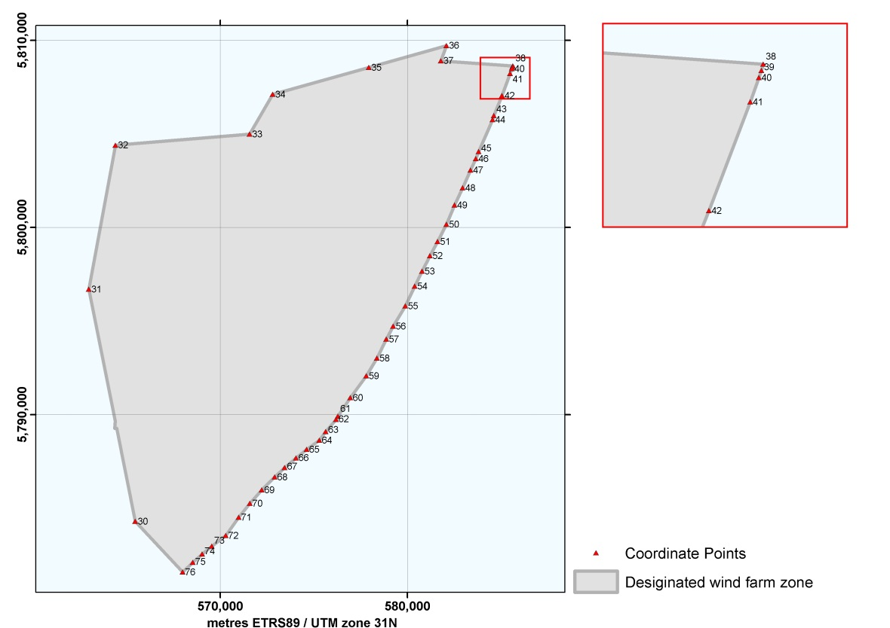
Figure 1 Overview of the Designated ,and Intended HKZWFZ

HKZWFZ
 | UTM |  |  |  | UTM
 | (ETRS89, zone 31) |  |  |  | (ETRS89, zone 31)
Point No. | Easting | Northing |  | Point No. | Easting | Northing
WFZ_30 | 565,470.5 | 5,784,279.9 |  | WFZ_54 | 580,393.7 | 5,796,861.7
WFZ_31 | 562,982.7 | 5,796,693.2 |  | WFZ_55 | 579,898.9 | 5,795,803.2
WFZ_32 | 564,404.0 | 5,804,398.4 |  | WFZ_56 | 579,248.3 | 5,794,721.1
WFZ_33 | 571,576.6 | 5,804,989.9 |  | WFZ_57 | 578,876.2 | 5,794,023.5
WFZ_34 | 572,804.4 | 5,807,112.0 |  | WFZ_58 | 578,378.3 | 5,793,014.6
WFZ_35 | 577,940.0 | 5,808,553.8 |  | WFZ_59 | 577,806.7 | 5,792,061.0
WFZ_36 | 582,093.6 | 5,809,722.8 |  | WFZ_60 | 576,959.0 | 5,790,898.9
WFZ_37 | 581,788.0 | 5,808,909.7 |  | WFZ_61 | 576,291.6 | 5,789,913.9
WFZ_38 | 585,637.2 | 5,808,634.1 |  | WFZ_62 | 576,190.2 | 5,789,734.6
WFZ_39 | 585,616.9 | 5,808,566.8 |  | WFZ_63 | 575,645.5 | 5,789,080.9
WFZ_40 | 585,589.4 | 5,808,488.5 |  | WFZ_64 | 575,295.7 | 5,788,618.4
WFZ_41 | 585,497.2 | 5,808,225.8 |  | WFZ_65 | 574,628.8 | 5,788,129.5
WFZ_42 | 585,050.6 | 5,807,047.7 |  | WFZ_66 | 574,056.7 | 5,787,679.7
WFZ_43 | 584,618.3 | 5,805,978.0 |  | WFZ_67 | 573,443.8 | 5,787,154.9
WFZ_44 | 584,549.1 | 5,805,759.5 |  | WFZ_68 | 572,912.4 | 5,786,661.2
WFZ_45 | 583,806.8 | 5,804,057.5 |  | WFZ_69 | 572,228.2 | 5,785,964.3
WFZ_46 | 583,658.0 | 5,803,670.2 |  | WFZ_70 | 571,590.0 | 5,785,242.2
WFZ_47 | 583,374.1 | 5,803,062.4 |  | WFZ_71 | 570,998.7 | 5,784,499.2
WFZ_48 | 582,960.1 | 5,802,115.9 |  | WFZ_72 | 570,303.3 | 5,783,529.5
WFZ_49 | 582,523.4 | 5,801,188.9 |  | WFZ_73 | 569,557.2 | 5,782,954.5
WFZ_50 | 582,086.2 | 5,800,162.1 |  | WFZ_74 | 569,045.5 | 5,782,532.7
WFZ_51 | 581,622.3 | 5,799,242.1 |  | WFZ_75 | 568,540.7 | 5,782,087.5
WFZ_52 | 581,211.5 | 5,798,487.2 |  | WFZ_76 | 567,997.4 | 5,781,570.0
WFZ_53 | 580,786.3 | 5,797,658.9
Table 1 Coordinates of the boundary points for the HKZWFZ

Hollandse Kust (zuid) Wind Farm Sites (HKZWFS)
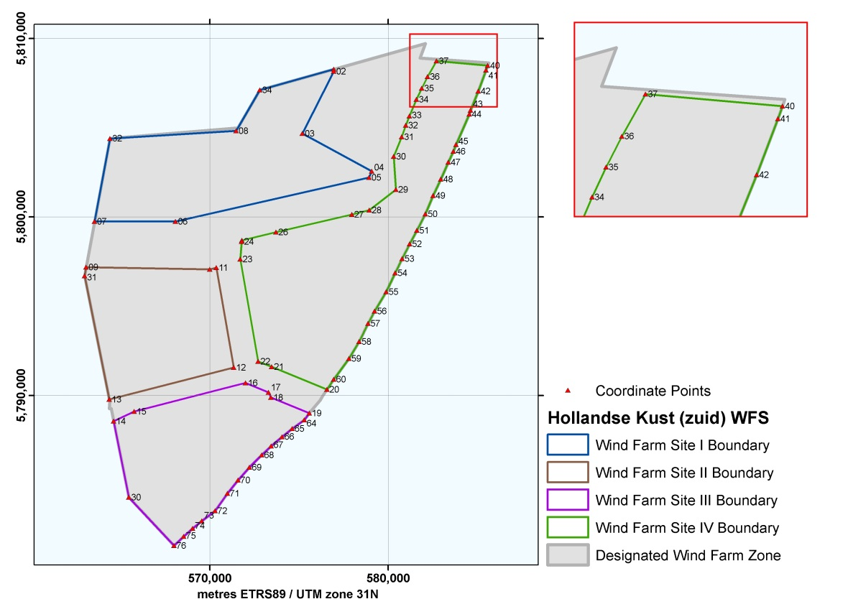
Figure 2 Overview of the HKZWFZ and Wind Farm Sites

Hollandse Kust (zuid) Wind Farm Site I (HKZWFS I)

Coordinates and maintenance zones
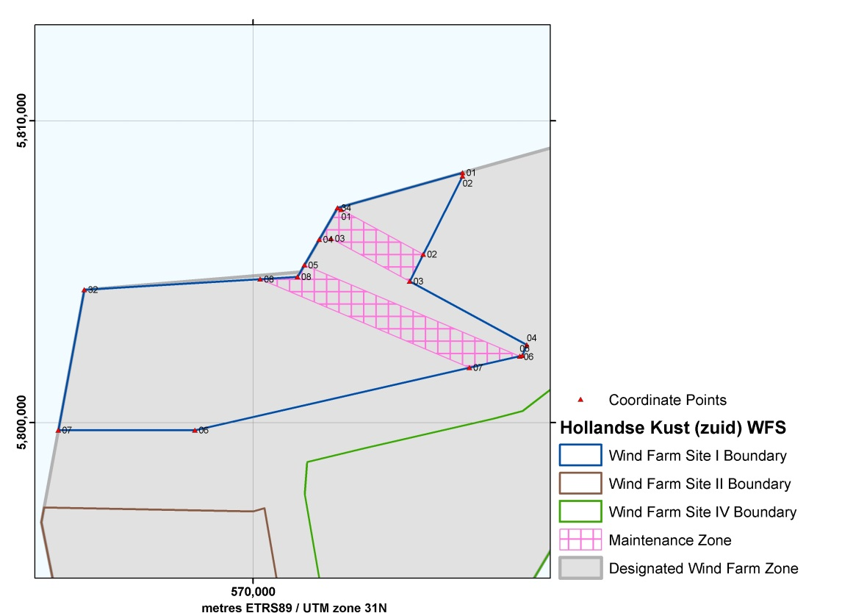
Figure 3 Hollandse Kust (zuid) Wind Farm Site I

Cable Entry Zone HKZWFS I
 | UTM |  |  |  | UTM
 | (ETRS89, zone 31) |  |  |  | (ETRS89, zone 31)
Point No. | Easting | Northing |  | Point No. | Easting | Northing
S_01 | 576,948.7 | 5,808,275.5 |  | S_06 | 568,076.4 | 5,799,744.2
S_02 | 576,952.6 | 5,808,157.7 |  | S_07 | 563,545.3 | 5,799,743.0
S_03 | 575,197.5 | 5,804,680.4 |  | WFZ_32 | 564,404.0 | 5,804,398.4
S_04 | 579,083.4 | 5,802,567.5 |  | S_08 | 571,480.7 | 5,804,824.1
S_05 | 578,933.5 | 5,802,214.5 |  | WFZ_34 | 572,804.4 | 5,807,112.0
Table 2 Coordinates of the HKZWFS I

Maintenance Zones HKZWFS I
 | UTM |  |  |  | UTM
 | (ETRS89, zone 31) |  |  |  | (ETRS89, zone 31)
Point No. | Easting | Northing |  | Point No. | Easting | Northing
WFZ_34 | 572,804.4 | 5,807,112.0 |  | MZ_05 | 571,707.3 | 5,805,215.8
MZ_01 | 572,930.6 | 5,807,051.4 |  | MZ_06 | 578,854.4 | 5,802,196.4
MZ_02 | 575,648.3 | 5,805,573.6 |  | MZ_07 | 577,182.7 | 5,801,816.5
S_03 | 575,197.5 | 5,804,680.4 |  | MZ_08 | 570,241.5 | 5,804,749.6
MZ_03 | 572,589.3 | 5,806,098.7 |  | S_08 | 571,480.7 | 5,804,824.1
MZ_04 | 572,197.7 | 5,806,063.4
Table 3 Coordinates of the maintenance zones in the HKZWFS I

Cable Entry Zone

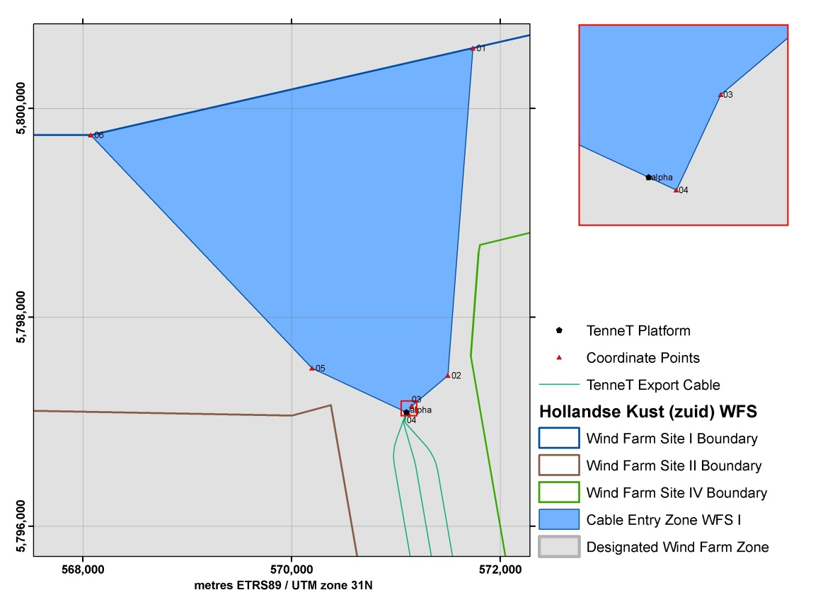
Figure 4 Cable Entry Zone HKZWFS I

Cable Entry Zone HKZWFS I
 | UTM |  |  |  | UTM
 | (ETRS89, zone 31) |  |  |  | (ETRS89, zone 31)
Point No. | Easting | Northing |  | Point No. | Easting | Northing
CE_01 | 571,736.3 | 5,800,577.1 |  | TOS_01 | 571,100.0 | 5,797,090.0
CE_02 | 571,497.2 | 5,797,442.1 |  | CE_05 | 570,195.2 | 5,797,511.9
CE_03 | 571,151.4 | 5,797,148.8 |  | S_06 | 568,076.4 | 5,799,744.2
CE_04 | 571,119.7 | 5,797,080.8
Table 4 Coordinates of the infield cable entry zone HKZWFS I

Possible archaeological objects and magnetic anomalies

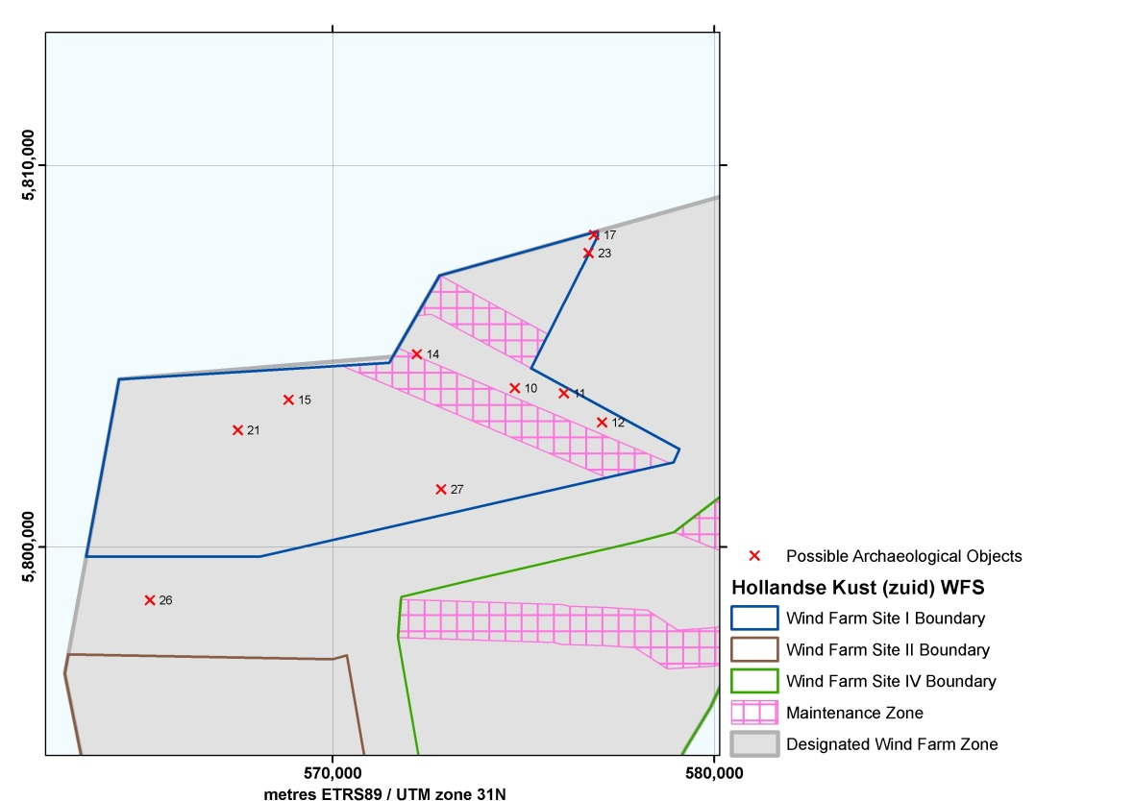
Figure 5 Possible Archaeological Objects in HKZWFS I

Possible Archaeological Objects in HKZWFS I
Point No. | Easting | Northing |  | Point No. | Easting | Northing
AV_10  (NCN-1956) | 574,777.0 | 5,804,155.0 |  | AV_17  (NCN-2737) | 576,849.0 | 5,808,168.0
AV_11  (NCN-1957) | 576,065.0 | 5,804,020.0 |  | AV_21  (NCN-7980) | 567,518.0 | 5,803,057.0
AV_12  (NCN-1958) | 577,061.0 | 5,803,263.0 |  | AV_23  (NCN-9563) | 576,711.2 | 5,807,696.2
AV_14  (NCN-1963) | 572,212.0 | 5,805,044.0 |  | AV_26 | 565,220.0 | 5,798,600.0
AV_15  (NCN-2497) | 568,847.0 | 5,803,855.0 |  | AV_27 | 572,850.0 | 5,801,510.0
Table 5 Coordinates of possible archaeological objects in HKZWFS I (including reference to the NCN database numbers)

A buffer zone of 100 m should be applied around the few objects found which have yet to be determined to have no archaeological value, thereby prohibiting any activities in their locations. This also applies to cable trenching and anchorages of work vessels. Please note that the buffer zone may be reduced if it can be substantiated that the applied activity and disturbance has no effect on the (possible) archaeological object.

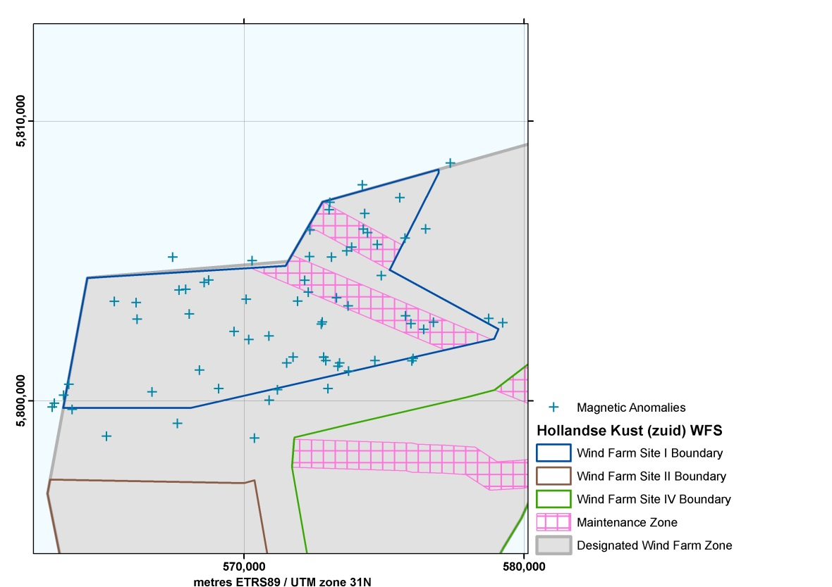
Figure 6 Magnetic Anomalies (possible buried ferrous objects) in HKZWFS I

Magnetic Anomalies in HKZWFS I
Point No. | Easting | Northing |  | Point No. | Easting | Northing
MA_01 | 576,036.0 | 5,801,508.0 |  | MA_38 | 574,231.0 | 5,807,711.0
MA_02 | 575,998.0 | 5,801,425.0 |  | MA_39 | 573,123.0 | 5,805,129.0
MA_03 | 576,418.0 | 5,802,547.0 |  | MA_40 | 570,901.0 | 5,800,018.0
MA_04 | 575,963.0 | 5,802,753.0 |  | MA_41 | 571,756.0 | 5,801,554.0
MA_05 | 575,768.0 | 5,803,028.0 |  | MA_42 | 571,200.0 | 5,800,389.0
MA_06 | 574,674.0 | 5,801,427.0 |  | MA_43 | 570,375.0 | 5,798,663.0
MA_07 | 576,490.0 | 5,806,139.0 |  | MA_44 | 573,845.0 | 5,805,491.0
MA_08 | 577,371.0 | 5,808,497.0 |  | MA_45 | 574,263.0 | 5,806,134.0
MA_09 | 573,735.0 | 5,801,062.0 |  | MA_46 | 573,305.0 | 5,803,676.0
MA_10 | 575,752.0 | 5,805,808.0 |  | MA_47 | 574,416.0 | 5,806,003.0
MA_11 | 569,096.0 | 5,800,428.0 |  | MA_48 | 572,925.0 | 5,801,433.0
MA_12 | 570,076.0 | 5,803,628.0 |  | MA_49 | 578,743.0 | 5,802,934.0
MA_13 | 567,626.0 | 5,799,189.0 |  | MA_50 | 579,244.0 | 5,802,787.0
MA_14 | 568,410.0 | 5,801,088.0 |  | MA_51 | 569,647.0 | 5,802,471.0
MA_15 | 570,288.0 | 5,805,006.0 |  | MA_52 | 570,171.0 | 5,802,184.0
MA_16 | 568,740.0 | 5,804,314.0 |  | MA_53 | 572,359.0 | 5,806,101.0
MA_17 | 568,581.0 | 5,804,228.0 |  | MA_54 | 570,892.0 | 5,802,315.0
MA_18 | 568,047.0 | 5,803,103.0 |  | MA_55 | 572,170.0 | 5,804,302.0
MA_19 | 566,720.0 | 5,800,309.0 |  | MA_56 | 574,313.0 | 5,806,692.0
MA_20 | 567,917.0 | 5,803,981.0 |  | MA_57 | 573,670.0 | 5,805,349.0
MA_21 | 567,453.0 | 5,805,133.0 |  | MA_58 | 572,759.0 | 5,802,735.0
MA_22 | 563,864.0 | 5,799,686.0 |  | MA_59 | 572,797.0 | 5,802,813.0
MA_23 | 565,374.0 | 5,803,551.0 |  | MA_60 | 571,918.0 | 5,803,556.0
MA_24 | 563,153.0 | 5,799,769.0 |  | MA_61 | 571,523.0 | 5,801,349.0
MA_25 | 563,224.0 | 5,799,910.0 |  | MA_62 | 576,766.0 | 5,802,803.0
MA_26 | 563,745.0 | 5,800,583.0 |  | MA_63 | 573,357.0 | 5,801,224.0
MA_27 | 563,560.0 | 5,800,194.0 |  | MA_64 | 573,418.0 | 5,801,345.0
MA_28 | 563,560.0 | 5,800,194.0 |  | MA_65 | 574,908.0 | 5,804,474.0
MA_29 | 566,149.0 | 5,803,506.0 |  | MA_66 | 572,300.0 | 5,803,878.0
MA_30 | 566,181.0 | 5,802,909.0 |  | MA_67 | 572,851.0 | 5,801,556.0
MA_31 | 567,678.0 | 5,803,958.0 |  | MA_68 | 574,764.0 | 5,805,584.0
MA_32 | 572,843.0 | 5,801,547.0 |  | MA_69 | 575,563.0 | 5,807,260.0
MA_33 | 573,721.0 | 5,803,385.0 |  | MA_70 | 573,040.0 | 5,806,828.0
MA_34 | 572,996.0 | 5,800,432.0 |  | MA_71 | 570,894.0 | 5,802,315.0
MA_35 | 573,067.0 | 5,807,091.0 |  | MA_72 | 565,089.0 | 5,798,728.0
MA_36 | 572,342.0 | 5,805,151.0 |  | MA_73 | 564,552.0 | 5,796,444.0
MA_37 | 571,916.0 | 5,803,556.0
Table 6 Coordinates of the magnetic anomalies (possible buried ferrous objects) in
HKZWFS I

Whilst installing wind turbines and the various infield and export cables, developers are advised to avoid areas where magnetic anomalies have been identified, again by implementing a 100 m buffer zone.

Hollandse Kust (zuid) Wind Farm Site II (HKZWFS II)

Coordinates and maintenance zones

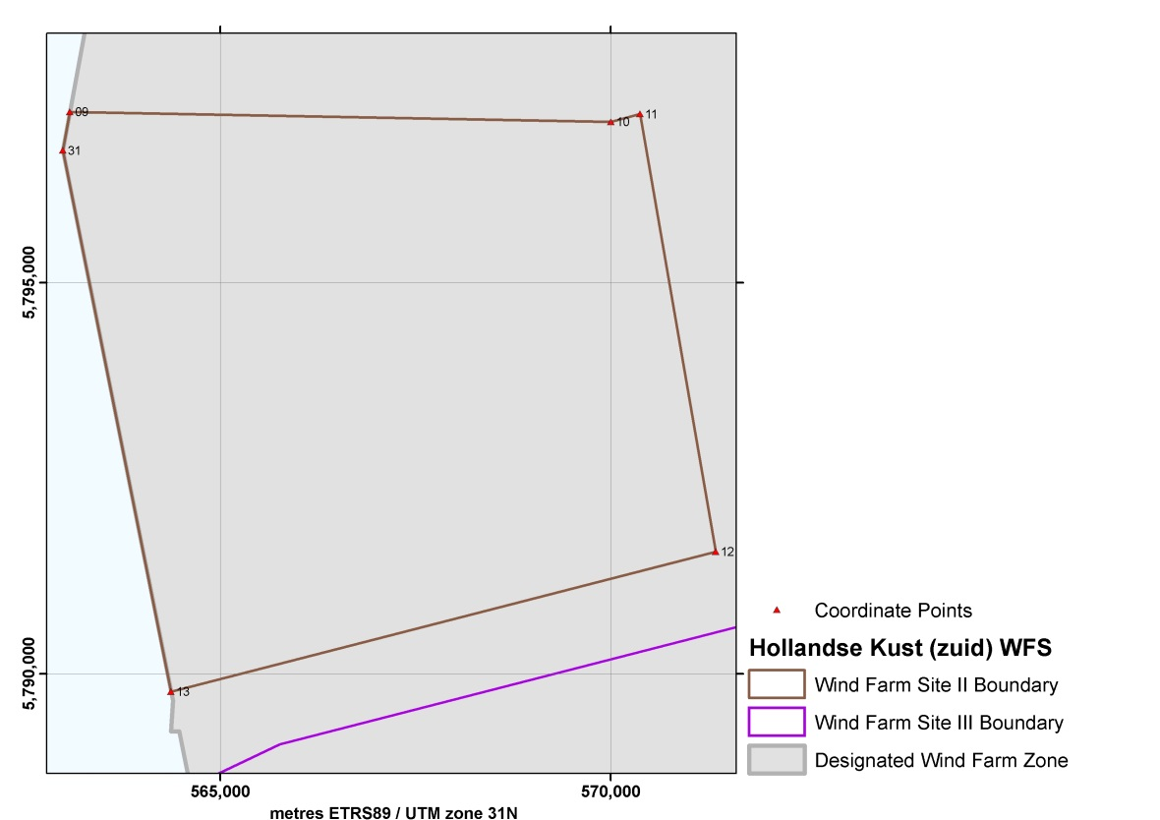
Figure 7 Hollandse Kust (zuid) Wind Farm Site II

HKZWFS II
 | UTM |  |  |  | UTM
 | (ETRS89, zone 31) |  |  |  | (ETRS89, zone 31)
Point No. | Easting | Northing |  | Point No. | Easting | Northing
S_09 | 563,073.9 | 5,797,187.7 |  | S_12 | 571,344.5 | 5,791,559.5
S_10 | 570,003.9 | 5,797,059.0 |  | S_13 | 564,370.2 | 5,789,770.2
S_11 | 570,376.5 | 5,797,159.5 |  | WFZ_31 | 562,982.7 | 5,796,693.2
Table 7 Coordinates of the HKZWFS II

Cable Entry Zone

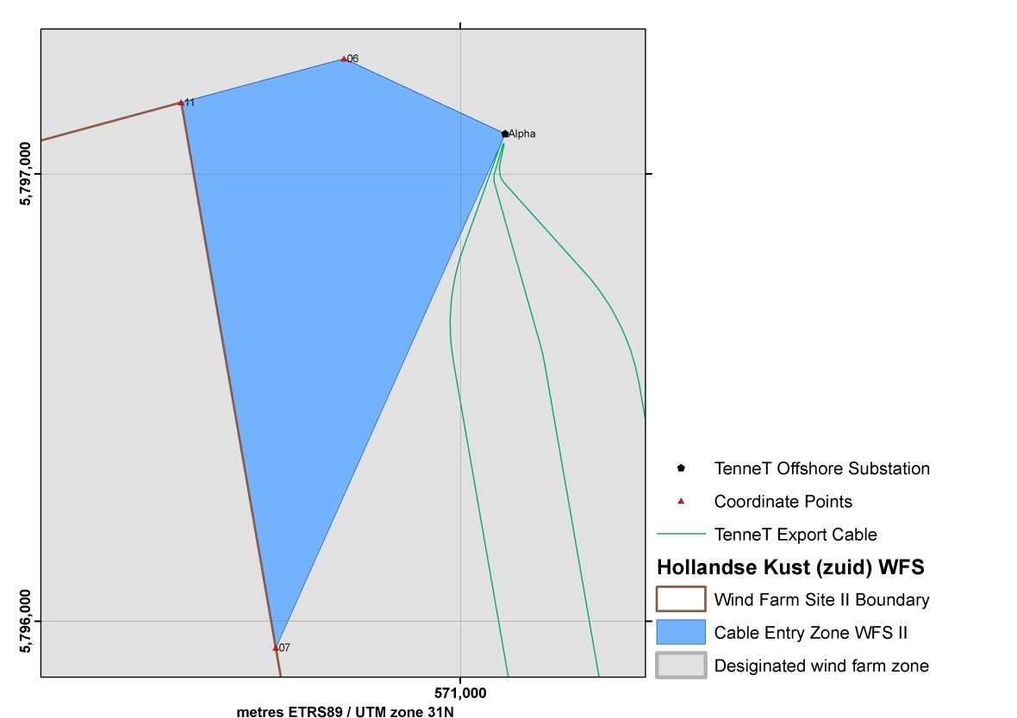
Figure 8 Cable Entry Zone HKZWFS II

Cable Entry Zone HKZWFS II
 | UTM |  |  |  | UTM
 | (ETRS89, zone 31) |  |  |  | (ETRS89, zone 31)
Point No. | Easting | Northing |  | Point No. | Easting | Northing
CE_06 | 570,740.4 | 5,797,257.7 |  | CE_07 | 570,588.1 | 5,795,940.8
TOS_01 | 571,100.0 | 5,797,090.0 |  | S_11 | 570,376.5 | 5,797,159.5
Table 8 Coordinates of the infield cable entry zone HKZWFS II

Possible archaeological objects and magnetic anomalies

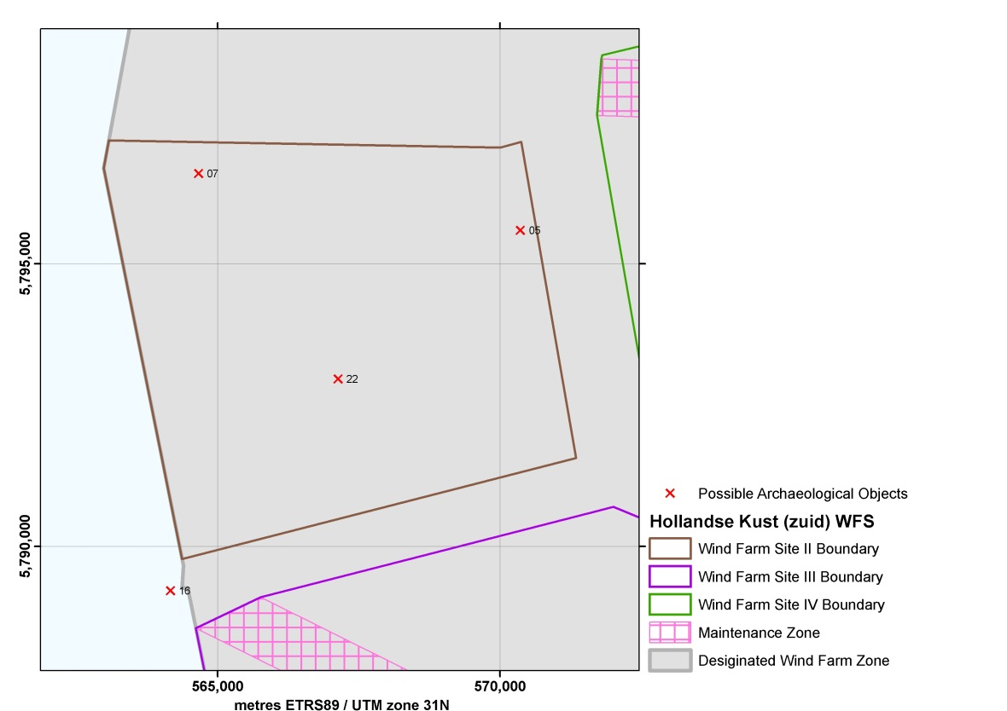
Figure 9 Possible Archaeological Objects in HKZWFS II

Possible Archaeological Objects in WFS II
Point No. | Easting | Northing |  | Point No. | Easting | Northing
AV_05  (NCN-1933) | 570,361.0 | 5,795,591.0 |  | AV_16  (NCN-2520) | 564,167.0 | 5,789,208.0
AV_07  (NCN-1941) | 564,665.0 | 5,796,595.0 |  | AV_22  (NCN-8011) | 567,134.0 | 5,792,960.0
Table 9 Coordinates of possible archaeological objects in HKZWFS II (including references to the NCN database numbers)

A buffer zone of 100 m should be applied around the few objects found which have yet to be determined to have no archaeological value, thereby prohibiting any activities in their locations. This also applies to cable trenching and anchorages of work vessels. Please note that the buffer zone may be reduced if it can be substantiated that the applied activity and disturbance has no effect on the (possible) archaeological object.

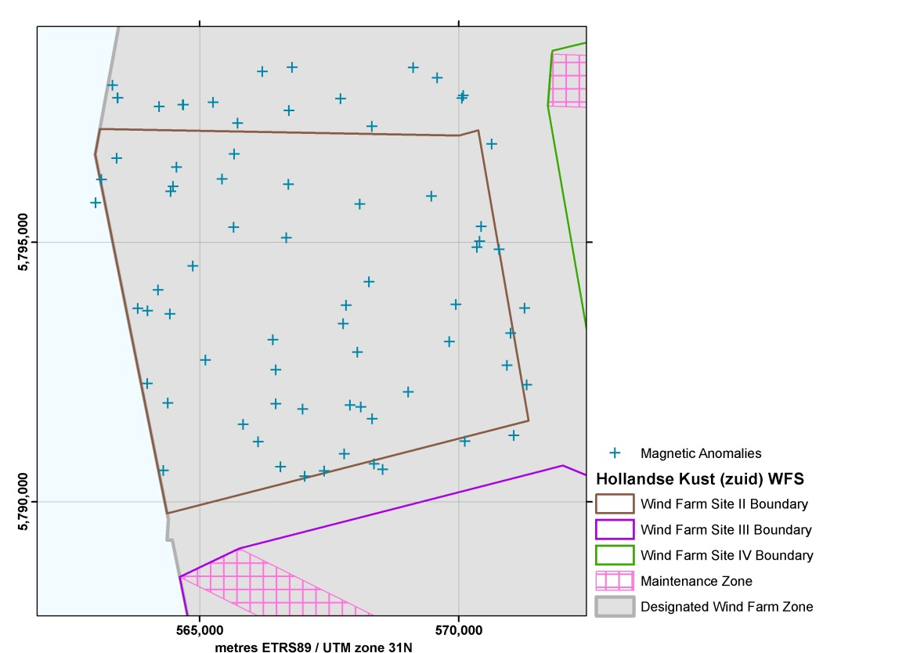
Figure 10 Magnetic Anomalies (possible buried ferrous objects) in HKZWFS II

Magnetic Anomalies in HKZWFS II
Point No. | Easting | Northing |  | Point No. | Easting | Northing
MA_73 | 564,552.0 | 5,796,444.0 |  | MA_109 | 566,557.0 | 5,790,666.0
MA_74 | 565,109.0 | 5,792,727.0 |  | MA_110 | 567,028.0 | 5,790,484.0
MA_75 | 566,712.0 | 5,796,115.0 |  | MA_111 | 567,404.0 | 5,790,584.0
MA_76 | 564,382.0 | 5,791,897.0 |  | MA_112 | 568,109.0 | 5,791,821.0
MA_77 | 565,654.0 | 5,795,285.0 |  | MA_113 | 568,328.0 | 5,791,589.0
MA_78 | 566,722.0 | 5,797,536.0 |  | MA_114 | 570,428.0 | 5,795,299.0
MA_79 | 563,990.0 | 5,792,271.0 |  | MA_115 | 569,945.0 | 5,793,797.0
MA_80 | 566,784.0 | 5,798,367.0 |  | MA_116 | 568,532.0 | 5,790,615.0
MA_81 | 565,664.0 | 5,796,697.0 |  | MA_117 | 570,774.0 | 5,794,857.0
MA_82 | 565,431.0 | 5,796,213.0 |  | MA_118 | 571,267.0 | 5,793,726.0
MA_83 | 566,207.0 | 5,798,289.0 |  | MA_119 | 570,998.0 | 5,793,242.0
MA_84 | 565,730.0 | 5,797,291.0 |  | MA_120 | 570,115.0 | 5,791,161.0
MA_85 | 563,995.0 | 5,793,672.0 |  | MA_121 | 564,867.0 | 5,794,540.0
MA_86 | 564,195.0 | 5,794,074.0 |  | MA_122 | 564,427.0 | 5,793,613.0
MA_87 | 564,438.0 | 5,795,975.0 |  | MA_123 | 564,300.0 | 5,790,598.0
MA_88 | 564,485.0 | 5,796,074.0 |  | MA_124 | 567,716.0 | 5,797,762.0
MA_89 | 565,257.0 | 5,797,691.0 |  | MA_125 | 568,087.0 | 5,795,732.0
MA_90 | 564,216.0 | 5,797,614.0 |  | MA_126 | 570,084.0 | 5,797,824.0
MA_91 | 563,400.0 | 5,796,616.0 |  | MA_127 | 570,062.0 | 5,797,777.0
MA_92 | 562,993.0 | 5,795,759.0 |  | MA_128 | 568,042.0 | 5,792,879.0
MA_93 | 563,103.0 | 5,796,203.0 |  | MA_129 | 569,472.0 | 5,795,884.0
MA_94 | 563,320.0 | 5,798,024.0 |  | MA_130 | 568,323.0 | 5,797,232.0
MA_95 | 563,418.0 | 5,797,778.0 |  | MA_131 | 566,988.0 | 5,791,780.0
MA_96 | 564,673.0 | 5,797,648.0 |  | MA_132 | 563,414.0 | 5,797,778.0
MA_97 | 567,786.0 | 5,790,916.0 |  | MA_133 | 564,683.0 | 5,797,646.0
MA_98 | 570,634.0 | 5,796,890.0 |  | MA_134 | 570,926.0 | 5,792,623.0
MA_99 | 569,021.0 | 5,792,108.0 |  | MA_135 | 567,902.0 | 5,791,857.0
MA_100 | 569,818.0 | 5,793,081.0 |  | MA_136 | 568,362.0 | 5,790,724.0
MA_101 | 566,410.0 | 5,793,115.0 |  | MA_137 | 570,349.0 | 5,794,899.0
MA_102 | 565,840.0 | 5,791,486.0 |  | MA_138 | 570,401.0 | 5,795,018.0
MA_103 | 569,119.0 | 5,798,364.0 |  | MA_139 | 569,583.0 | 5,798,165.0
MA_104 | 566,465.0 | 5,792,539.0 |  | MA_140 | 563,803.0 | 5,793,719.0
MA_105 | 566,467.0 | 5,791,879.0 |  | MA_141 | 566,673.0 | 5,795,081.0
MA_106 | 566,126.0 | 5,791,147.0 |  | MA_142 | 567,825.0 | 5,793,783.0
MA_107 | 567,766.0 | 5,793,424.0 |  | MA_143 | 571,062.0 | 5,791,269.0
MA_108 | 568,266.0 | 5,794,235.0 |  | MA_144 | 571,309.0 | 5,792,246.0
Table 10 Coordinates of the magnetic anomalies (possible buried ferrous objects) in
HKZWFS II

Whilst installing wind turbines and the various infield and export cables, developers are advised to avoid areas where magnetic anomalies have been identified, again by implementing a 100 m buffer zone

Hollandse Kust (zuid) Wind Farm Site III (HKZWFS III)

Coordinates and maintenance zones

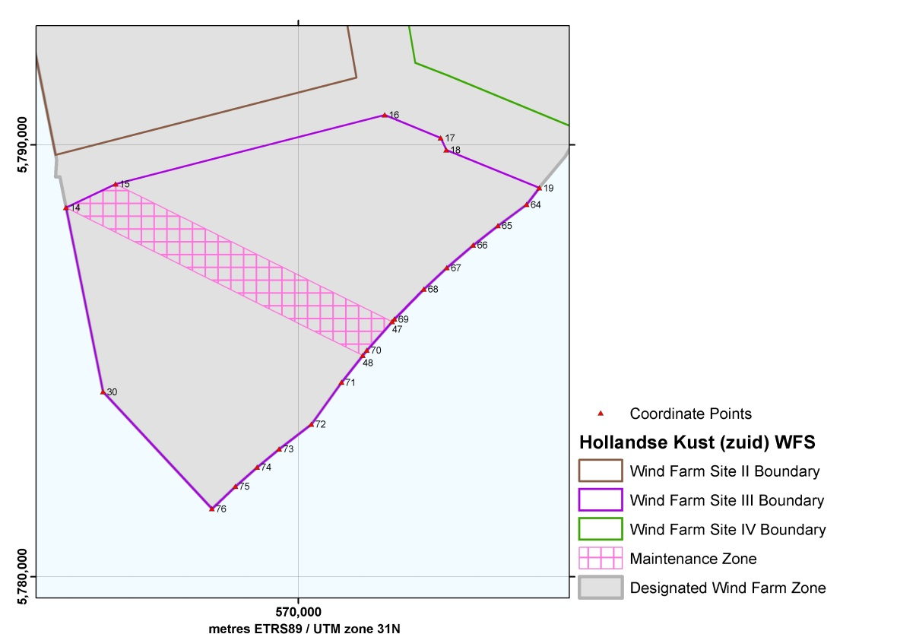
Figure 11 Hollandse Kust (zuid) Wind Farm Site III

HKZWFS III
 | UTM |  |  |  | UTM
 | (ETRS89, zone 31) |  |  |  | (ETRS89, zone 31)
Point No. | Easting | Northing |  | Point No. | Easting | Northing
S_14 | 564,614.8 | 5,788,549.4 |  | WFZ_68 | 572,912.4 | 5,786,661.2
S_15 | 565,761.4 | 5,789,096.5 |  | WFZ_69 | 572,228.2 | 5,785,964.3
S_16 | 572,004.3 | 5,790,697.8 |  | WFZ_70 | 571,590.0 | 5,785,242.2
S_17 | 573,302.2 | 5,790,162.1 |  | WFZ_71 | 570,998.7 | 5,784,499.2
S_18 | 573,429.2 | 5,789,883.6 |  | WFZ_72 | 570,303.3 | 5,783,529.5
S_19 | 575,586.6 | 5,789,003.0 |  | WFZ_73 | 569,557.2 | 5,782,954.5
WFZ_64 | 575,295.7 | 5,788,618.4 |  | WFZ_74 | 569,045.5 | 5,782,532.7
WFZ_65 | 574,628.8 | 5,788,129.5 |  | WFZ_75 | 568,540.7 | 5,782,087.5
WFZ_66 | 574,056.7 | 5,787,679.7 |  | WFZ_76 | 567,997.4 | 5,781,570.0
WFZ_67 | 573,443.8 | 5,787,154.9 |  | WFZ_30 | 565,470.5 | 5,784,279.9
Table 11 Coordinates of the HKZWFS III

Maintenance Zone HKZWFS III
 | UTM |  |  |  | UTM
 | (ETRS89, zone 31) |  |  |  | (ETRS89, zone 31)
Point No. | Easting | Northing |  | Point No. | Easting | Northing
MZ_47 | 572,174.6 | 5,785,903.7 |  | S_14 | 564,614.8 | 5,788,549.4
WFZ_70 | 571,590.0 | 5,785,242.2 |  | S_15 | 565,761.4 | 5,789,096.5
MZ_48 | 571,496.2 | 5,785,124.4
Table 12 Coordinates of the maintenance zones in the HKZWFS III

Cable Entry Zone
Please Note: the location of Platform Beta and the coordinates of the Cable Entry Zone for HKZWFS III and IV are final.

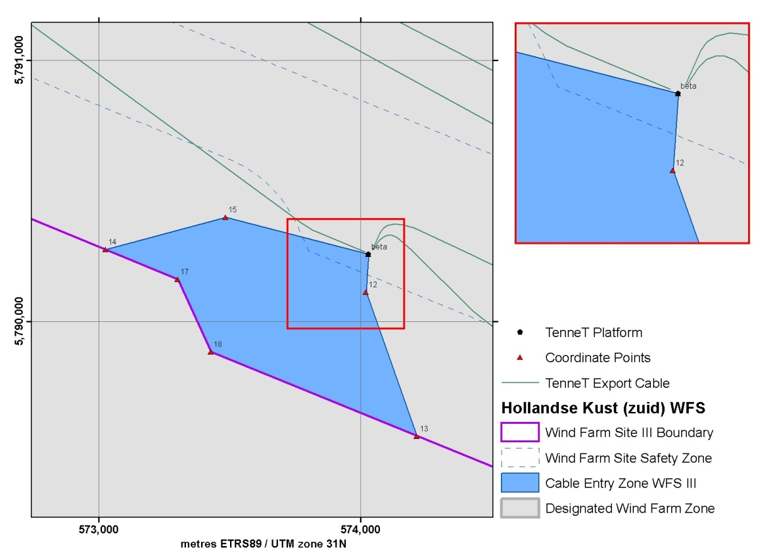
Figure 12 Cable Entry Zone HKZWFS III

Cable Entry Zone HKZWFS III
 | UTM |  |  |  | UTM
 | (ETRS89, zone 31) |  |  |  | (ETRS89, zone 31)
Point No. | Easting | Northing |  | Point No. | Easting | Northing
CE_12 | 574,022.3 | 5,790,112.3 |  | S_17 | 573,302.2 | 5,790,162.1
CE_13 | 574,217.5 | 5,789,561.9 |  | CE_14 | 573,025.7 | 5,790,276.3
S_18 | 573,429.2 | 5,789,883.6 |  | CE_15 | 573,484.6 | 5,790,399.2
 |  |  |  | TOS_02 | 574,032.2 | 5,790,258.7
Table 13 Coordinates of the infield cable entry zone HKZWFS III

Possible archaeological objects and magnetic anomalies

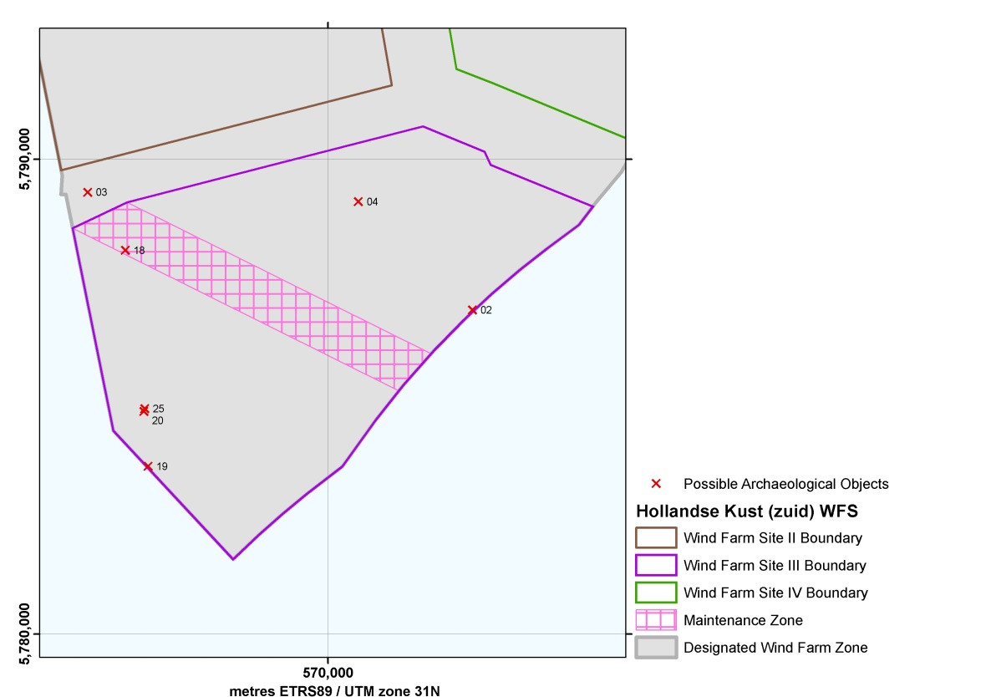
Figure 13 Possible Archaeological Objects in HKZWFS III

Possible Archaeological Objects in WFS III
Point No. | Easting | Northing |  | Point No. | Easting | Northing
AV_02  (NCN-1920) | 573,048.0 | 5,786,823.0 |  | AV_19  (NCN-4660) | 566,205.0 | 5,783,526.0
AV_03  (NCN-1922) | 564,932.0 | 5,789,305.0 |  | AV_20  (NCN-4664) | 566,116.0 | 5,784,683.0
AV_04  (NCN-1923) | 570,643.0 | 5,789,106.0 |  | AV_25  (NCN-14632) | 566,137.0 | 5,784,742.0
AV_18  (NCN-4655) | 565,725.0 | 5,788,081.0
Table 14 Coordinates of possible archaeological objects in HKZWFS III (including references to the NCN database)

A buffer zone of 100 m should be applied around the few objects found which have yet to be determined to have no archaeological value, thereby prohibiting any activities in their locations. This also applies to cable trenching and anchorages of work vessels. Please note that the buffer zone may be reduced if it can be substantiated that the applied activity and disturbance has no effect on the (possible) archaeological object.

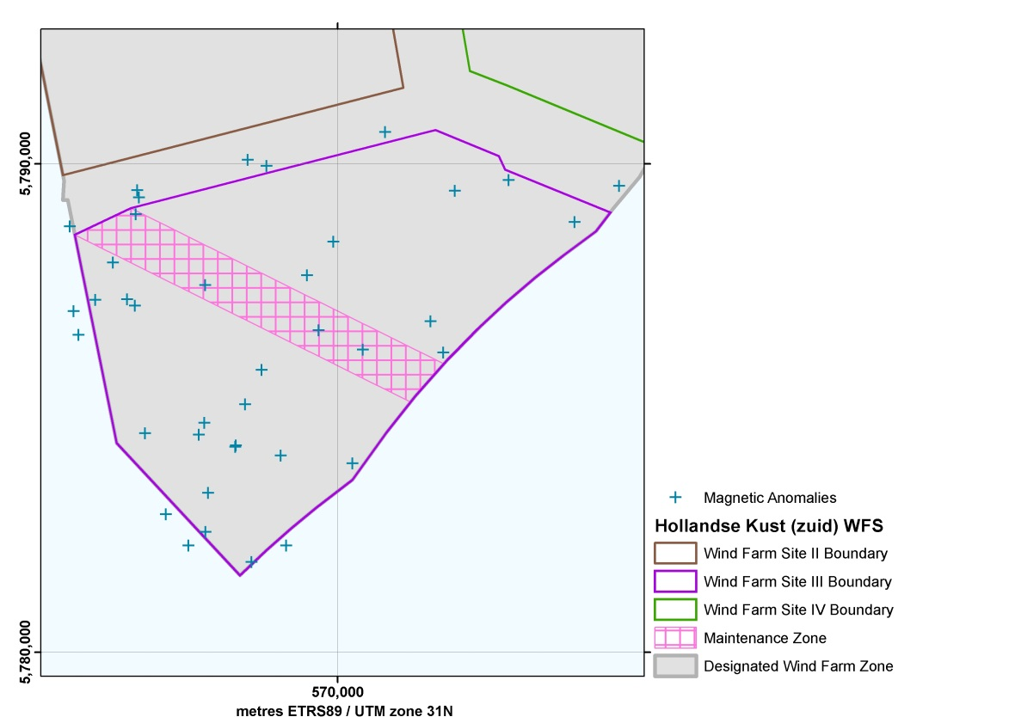
Figure 14 Magnetic Anomalies (possible buried ferrous objects) in HKZWFS III

Magnetic Anomalies in HKZWFS III
Point No, | Easting | Northing |  | Point No, | Easting | Northing
MA_145 | 566,055.0 | 5,784,478.0 |  | MA_165 | 574,856.0 | 5,788,802.0
MA_146 | 565,865.0 | 5,788,962.0 |  | MA_166 | 571,901.0 | 5,786,772.0
MA_147 | 565,394.0 | 5,787,975.0 |  | MA_167 | 570,303.0 | 5,783,860.0
MA_148 | 565,034.0 | 5,787,211.0 |  | MA_168 | 568,232.0 | 5,781,838.0
MA_149 | 564,690.0 | 5,786,491.0 |  | MA_169 | 569,610.0 | 5,786,585.0
MA_150 | 565,891.0 | 5,789,454.0 |  | MA_170 | 568,106.0 | 5,785,068.0
MA_151 | 568,944.0 | 5,782,180.0 |  | MA_171 | 568,441.0 | 5,785,775.0
MA_152 | 572,400.0 | 5,789,442.0 |  | MA_172 | 569,369.0 | 5,787,712.0
MA_153 | 568,831.0 | 5,784,023.0 |  | MA_173 | 567,290.0 | 5,782,458.0
MA_154 | 566,942.0 | 5,782,180.0 |  | MA_174 | 567,342.0 | 5,783,257.0
MA_155 | 567,901.0 | 5,784,199.0 |  | MA_175 | 567,153.0 | 5,784,445.0
MA_156 | 567,915.0 | 5,784,228.0 |  | MA_176 | 567,268.0 | 5,784,691.0
MA_157 | 569,911.0 | 5,788,399.0 |  | MA_177 | 566,482.0 | 5,782,820.0
MA_158 | 570,974.0 | 5,790,646.0 |  | MA_178 | 568,543.0 | 5,789,955.0
MA_159 | 565,683.0 | 5,787,219.0 |  | MA_179 | 565,844.0 | 5,787,091.0
MA_160 | 572,164.0 | 5,786,131.0 |  | MA_180 | 565,928.0 | 5,789,309.0
MA_161 | 570,515.0 | 5,786,189.0 |  | MA_181 | 567,283.0 | 5,787,512.0
MA_162 | 575,770.0 | 5,789,547.0 |  | MA_182 | 568,159.0 | 5,790,080.0
MA_163 | 564,587.0 | 5,786,980.0 |  | MA_183 | 564,512.0 | 5,788,713.0
MA_164 | 573,502.0 | 5,789,662.0
Table 15 Coordinates of the magnetic anomalies (possible buried ferrous objects) in HKZWFS IV

Whilst installing wind turbines and the various infield and export cables, developers are advised to avoid areas where magnetic anomalies have been identified, again by implementing a 100 m buffer zone

Hollandse Kust (zuid) Wind Farm Sites IV (HKZWFS IV)

Coordinates and maintenance zones

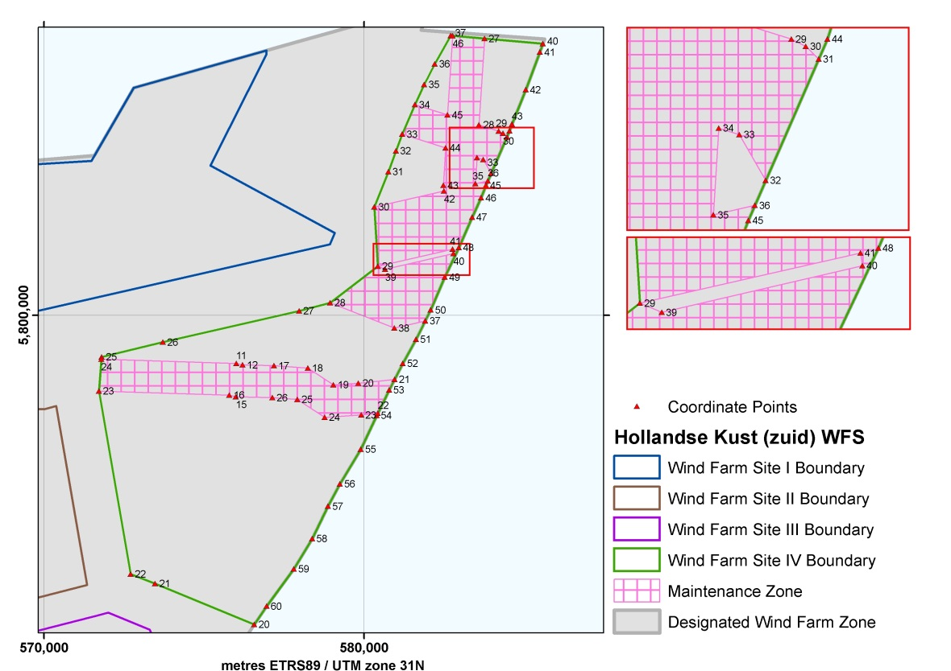
Figure 15 Hollandse Kust (zuid) Wind Farm Site IV

HKZWFS IV
 | UTM |  |  |  | UTM
 | (ETRS89, zone 31) |  |  |  | (ETRS89, zone 31)
Point No. | Easting | Northing |  | Point No. | Easting | Northing
S_20 | 576,572.1 | 5,790,327.9 |  | WFZ_42 | 585,050.6 | 5,807,047.7
S_21 | 573,472.2 | 5,791,607.2 |  | WFZ_43 | 584,618.3 | 5,805,978.0
S_22 | 572,710.0 | 5,791,903.1 |  | WFZ_44 | 584,549.1 | 5,805,759.5
S_23 | 571,716.1 | 5,797,627.9 |  | WFZ_45 | 583,806.8 | 5,804,057.5
S_24 | 571,790.9 | 5,798,626.0 |  | WFZ_46 | 583,658.0 | 5,803,670.2
S_25 | 571,805.0 | 5,798,693.2 |  | WFZ_47 | 583,374.1 | 5,803,062.4
S_26 | 573,716.5 | 5,799,154.4 |  | WFZ_48 | 582,960.1 | 5,802,115.9
S_27 | 577,973.7 | 5,800,132.7 |  | WFZ_49 | 582,523.4 | 5,801,188.9
S_28 | 578,941.5 | 5,800,385.9 |  | WFZ_50 | 582,086.2 | 5,800,162.1
S_29 | 580,431.8 | 5,801,530.6 |  | WFZ_51 | 581,622.3 | 5,799,242.1
S_30 | 580,316.8 | 5,803,383.2 |  | WFZ_52 | 581,211.5 | 5,798,487.2
S_31 | 580,760.7 | 5,804,487.0 |  | WFZ_53 | 580,786.3 | 5,797,658.9
S_32 | 580,994.8 | 5,805,140.0 |  | WFZ_54 | 580,393.7 | 5,796,861.7
S_33 | 581,193.4 | 5,805,657.9 |  | WFZ_55 | 579,898.9 | 5,795,803.2
S_34 | 581,587.2 | 5,806,582.3 |  | WFZ_56 | 579,248.3 | 5,794,721.1
S_35 | 581,882.3 | 5,807,210.7 |  | WFZ_57 | 578,876.2 | 5,794,023.5
S_36 | 582,211.3 | 5,807,858.3 |  | WFZ_58 | 578,378.3 | 5,793,014.6
S_37 | 582,711.5 | 5,808,742.7 |  | WFZ_59 | 577,806.7 | 5,792,061.0
WFZ_40 | 585,589.4 | 5,808,488.5 |  | WFZ_60 | 576,959.0 | 5,790,898.9
WFZ_41 | 585,497.2 | 5,808,225.8
Table 16 Coordinates of the HKZWFS IV

Maintenance Zones HKZWFS IV
 | UTM |  |  |  | UTM
 | (ETRS89, zone 31) |  |  |  | (ETRS89, zone 31)
Point No. | Easting | Northing |  | Point No. | Easting | Northing
MZ_11 | 576,009.0 | 5,798,493.2 |  | MZ_34 | 583,529.2 | 5,804,923.7
MZ_12 | 576,205.4 | 5,798,446.1 |  | MZ_35 | 583,479.4 | 5,804,108.6
MZ_17 | 577,189.5 | 5,798,420.2 |  | MZ_36 | 583,868.3 | 5,804,198.4
MZ_18 | 578,245.8 | 5,798,345.1 |  | WFZ_45 | 583,806.8 | 5,804,057.5
MZ_19 | 579,044.1 | 5,797,824.7 |  | WFZ_46 | 583,658.0 | 5,803,670.2
MZ_20 | 579,824.0 | 5,797,873.5 |  | WFZ_47 | 583,374.1 | 5,803,062.4
MZ_21 | 580,957.2 | 5,797,991.9 |  | WFZ_48 | 582,960.1 | 5,802,115.9
WFZ_53 | 580,786.3 | 5,797,658.9 |  | WFZ_49 | 582,523.4 | 5,801,188.9
MZ_22 | 580,427.9 | 5,796,931.1 |  | WFZ_50 | 582,086.2 | 5,800,162.1
MZ_23 | 579,910.6 | 5,796,877.1 |  | MZ_37 | 581,914.7 | 5,799,822.1
MZ_24 | 578,774.1 | 5,796,805.8 |  | MZ_38 | 580,945.7 | 5,799,594.8
MZ_25 | 577,918.9 | 5,797,365.8 |  | S_28 | 578,941.5 | 5,800,385.9
MZ_26 | 577,140.2 | 5,797,421.3 |  | S_29 | 580,431.8 | 5,801,530.6
MZ_15 | 575,995.6 | 5,797,451.2 |  | MZ_39 | 580,662.8 | 5,801,433.2
MZ_16 | 575,794.3 | 5,797,499.4 |  | MZ_40 | 582,791.4 | 5,801,929.2
S_23 | 571,716.1 | 5,797,627.9 |  | MZ_41 | 582,771.2 | 5,802,064.2
S_24 | 571,790.9 | 5,798,626.0 |  | S_29 | 580,431.8 | 5,801,530.6
MZ_27 | 583,763.5 | 5,808,649.8 |  | S_30 | 580,316.8 | 5,803,383.2
MZ_28 | 583,593.5 | 5,805,951.7 |  | MZ_42 | 582,497.8 | 5,803,882.8
MZ_29 | 584,209.9 | 5,805,758.0 |  | MZ_43 | 582,476.5 | 5,804,059.1
MZ_30 | 584,346.5 | 5,805,690.7 |  | MZ_44 | 582,546.5 | 5,805,232.6
MZ_31 | 584,467.0 | 5,805,571.3 |  | S_33 | 581,193.4 | 5,805,657.9
MZ_32 | 583,970.3 | 5,804,432.4 |  | S_34 | 581,587.2 | 5,806,582.3
MZ_33 | 583,723.5 | 5,804,862.6 |  | MZ_45 | 582,611.0 | 5,806,260.5
 |  |  |  | MZ_46 | 582,767.0 | 5,808,737.8
Table 17 Coordinates of maintenance zones in the HKZWFS IV

Cable Entry Zone
Please Note: the location of Platform Beta and the coordinates of the Cable Entry Zone for HKZWFS III and IV are final.

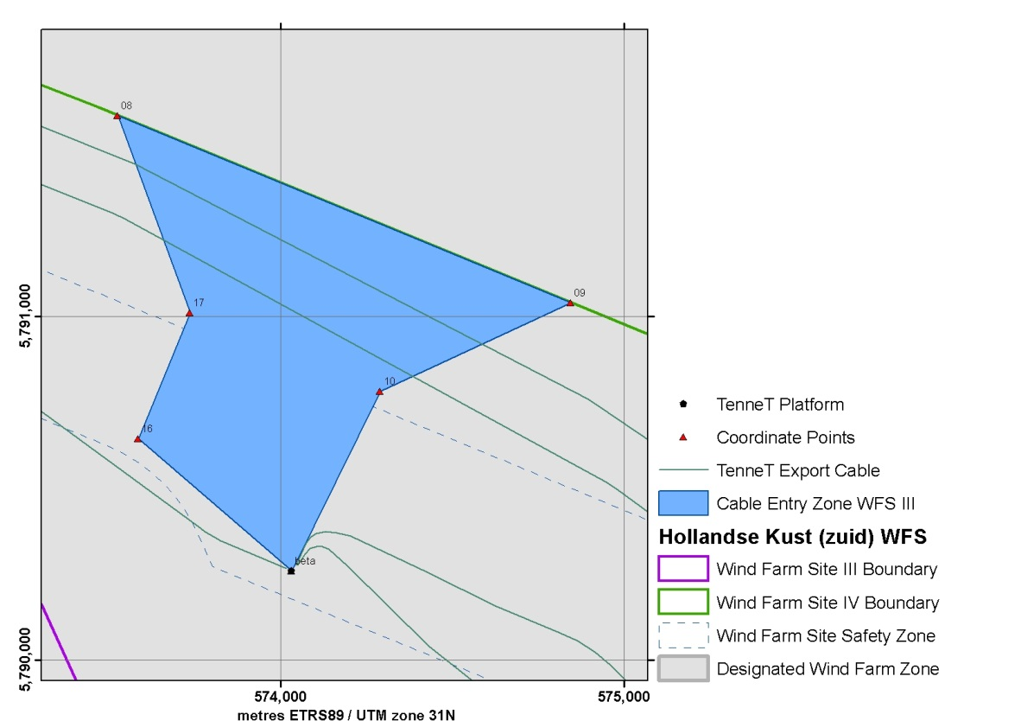
Figure 16 Cable Entry Zone HKZWFS IV

Cable Entry Zone HKZWFS IV
 | UTM |  |  |  | UTM
 | (ETRS89, zone 31) |  |  |  | (ETRS89, zone 31)
Point No. | Easting | Northing |  | Point No. | Easting | Northing
CE_08 | 573,526.2 | 5,791,584.9 |  | TOS_02 | 574,032.2 | 5,790,258.7
CE_09 | 574,845.9 | 5,791,040.3 |  | CE_16 | 573,585.8 | 5,790,644.5
CE_10 | 574,291.3 | 5,790,781.7 |  | CE_17 | 573,737.0 | 5,791,010.4
Table 18 Coordinates of the infield cable entry zone HKZWFS IV

Possible archaeological objects and magnetic anomalies

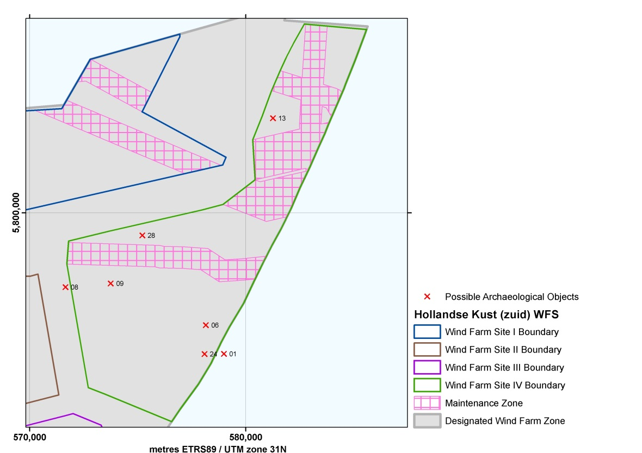
Figure 17 Possible Archaeological Objects in HKZWFS IV

Possible Archaeological Objects in HKZWFS IV
Point No. | Easting | Northing |  | Point No. | Easting | Northing
AV_01  (NCN-253) | 578,989.2 | 5,793,459.3 |  | AV_13  (NCN-1959) | 581,257.0 | 5,804,376.0
AV_06  (NCN-1934) | 578,156.0 | 5,794,786.0 |  | AV_24  (NCN-15198) | 578,092.0 | 5,793,448.0
AV_08  (NCN-1942) | 571,658.0 | 5,796,547.0 |  | AV_28 | 575,216.0 | 5,798,950.0
AV_09  (NCN-1943) | 573,754.0 | 5,796,722.0
Table 19 Coordinates of possible archaeological objects in HKZWFS IV (including references to the NCN database)

A buffer zone of 100 m should be applied around the few objects found which have yet to be determined to have no archaeological value, thereby prohibiting any activities in their locations. This also applies to cable trenching and anchorages of work vessels. Please note that the buffer zone may be reduced if it can be substantiated that the applied activity and disturbance has no effect on the (possible) archaeological object.

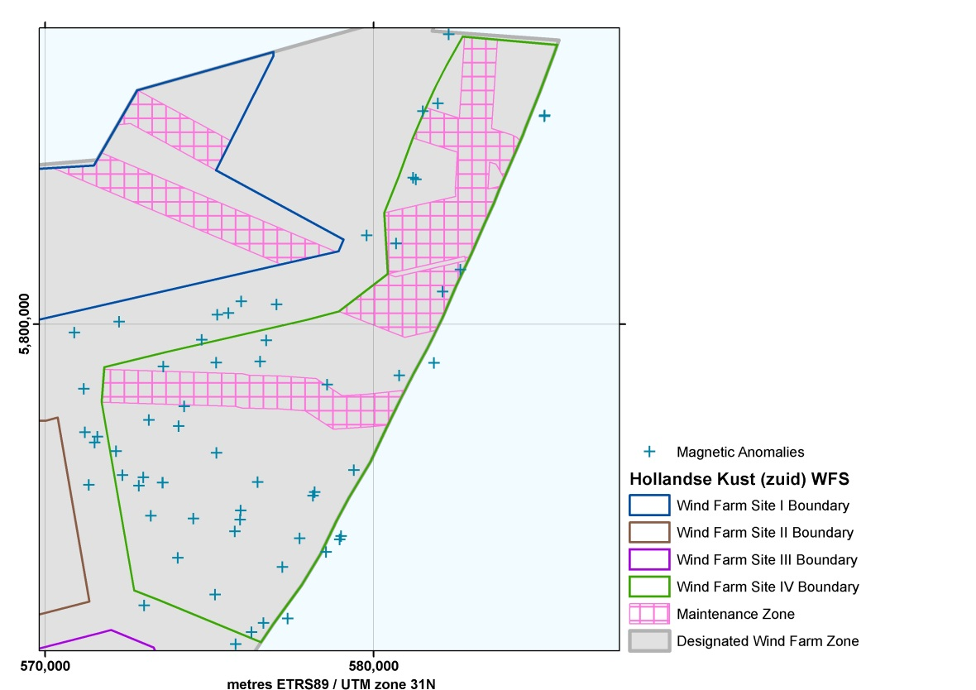
Figure 18 Magnetic Anomalies (possible buried ferrous objects) in HKZWFS IV

Magnetic Anomalies in HKZWFS IV
Point No. | Easting | Northing |  | Point No. | Easting | Northing
MA_184 | 571,179.0 | 5,798,028.0 |  | MA_215 | 581,502.0 | 5,806,463.0
MA_185 | 570,887.0 | 5,799,738.0 |  | MA_216 | 585,196.0 | 5,806,315.0
MA_186 | 572,255.0 | 5,800,063.0 |  | MA_217 | 585,206.0 | 5,806,337.0
MA_187 | 579,786.0 | 5,802,686.0 |  | MA_218 | 578,550.0 | 5,793,062.0
MA_188 | 571,330.0 | 5,795,099.0 |  | MA_219 | 582,640.0 | 5,801,644.0
MA_189 | 572,850.0 | 5,795,077.0 |  | MA_220 | 577,384.0 | 5,791,042.0
MA_190 | 578,582.0 | 5,798,154.0 |  | MA_221 | 582,103.0 | 5,800,979.0
MA_191 | 577,040.0 | 5,800,593.0 |  | MA_222 | 579,398.0 | 5,795,549.0
MA_192 | 575,238.0 | 5,800,278.0 |  | MA_223 | 580,774.0 | 5,798,433.0
MA_193 | 574,035.0 | 5,792,881.0 |  | MA_224 | 576,648.0 | 5,790,899.0
MA_194 | 575,204.0 | 5,798,822.0 |  | MA_225 | 577,749.0 | 5,793,478.0
MA_195 | 574,233.0 | 5,797,487.0 |  | MA_226 | 578,155.0 | 5,794,772.0
MA_196 | 575,583.0 | 5,800,331.0 |  | MA_227 | 578,207.0 | 5,794,881.0
MA_197 | 571,208.0 | 5,796,706.0 |  | MA_228 | 580,686.0 | 5,802,445.0
MA_198 | 575,170.0 | 5,791,763.0 |  | MA_229 | 581,283.0 | 5,804,388.0
MA_199 | 581,203.0 | 5,804,441.0 |  | MA_230 | 575,951.0 | 5,794,326.0
MA_200 | 581,951.0 | 5,806,703.0 |  | MA_231 | 574,508.0 | 5,794,080.0
MA_201 | 575,938.0 | 5,794,046.0 |  | MA_232 | 576,731.0 | 5,799,495.0
MA_202 | 575,770.0 | 5,793,692.0 |  | MA_233 | 573,213.0 | 5,794,161.0
MA_203 | 573,017.0 | 5,791,437.0 |  | MA_234 | 573,575.0 | 5,795,169.0
MA_204 | 575,218.0 | 5,796,074.0 |  | MA_235 | 573,577.0 | 5,795,170.0
MA_205 | 576,542.0 | 5,798,852.0 |  | MA_236 | 573,159.0 | 5,797,079.0
MA_206 | 581,835.0 | 5,798,810.0 |  | MA_237 | 572,354.0 | 5,795,402.0
MA_207 | 578,964.0 | 5,793,446.0 |  | MA_238 | 572,158.0 | 5,796,131.0
MA_208 | 579,011.0 | 5,793,544.0 |  | MA_239 | 573,595.0 | 5,798,703.0
MA_209 | 575,795.0 | 5,790,260.0 |  | MA_240 | 571,594.0 | 5,796,569.0
MA_210 | 576,283.0 | 5,790,622.0 |  | MA_241 | 571,506.0 | 5,796,388.0
MA_211 | 577,225.0 | 5,792,602.0 |  | MA_242 | 572,988.0 | 5,795,334.0
MA_212 | 582,283.0 | 5,808,799.0 |  | MA_243 | 574,064.0 | 5,796,888.0
MA_213 | 576,472.0 | 5,795,184.0 |  | MA_244 | 575,968.0 | 5,800,684.0
MA_214 | 575,931.0 | 5,794,047.0 |  | MA_245 | 574,770.0 | 5,799,514.0
Table 20 Coordinates of the magnetic anomalies (possible buried ferrous objects) in
HKZWFS II

Whilst installing wind turbines and the various infield and export cables, developers are advised to avoid areas where magnetic anomalies have been identified, again by implementing a 100 m buffer zone.

TenneT infrastructure
Please Note: the location of Platform Beta and the coordinates of the Cable Entry Zone for HKZWFS III and IV are final.

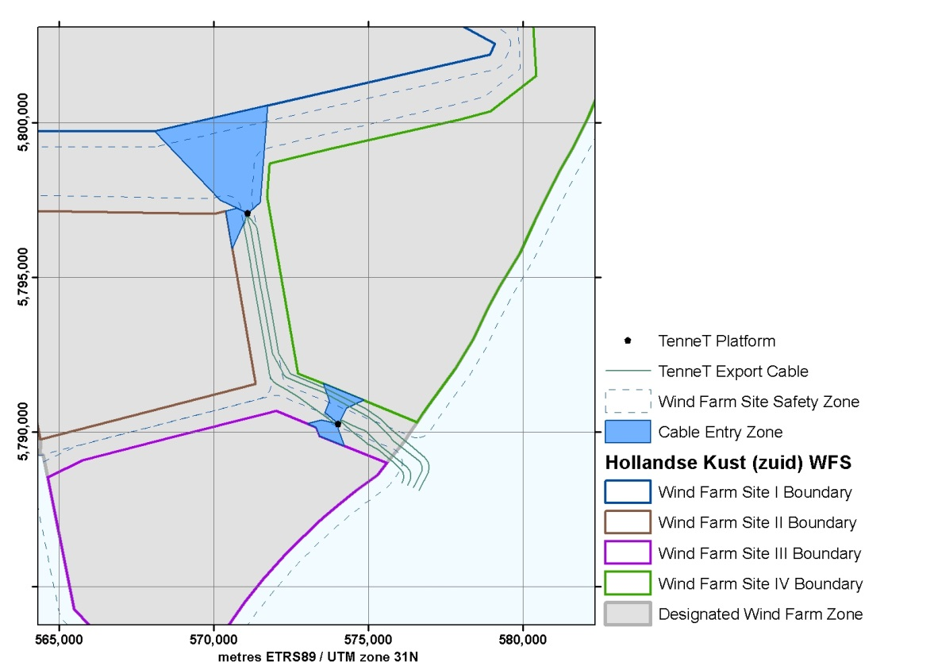
Figure 19 TenneT Platforms Alpha and Beta, the export and redundancy cable routes and the infield cable corridors in the HKZWFZ

TenneT Platforms

TenneT Platforms Alpha and Beta
Point No. | Easting | Northing |  | Point No. | Easting | Northing
TOS_01 | 571,100.0 | 5,797,090.0 |  | TOS_02 | 574,032.2 | 5,790,258.7
Table 21 Coordinates of the TenneT Platforms Alpha and Beta in the HKZWFZ

Existing infrastructure - cables and pipelines

Cables and pipelines

There are several existing and planned cables and pipelines (both active and inactive) crossing the HKZWFZ. This includes the planned COAM cable, for which a permit has now been granted. The coordinates for the COAM cable shown in the Table are based on the permit conditions. Those for all other cables and pipelines listed in the other tables below are based on as laid data which have been verified on the basis of the results from the geophysical survey of the HKZWFZ completed in 2016. (Please see: http://offshorewind.rvo.nl/studieszh).
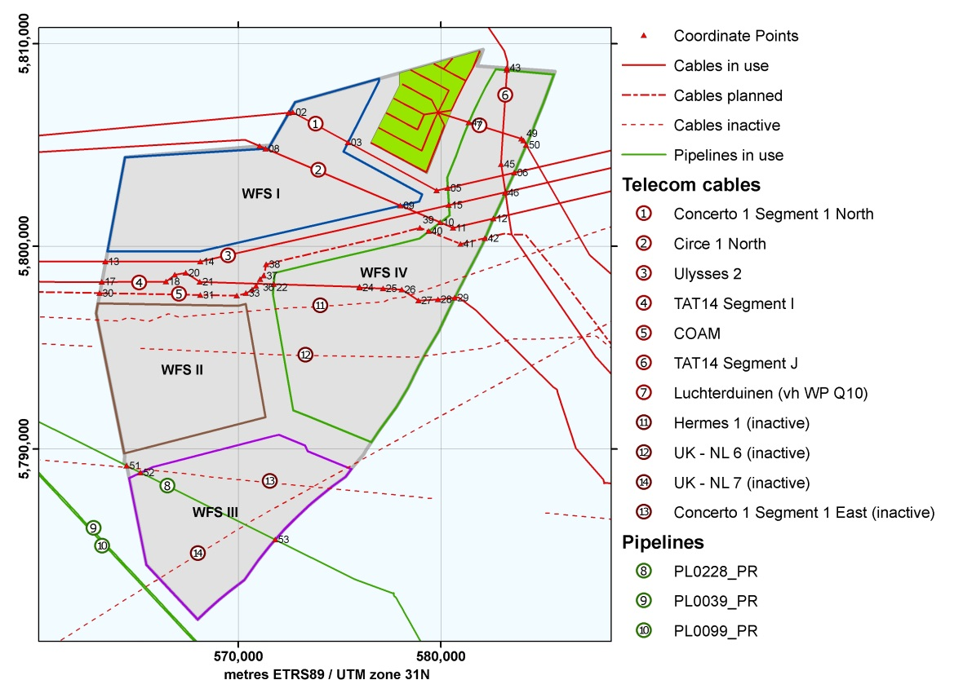
Figure 20 Active and inactive cables and pipes in and near the HKZWFZ

Cables in use
 | Name | Route | Material | Type | Status
1 | Concerto 1 Segment 1 North | Zandvoort (NL) to Sizewell (GB) | Fibre Optic | Telecom | In use
2 | Circe 1 North | Zandvoort (NL) to Lowesoft (GB) | Fibre Optic | Telecom | In use
3 | Ulysses 2 | IJmuiden (NL) to Lowesoft (GB) | Fibre Optic | Telecom | In use
4 | TAT14 Segment I | Katwijk (NL) to Saint Valery en Caux (F) | Fibre Optic | Telecom | In use
5 | COAM | Cork (IR) to Katwijk (NL) | Fibre Optic | Telecom | Planned
6 | TAT14 Segment J | Katwijk (NL) to Norden (D) | Fibre Optic | Telecom | In use
7 | Luchterduinen | Noordwijk (NL) to Luchterduinen (NL) | Copper | Electricity | In use
Table 22 Existing active pipelines in the HKZWFZ

Pipelines in use
 | Name | Route | Material | Type | Status
8 | PL0228_PR | Q13a-A to P15-C | Pipeline | Oil | In use
9 | PL0039_PR | P15-C to Hoek van Holland (NL) | Pipeline | Oil | In use
10 | PL0099_PR | P15-D to Maasvlakte (NL) | Pipeline | Gas | In use
Table 23 Existing active pipelines in the HKZWFZ

Cables inactive
 | Name | Route | Material | Type | Status
11 | Hermes 1 | Zandvoort (NL) to Aldeburgh (GB) | Fibre Optic | Telecom | Inactive
12 | UK - NL 6 | Katwijk (NL) to Covehithe (GB) | Coaxial | Telecom | Inactive
13 | UK - NL 7 | Katwijk (NL) to Covehithe (GB) | Coaxial | Telecom | Inactive
14 | Concerto 1 Segment 1 East | Zandvoort (NL) to Zeebrugge (B) | Fibre Optic | Telecom | Inactive
Table 24 Existing inactive cables in the HKZWFZ

(1) Concerto I
Point No. | Easting | Northing |  | Point No. | Easting | Northing
CP_01 | 572,504.1 | 5,806,593.0 |  | CP_04 | 579,793.6 | 5,802,750.4
CP_02 | 572,695.1 | 5,806,610.2 |  | CP_05 | 580,348.2 | 5,802,877.4
CP_03 | 575,422.9 | 5,805,127.0 |  | CP_06 | 583,640.5 | 5,803,632.6
Table 25 Coordinates for the Concerto I telecom cable

(2) Circe 1
Point No. | Easting | Northing |  | Point No. | Easting | Northing
CP_07 | 571,058.4 | 5,804,947.2 |  | CP_10 | 579,975.6 | 5,801,180.2
CP_08 | 571,365.9 | 5,804,817.2 |  | CP_11 | 580,618.3 | 5,800,909.4
CP_09 | 578,018.1 | 5,802,006.2 |  | CP_12 | 582,610.4 | 5,801,373.7
Table 26 Coordinates for the Circe I telecom cable

(3) Ulysses 2
Point No. | Easting | Northing |  | Point No. | Easting | Northing
CP_13 | 563,453.0 | 5,799,242.9 |  | CP_15 | 580,400.4 | 5,802,036.2
CP_14 | 568,134.0 | 5,799,244.3 |  | CP_16 | 583,205.1 | 5,802,676.1
Table 27 Coordinates for the Ulysses 2 telecom cable

(4) TAT14 Segment I
segment I | Easting | Northing |  | Point No. | Easting | Northing
CP_17 | 563,267.5 | 5,798,237.3 |  | CP_24 | 576,008.6 | 5,797,951.0
CP_18 | 566,441.4 | 5,798,257.7 |  | CP_25 | 577,164.5 | 5,797,920.8
CP_19 | 566,870.7 | 5,798,599.2 |  | CP_26 | 578,081.3 | 5,797,855.5
CP_20 | 567,422.6 | 5,798,691.9 |  | CP_27 | 578,908.8 | 5,797,315.2
CP_21 | 568,112.6 | 5,798,241.6 |  | CP_28 | 579,865.7 | 5,797,375.1
CP_22 | 571,753.5 | 5,798,126.9 |  | CP_29 | 580,688.9 | 5,797,461.1
CP_23 | 575,993.3 | 5,797,993.4
Table 28 Coordinates for the TAT14 Segment I telecom cable

(5) COAM
Point No. | Easting | Northing |  | Point No. | Easting | Northing
CP_30 | 563,165.8 | 5,797,686.0 |  | CP_37 | 571,264.1 | 5,798,548.7
CP_31 | 568,139.2 | 5,797,592.1 |  | CP_38 | 571,380.1 | 5,799,105.1
CP_32 | 569,942.2 | 5,797,560.2 |  | CP_39 | 578,972.9 | 5,800,911.0
CP_33 | 570,387.0 | 5,797,680.2 |  | CP_40 | 579,403.7 | 5,800,741.0
CP_34 | 570,698.1 | 5,797,861.0 |  | CP_41 | 580,983.8 | 5,800,117.3
CP_35 | 570,879.7 | 5,798,039.9 |  | CP_42 | 582,187.3 | 5,800,399.6
CP_36 | 571,088.2 | 5,798,379.6
Table 29 Coordinates for the planned COAM telecom cable

(6) TAT14 Segment J
segment J | Easting | Northing |  | Point No. | Easting | Northing
CP_43 | 583,272.2 | 5,808,803.4 |  | CP_45 | 582,977.8 | 5,804,053.6
CP_44 | 583,265.3 | 5,808,693.8 |  | CP_46 | 583,190.4 | 5,802,642.5
Table 30 Coordinates for the TAT14 Segment J telecom cable

(7) Export cable WP Luchterduinen
Point No. | Easting | Northing |  | Point No. | Easting | Northing
CP_47 | 581,387.5 | 5,806,113.7 |  | CP_49 | 584,090.7 | 5,805,223.3
CP_48 | 583,988.2 | 5,805,306.4 |  | CP_50 | 584,219.2 | 5,805,003.0
Table 31 Coordinates for the electricity export cable from the Luchterduinen Wind Farm

PL0228_PR
Point No. | Easting | Northing |  | Point No. | Easting | Northing
CP_51 | 564,490.7 | 5,789,168.8 |  | CP_53 | 571,831.8 | 5,785,515.8
CP_52 | 565,186.9 | 5,788,822.4
Table 32 Coordinates for the PL0228_PR oil pipeline

Wind turbines in existing nearby wind farms
Three existing wind farms are located in the vicinity of the HKZWFZ. Windfarm Luchterduinen is located within the HKZWFZ, the wind farms Prinses Amaliawindpark and Offshore Wind Farm Egmond aan Zee are situated north of the HKZWFZ, where the Prinses Amaliawindpark is located in the Hollandse Kust (noord) Wind Farm Zone (HKNWFZ). The coordinates and information of the wind turbines in these wind farms are presented in the tables in this section. For Windfarm Luchterduinen the coordinates of the outer boundary and safety zone are presented as well.

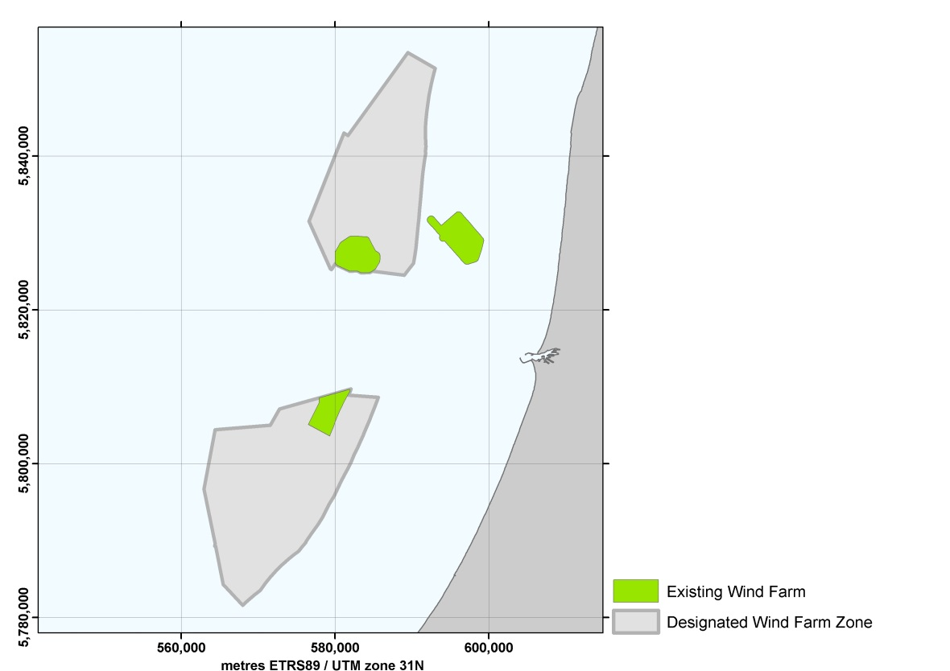
Figure 21 Existing wind farms in the vicinity of HKZWFZ

Wind Farm Luchterduinen
Point No. | Easting | Northing |  | Point No. | Easting | Northing
LD_01 | 577,939.9 | 5,808,557.4 |  | LD_09 | 580,284.0 | 5,806,079.3
LD_02 | 581,937.0 | 5,809,676.3 |  | LD_10 | 580,057.0 | 5,805,487.3
LD_03 | 581,980.0 | 5,809,460.3 |  | LD_11 | 579,833.0 | 5,804,860.3
LD_04 | 581,773.0 | 5,809,130.3 |  | LD_12 | 579,388.0 | 5,803,754.3
LD_05 | 581,328.0 | 5,808,327.3 |  | LD_13 | 579,321.0 | 5,803,577.3
LD_06 | 580,984.0 | 5,807,650.3 |  | LD_14 | 576,527.3 | 5,805,095.7
LD_07 | 580,703.0 | 5,807,053.3 |  | LD_15 | 577,960.5 | 5,807,935.4
LD_08 | 580,561.0 | 5,806,743.3 |  | LD_16 | 577,939.9 | 5,808,557.4
Table 33 Coordinates of the boundary of the Luchterduinen Wind Farm (43 Vestas V112 3MW turbines, hub height 81m (LAT))

Safety Zone Wind Farm Luchterduinen
Point No. | Easting | Northing |  | Point No. | Easting | Northing
LS_01 | 581,802.2 | 5,810,157.6 |  | LS_14 | 580,296.7 | 5,804,673.7
LS_02 | 582,073.3 | 5,810,157.2 |  | LS_15 | 579,853.6 | 5,803,572.5
LS_03 | 582,304.2 | 5,810,015.4 |  | LS_16 | 579,788.5 | 5,803,400.3
LS_04 | 582,427.2 | 5,809,773.9 |  | LS_17 | 579,621.9 | 5,803,178.2
LS_05 | 582,470.2 | 5,809,557.9 |  | LS_18 | 579,362.4 | 5,803,079.2
LS_06 | 582,403.4 | 5,809,194.6 |  | LS_19 | 579,082.3 | 5,803,138.1
LS_07 | 582,287.0 | 5,809,007.9 |  | LS_20 | 576,288.6 | 5,804,656.5
LS_08 | 581,769.5 | 5,808,092.8 |  | LS_21 | 576,050.1 | 5,804,946.6
LS_09 | 581,433.0 | 5,807,430.6 |  | LS_22 | 576,081.0 | 5,805,320.9
LS_10 | 581,156.4 | 5,806,842.8 |  | LS_23 | 577,456.7 | 5,808,046.5
LS_11 | 581,019.0 | 5,806,542.9 |  | LS_24 | 577,440.7 | 5,808,530.9
LS_12 | 580,748.1 | 5,805,893.5 |  | LS_25 | 577,534.9 | 5,808,850.5
LS_13 | 580,525.8 | 5,805,313.7 |  | LS_26 | 577,809.9 | 5,809,040.1
Table 34 Coordinates of the safety zone of the Luchterduinen Wind Farm

Luchterduinen Wind Farm
Point No. | Easting | Northing |  | Point No. | Easting | Northing
NW_01 | 579,282.2 | 5,803,658.3 |  | NW_23 | 578,169.2 | 5,807,039.2
NW_02 | 578,737.2 | 5,803,948.3 |  | NW_24 | 577,666.2 | 5,807,306.2
NW_03 | 578,191.2 | 5,804,238.3 |  | NW_25 | 580,524.2 | 5,806,709.2
NW_04 | 577,645.2 | 5,804,529.3 |  | NW_26 | 580,037.2 | 5,806,968.2
NW_05 | 577,100.2 | 5,804,819.3 |  | NW_27 | 579,550.2 | 5,807,227.2
NW_06 | 576,554.2 | 5,805,110.3 |  | NW_28 | 579,063.2 | 5,807,486.2
NW_07 | 579,584.2 | 5,804,435.3 |  | NW_29 | 578,575.2 | 5,807,745.2
NW_08 | 579,053.2 | 5,804,718.3 |  | NW_30 | 578,088.2 | 5,808,005.2
NW_09 | 578,521.2 | 5,805,000.3 |  | NW_31 | 580,867.2 | 5,807,450.2
NW_10 | 577,990.2 | 5,805,283.3 |  | NW_32 | 580,392.2 | 5,807,703.2
NW_11 | 577,458.2 | 5,805,566.3 |  | NW_33 | 579,917.2 | 5,807,955.2
NW_12 | 576,927.2 | 5,805,849.3 |  | NW_34 | 579,442.2 | 5,808,207.2
NW_13 | 579,889.2 | 5,805,212.3 |  | NW_35 | 578,968.2 | 5,808,460.2
NW_14 | 579,372.2 | 5,805,487.2 |  | NW_36 | 578,493.2 | 5,808,712.2
NW_15 | 578,855.2 | 5,805,762.3 |  | NW_37 | 581,237.2 | 5,808,169.2
NW_16 | 578,337.2 | 5,806,037.2 |  | NW_38 | 580,640.2 | 5,808,486.2
NW_17 | 577,820.2 | 5,806,312.2 |  | NW_39 | 580,144.2 | 5,808,749.2
NW_18 | 577,303.2 | 5,806,588.2 |  | NW_40 | 579,648.2 | 5,809,013.2
NW_19 | 580,182.2 | 5,805,968.3 |  | NW_41 | 581,601.5 | 5,808,840.7
NW_20 | 579,678.2 | 5,806,236.2 |  | NW_42 | 580,591.4 | 5,809,287.2
NW_21 | 579,175.2 | 5,806,503.3 |  | NW_43 | 581,920.2 | 5,809,650.2
NW_22 | 578,672.2 | 5,806,771.2
Table 35 Coordinates of the wind turbines installed at the Luchterduinen Wind Farm (43 Vestas 3 MW V112 turbines, hub height 81 m (LAT))

Princess Amalia Wind Farm
Point No. | Easting | Northing |  | Point No. | Easting | Northing
NW_44 | 584,022.0 | 5,829,007.0 |  | NW_74 | 584,887.0 | 5,826,200.0
NW_45 | 583,071.0 | 5,829,056.0 |  | NW_75 | 581,041.1 | 5,827,763.0
NW_46 | 583,532.0 | 5,828,757.0 |  | NW_76 | 581,523.0 | 5,827,499.0
NW_47 | 583,994.0 | 5,828,458.0 |  | NW_77 | 582,005.1 | 5,827,235.0
NW_48 | 584,455.0 | 5,828,159.0 |  | NW_78 | 582,488.1 | 5,826,971.0
NW_49 | 582,103.0 | 5,829,063.0 |  | NW_79 | 582,970.0 | 5,826,707.0
NW_50 | 582,570.0 | 5,828,772.0 |  | NW_80 | 583,452.0 | 5,826,443.0
NW_51 | 583,037.0 | 5,828,481.0 |  | NW_81 | 583,935.0 | 5,826,179.0
NW_52 | 583,503.0 | 5,828,191.0 |  | NW_82 | 584,417.0 | 5,825,915.0
NW_53 | 583,970.0 | 5,827,900.0 |  | NW_83 | 584,900.0 | 5,825,651.0
NW_54 | 584,437.0 | 5,827,608.0 |  | NW_84 | 580,531.1 | 5,827,405.0
NW_55 | 584,904.0 | 5,827,318.0 |  | NW_85 | 581,019.1 | 5,827,150.0
NW_56 | 585,371.0 | 5,827,027.0 |  | NW_86 | 581,506.1 | 5,826,895.0
NW_57 | 581,585.1 | 5,828,734.0 |  | NW_87 | 581,993.0 | 5,826,640.0
NW_58 | 582,057.0 | 5,828,452.0 |  | NW_88 | 582,481.0 | 5,826,385.0
NW_59 | 582,529.0 | 5,828,170.0 |  | NW_89 | 582,968.0 | 5,826,130.0
NW_60 | 583,002.0 | 5,827,888.0 |  | NW_90 | 583,455.0 | 5,825,875.0
NW_61 | 583,474.0 | 5,827,606.0 |  | NW_91 | 583,942.0 | 5,825,620.0
NW_62 | 583,946.0 | 5,827,323.0 |  | NW_92 | 584,430.0 | 5,825,365.0
NW_63 | 584,418.0 | 5,827,041.0 |  | NW_93 | 580,527.1 | 5,826,802.0
NW_64 | 584,890.0 | 5,826,759.0 |  | NW_94 | 581,019.1 | 5,826,556.0
NW_65 | 585,362.0 | 5,826,477.0 |  | NW_95 | 581,511.0 | 5,826,310.0
NW_66 | 581,068.1 | 5,828,385.0 |  | NW_96 | 582,002.1 | 5,826,064.0
NW_67 | 581,545.0 | 5,828,111.0 |  | NW_97 | 582,494.0 | 5,825,818.0
NW_68 | 582,024.0 | 5,827,839.0 |  | NW_98 | 582,986.0 | 5,825,571.0
NW_69 | 582,500.0 | 5,827,566.0 |  | NW_99 | 583,478.0 | 5,825,325.0
NW_70 | 582,978.0 | 5,827,293.0 |  | NW_100 | 580,547.1 | 5,826,228.0
NW_71 | 583,455.0 | 5,827,020.0 |  | NW_101 | 581,043.1 | 5,825,990.0
NW_72 | 583,932.0 | 5,826,747.0 |  | NW_102 | 581,539.1 | 5,825,752.0
NW_73 | 584,410.0 | 5,826,473.0 |  | NW_103 | 582,035.1 | 5,825,515.0
Table 36 Coordinates of the wind turbines installed at the Prinses Amaliawindpark (60 Vestas 2 MW V80 turbines, hub height 59 m (LAT))

Offshore Wind Farm Egmond aan Zee (OWEZ)
Point No. | Easting | Northing |  | Point No. | Easting | Northing
NW_104 | 597,181.1 | 5,826,380.1 |  | NW_122 | 595,384.1 | 5,829,940.1
NW_105 | 596,756.1 | 5,826,863.1 |  | NW_123 | 594,959.1 | 5,830,424.1
NW_106 | 596,339.1 | 5,827,338.1 |  | NW_124 | 594,534.1 | 5,830,908.1
NW_107 | 595,914.1 | 5,827,822.1 |  | NW_125 | 598,548.1 | 5,827,853.1
NW_108 | 595,490.1 | 5,828,305.1 |  | NW_126 | 598,119.1 | 5,828,338.1
NW_109 | 595,065.1 | 5,828,789.1 |  | NW_127 | 597,695.1 | 5,828,826.1
NW_110 | 594,633.1 | 5,829,281.1 |  | NW_128 | 597,038.1 | 5,829,572.1
NW_111 | 594,208.1 | 5,829,764.1 |  | NW_129 | 596,560.1 | 5,830,116.1
NW_112 | 593,783.1 | 5,830,248.1 |  | NW_130 | 596,135.1 | 5,830,600.1
NW_113 | 593,366.1 | 5,830,739.1 |  | NW_131 | 595,710.1 | 5,831,084.1
NW_114 | 592,933.1 | 5,831,216.1 |  | NW_132 | 595,285.1 | 5,831,568.1
NW_115 | 592,508.1 | 5,831,700.1 |  | NW_133 | 598,868.1 | 5,828,998.1
NW_116 | 598,189.1 | 5,826,748.1 |  | NW_134 | 598,446.1 | 5,829,486.1
NW_117 | 597,764.1 | 5,827,232.1 |  | NW_135 | 597,796.1 | 5,830,224.1
NW_118 | 597,339.1 | 5,827,715.1 |  | NW_136 | 597,312.1 | 5,830,776.1
NW_119 | 596,914.1 | 5,828,199.1 |  | NW_137 | 596,887.1 | 5,831,260.1
NW_120 | 596,234.1 | 5,828,973.1 |  | NW_138 | 596,462.1 | 5,831,744.1
NW_121 | 595,809.1 | 5,829,457.1 |  | NW_139 | 596,037.1 | 5,832,228.1
Table 37 Coordinates of the wind turbines installed at the Offshore Wind Farm Egmond aan Zee (36 Vestas 3 MW V90 turbines, hub height 70 m (MSL))

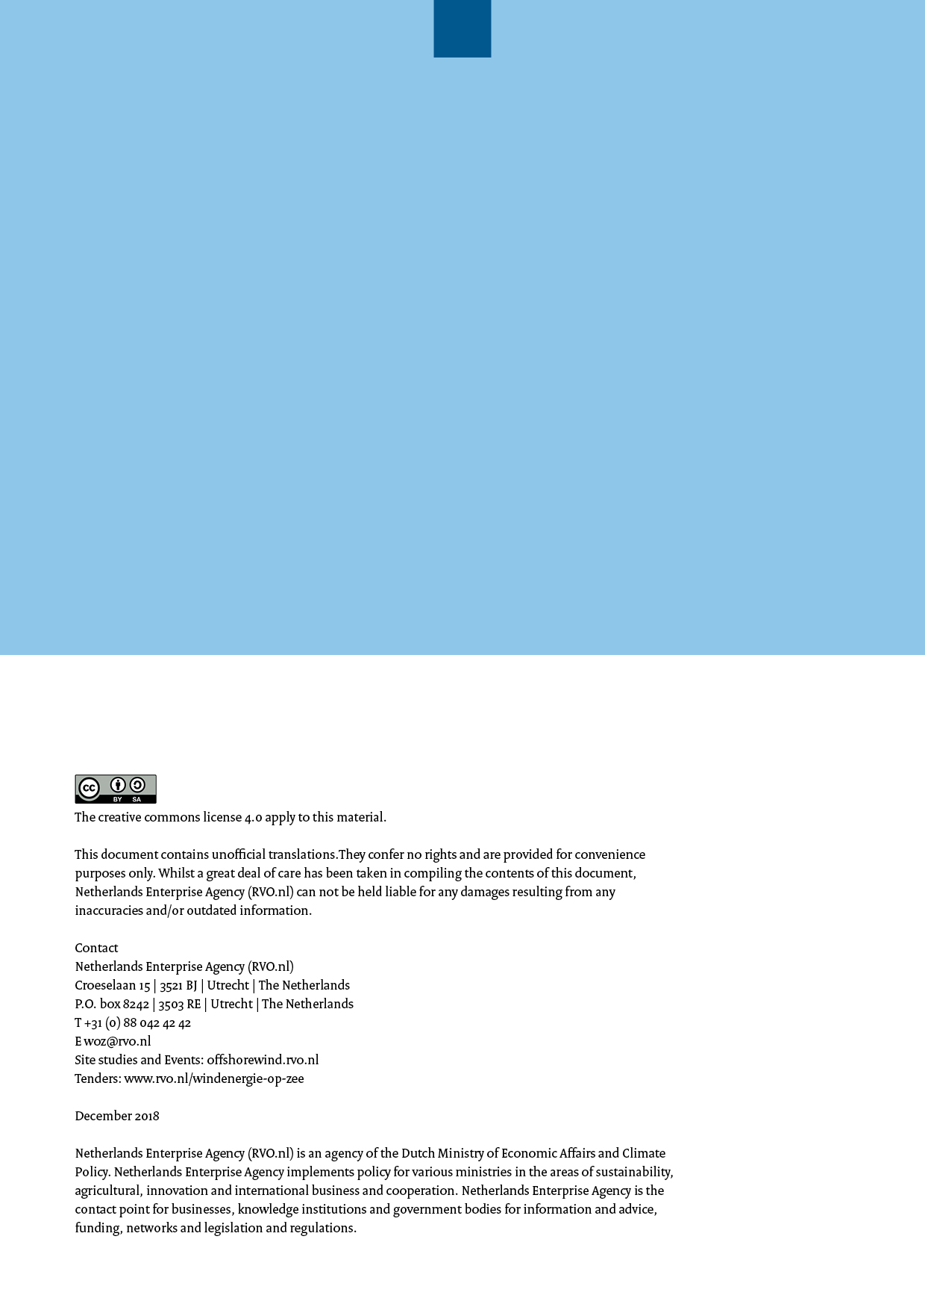

The Dutch Nationaal Contact Nummer database, see archaeological assessment of geophysical survey results (phase II) see: http://offshorewind.rvo.nl/studieszh

