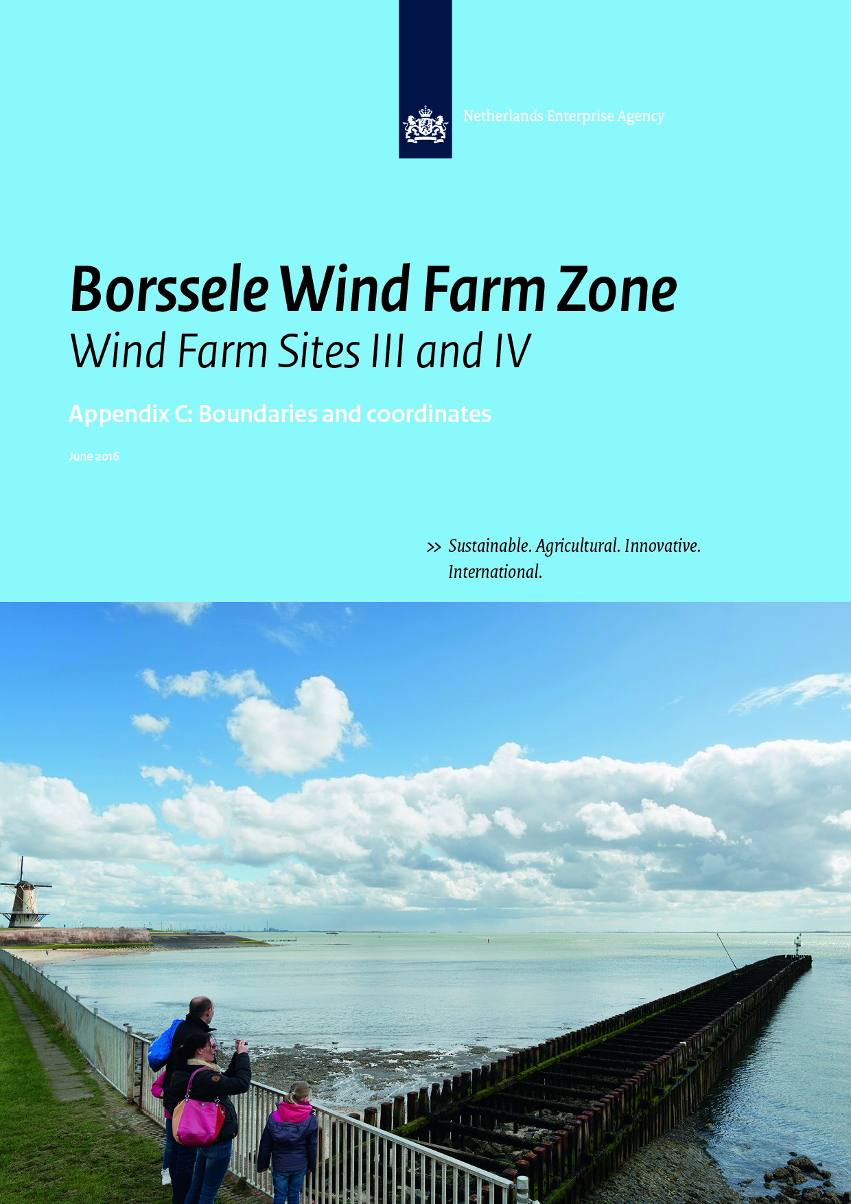
Colophon
Project name | Site Studies Borssele Wind Farm Zone
Version | June 2016
File name | 20160620_SDB_RVO_Boundaries_and_Coordinates_Borssele_WFZ_v3.docx
Project manager | Ruud de Bruijne
Annex(es) | -
Authors | R. van der Heijden (RVO.nl)
Reviewed | Rene van ’t Hart (RWS); Ruud de Bruijne (RVO.nl)
Approved | T. Collette (RWS)

Only the coordinates and boundaries in the final Wind Farm Site Decisions are legally binding. Nonetheless, please note that some coordinates published in the final Wind Farm Site Decisions documents need to be amended. In the summer of 2016 so-called ‘ontwerp wijzigingsbesluit’ (draft amending decision) is expected to be issued for BWFS III, IV and V. In these amending decisions the coordinates will be aligned with this Appendix.
Please note this Appendix confers no rights and is provided for convenience only.

Contents

1 Introduction 5
2 The Borssele Wind Farm Zone 7
3 Borssele Wind Farm Sites (BWFS’s) 8
4 Infrastructure 24
5 Shipping Corridor 31
6 Reference documents 33

Introduction

Purpose
The purpose of this memo is to establish the exact definition for the Borssele Wind Farm Sites (in Dutch: kavels) and the zone around each Wind Farm Site. The geographical information is based on the data available on November 2015.

Only the coordinates and boundaries in the final Wind Farm Site Decisions are legally binding. Nonetheless, please note that some coordinates published in the final Wind Farm Site Decisions documents need to be amended. In the summer of 2016 so-called ‘ontwerp wijzigingsbesluit’ (draft amending decision) is expected to be issued for BWFS III, IV and V. In these amending decisions the coordinates will be aligned with this Appendix.
Please note this Appendix confers no rights and is provided for convenience only.

Revisions
A general overview of the revisions compared to v2.1 issued February 2016:
- Only the UTM projection will be used from now on for WFS III, IV and V. In this memo also the geographical coordinates for WFS I and II have been removed for consistency reasons. Please note that the (irrevocable) Wind Farm Site Decisions I and II will not be amended.
- Figure and table 6 BWFS III Safety Zone: coordinates CP_23; CP_24; CP_25; CP_26 en SZ_36 added.
- Table 11.3 Cable Entry Zone BWFS III: coordinates P_88 and T_14 removed. Coordinate P_50 added.
- All tables: Coordinates sorted
- All descriptions: removed (to be found in the PSD main document)

Horizontal datum
The geodetic system used for horizontal projections is European Terrestrial Reference System 1989 (ETRS89).

For UTM projections the following is applicable
- Local datum European Datum (ETRS89)
- Central Meridian 3° E (Zone 31)

GIS Information
All coordinates given in this document correspond to GIS data that is made available by RVO through the MPK file of the BWFZ [1].

Coordinate numbering
The coordinates given in this document are numbered according to the following system (maintenance zones have not specifically been numbered since these zones are determined by the other elements that are specifically numbered):
- Coordinates that determine the boundaries of the Borssele Wind Farm Zone start with the letter code WFZ followed by an underscore and a number (WFZ_1, WFZ_2, …);
- Coordinates that determine the boundaries of the different parcels in the Borssele Wind Farm Zone start with the letter code P followed by an underscore and a number (P_1, P_2, …);
- Coordinates that determine the safety zone of the different wind farm sites in the Borssele Wind Farm Zone start with the letter code SZ followed by an underscore and a number (SZ_1, SZ_2, …);
- Coordinates that determine the location of the different cables and pipelines in the Borssele Wind Farm Zone start with the letter code CP followed by an underscore and a number (CP_1, CP_2, …);
- Coordinates that determine the locations of the TenneT infrastructure in the Borssele Wind Farm Zone start with the letter code T followed by an underscore and a number (T_1, T_2, …);
- Coordinates that determine the shipping corridor in the Borssele Wind Farm Zone start with the letter code SL followed by an underscore and a number (SL_1, SL_2, …).

The Borssele Wind Farm Zone

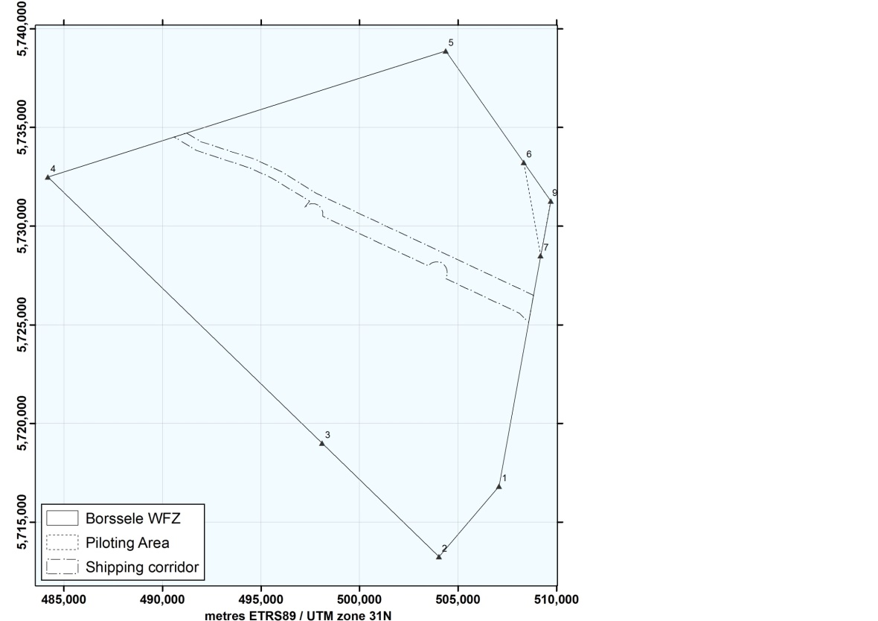
Figure 1 Overview of the Borssele Wind Farm Zone

BWFZ | UTM
 | (ETRS89, zone 31)
Point No. | Easting | Northing
WFZ_1 | 507,087.1 | 5,716,811.7
WFZ_2 | 504,039.6 | 5,713,246.1
WFZ_3 | 498,105.4 | 5,718,993.7
WFZ_4 | 484,178.5 | 5,732,482.8
WFZ_5 | 504,373.7 | 5,738,878.4
WFZ_6 | 508,339.0 | 5,733,222.4
WFZ_9 | 509,706.9 | 5,731,271.3
WFZ_7 | 509,197.8 | 5,728,498.9

Table 1 Coordinates of boundary points Borssele Wind Farm Zone

Borssele Wind Farm Sites (BWFS’s)
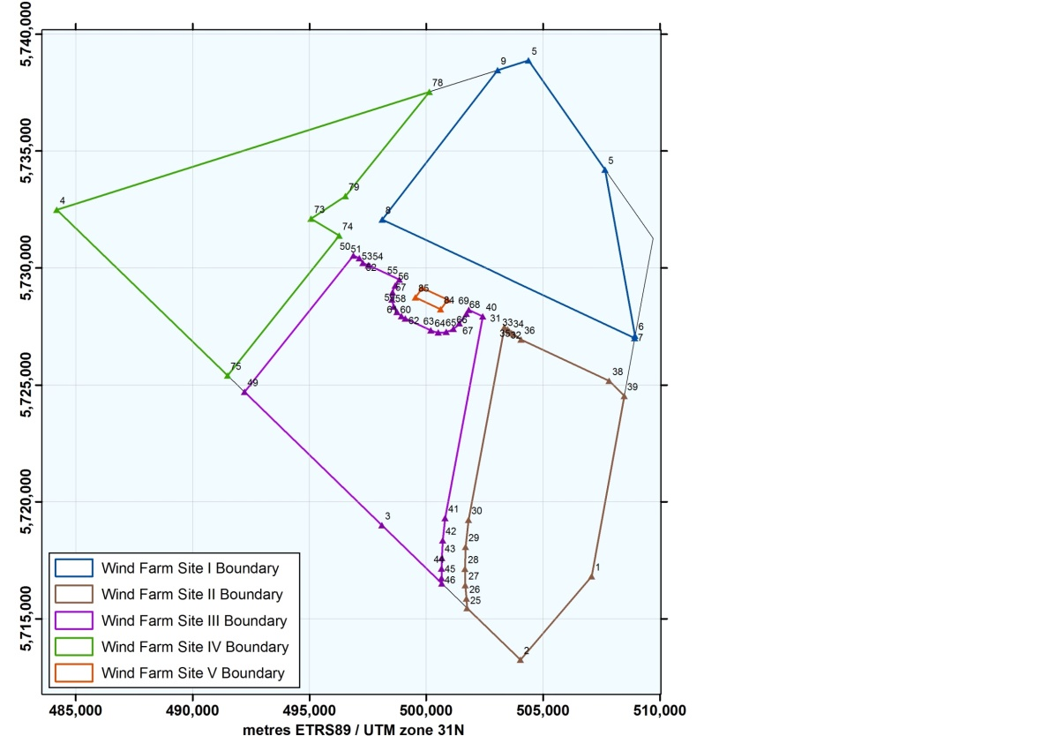
Figure 2 Overview of the Borssele Wind Farm Zone and Wind Farm Sites

Borssele Wind Farm Site I (BWFS I)

BWFS I | UTM
 | (ETRS89, zone 31)
Point No. | Easting | Northing
P_5 | 507,652.8 | 5,734,201.1
P_6 | 508,942.8 | 5,727,106.6
P_7 | 508,924.4 | 5,727,004.4
P_8 | 498,110.2 | 5,732,071.4
P_9 | 503,052.7 | 5,738,460.0
WFZ_5 | 504,373.7 | 5,738,878.4
Table 2.1 Coordinates of the Borssele Wind Farm Site I

Borssele Wind Farm Site II (BWFS II)

BWFS II | UTM
 | (ETRS89, zone 31)
Point No. | Easting | Northing
P_25 | 501,753.3 | 5,715,460.5
P_26 | 501,720.0 | 5,715,858.6
P_27 | 501,673.9 | 5,716,438.6
P_28 | 501,658.8 | 5,717,132.6
P_29 | 501,685.1 | 5,718,073.0
P_30 | 501,812.0 | 5,719,229.4
P_31 | 503,352.1 | 5,727,468.4
P_32 | 503,486.1 | 5,727,368.4
P_33 | 503,561.0 | 5,727,281.4
P_34 | 503,653.0 | 5,727,212.7
P_35 | 503,757.8 | 5,727,165.7
P_36 | 504,063.2 | 5,726,937.9
P_38 | 507,833.4 | 5,725,165.1
P_39 | 508,476.6 | 5,724,520.4
WFZ_1 | 507,087.1 | 5,716,811.7
WFZ_2 | 504,039.6 | 5,713,246.1
Table 2.2 Coordinates of the Borssele Wind Farm Site II

Borssele Wind Farm Sites III (BWFS III)

BWFS III | UTM
 | (ETRS89, zone 31)
Point No. | Easting | Northing
P_40 | 502,426.5 | 5,727,928.5
P_41 | 500,813.5 | 5,719,302.6
P_42 | 500,704.5 | 5,718,354.3
P_43 | 500,666.3 | 5,717,604.8
P_44 | 500,658.9 | 5,717,143.2
P_45 | 500,660.2 | 5,716,737.1
P_46 | 500,666.1 | 5,716,513.5
WFZ_3 | 498,105.4 | 5,718,993.7
P_49 | 492,218.7 | 5,724,695.4
P_50 | 496,881.0 | 5,730,532.8
P_51 | 497,139.9 | 5,730,411.2
P_52 | 497,289.1 | 5,730,215.2
P_53 | 497,518.6 | 5,730,107.2
P_54 | 497,575.3 | 5,730,099.1
P_55 | 498,850.7 | 5,729,499.4
P_56 | 498,670.2 | 5,729,247.3
P_57 | 498,558.1 | 5,728,957.4
P_58 | 498,540.2 | 5,728,647.2
P_59 | 498,618.2 | 5,728,346.4
P_60 | 498,752.8 | 5,728,122.6
P_61 | 498,940.6 | 5,727,941.3
P_62 | 499,109.6 | 5,727,840.0
P_63 | 500,195.7 | 5,727,329.7
P_64 | 500,520.8 | 5,727,240.4
P_65 | 500,857.1 | 5,727,263.6
P_66 | 501,166.7 | 5,727,397.2
P_67 | 501,420.7 | 5,727,634.5
P_68 | 501,721.8 | 5,728,035.7
P_69 | 501,826.6 | 5,728,210.6

Table 2.3 Coordinates of the Borssele Wind Farm Site III

Borssele Wind Farm Sites IV (BWFS IV)

BWFS IV | UTM
 | (ETRS89, zone 31)
Point No. | Easting | Northing
P_73 | 495,068.1 | 5,732,104.1
P_74 | 496,277.2 | 5,731,380.0
P_75 | 491,497.3 | 5,725,394.1
WFZ_4 | 484,178.5 | 5,732,482.8
P_78 | 500,129.9 | 5,737,534.4
P_79 | 496,541.5 | 5,733,070.9
Table 2.4 Coordinates of the Borssele Wind Farm Site IV

Borssele Wind Farm Sites V (BWFS V)

BWFS V | UTM
 | (ETRS89, zone 31)
Point No. | Easting | Northing
P_83 | 500,922.0 | 5,728,636.0
P_84 | 500,621.0 | 5,728,234.8
P_85 | 499,534.9 | 5,728,745.1
P_86 | 499,836.2 | 5,729,146.6
Table 2.5 Coordinates of the Borssele Wind Farm Site V

Borssele Wind Farm Sites and Parcels

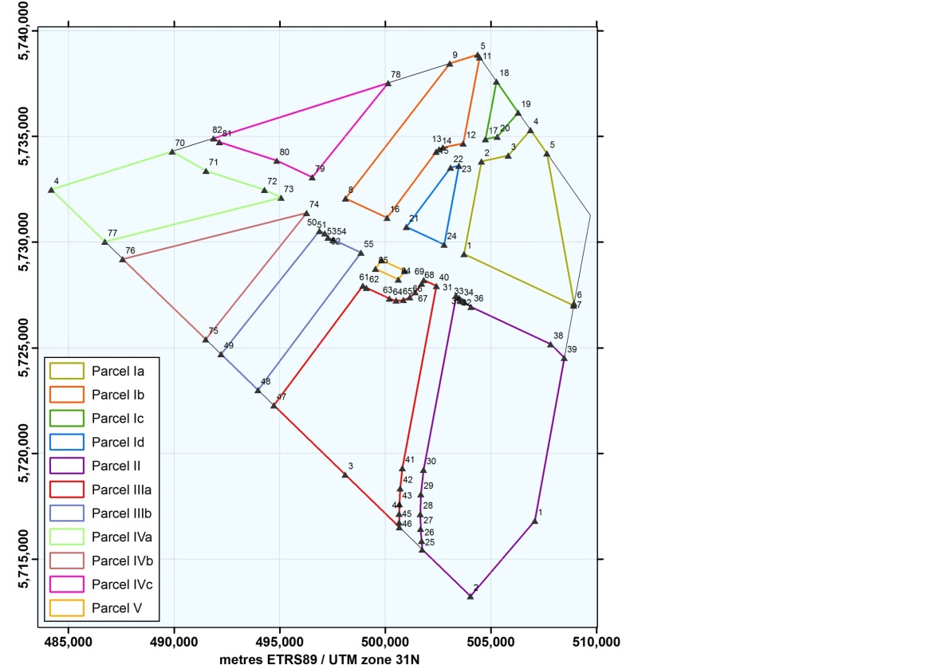
Figure 3 Parcels in the Borssele Wind Farm Sites

Parcel Ia | UTM
 | (ETRS89, zone 31)
Point No. | Easting | Northing
P_1 | 503,726.3 | 5,729,436.4
P_2 | 504,554.7 | 5,733,823.5
P_3 | 505,822.9 | 5,734,098.7
P_4 | 506,881.9 | 5,735,300.8
P_5 | 507,652.8 | 5,734,201.1
P_6 | 508,942.8 | 5,727,106.6
P_7 | 508,924.4 | 5,727,004.4
Table 3.1a Boundary points of parcel Ia

Parcel Ib | UTM
 | (ETRS89, zone 31)
Point No. | Easting | Northing
P_8 | 498,110.2 | 5,732,071.4
P_9 | 503,052.7 | 5,738,460.0
WFZ_5 | 504,373.7 | 5,738,878.4
P_11 | 504,463.3 | 5,738,750.6
P_12 | 503,691.5 | 5,734,672.8
P_13 | 502,732.4 | 5,734,476.1
P_14 | 502,543.5 | 5,734,391.2
P_15 | 502,414.0 | 5,734,276.6
P_16 | 500,084.5 | 5,731,151.3
Table 2.1b Boundary points of parcel Ib

Parcel Ic | UTM
 | (ETRS89, zone 31)
Point No. | Easting | Northing
P_17 | 504,746.4 | 5,734,877.4
P_18 | 505,263.0 | 5,737,609.9
P_19 | 506,301.9 | 5,736,128.1
P_20 | 505,304.3 | 5,734,995.0
Table 3.1c Boundary points of parcel Ic

Parcel Id | UTM
 | (ETRS89, zone 31)
Point No. | Easting | Northing
P_21 | 501,002.9 | 5,730,715.5
P_22 | 503,101.0 | 5,733,534.1
P_23 | 503,491.7 | 5,733,618.6
P_24 | 502,790.4 | 5,729,887.6
Table 3.1d Boundary points of parcel Id

Parcel II | UTM
 | (ETRS89, zone 31)
Point No. | Easting | Northing
P_25 | 501,753.3 | 5,715,460.5
P_26 | 501,720.0 | 5,715,858.6
P_27 | 501,673.9 | 5,716,438.6
P_28 | 501,658.8 | 5,717,132.6
P_29 | 501,685.1 | 5,718,073.0
P_30 | 501,812.0 | 5,719,229.4
P_31 | 503,352.1 | 5,727,468.4
P_32 | 503,486.1 | 5,727,368.4
P_33 | 503,561.0 | 5,727,281.4
P_34 | 503,653.0 | 5,727,212.7
P_35 | 503,757.8 | 5,727,165.7
P_36 | 504,063.2 | 5,726,937.9
P_38 | 507,833.4 | 5,725,165.1
P_39 | 508,476.6 | 5,724,520.4
WFZ_1 | 507,087.1 | 5,716,811.7
WFZ_2 | 504,039.6 | 5,713,246.1
Table 3.2 Boundary points of parcel II

Parcel IIIa | UTM
 | (ETRS89, zone 31)
Point No. | Easting | Northing
P_40 | 502,426.5 | 5,727,928.5
P_41 | 500,813.5 | 5,719,302.6
P_42 | 500,704.5 | 5,718,354.3
P_43 | 500,666.3 | 5,717,604.8
P_44 | 500,658.9 | 5,717,143.2
P_45 | 500,660.2 | 5,716,737.1
P_46 | 500,666.1 | 5,716,513.5
WFZ_3 | 498,105.4 | 5,718,993.7
P_47 | 494,719.1 | 5,722,273.6
P_61 | 498,940.6 | 5,727,941.3
P_62 | 499,109.6 | 5,727,840.0
P_63 | 500,195.7 | 5,727,329.7
P_64 | 500,520.8 | 5,727,240.4
P_65 | 500,857.1 | 5,727,263.6
P_66 | 501,166.7 | 5,727,397.2
P_67 | 501,420.7 | 5,727,634.5
P_68 | 501,721.8 | 5,728,035.7
P_69 | 501,826.6 | 5,728,210.6
Table 3.3a Boundary points of parcel IIIa

parcel IIIb | UTM
 | (ETRS89, zone 31)
Point No. | Easting | Northing
P_48 | 493,970.0 | 5,722,999.1
P_49 | 492,218.7 | 5,724,695.4
P_50 | 496,881.0 | 5,730,532.8
P_51 | 497,139.9 | 5,730,411.2
P_52 | 497,289.1 | 5,730,215.2
P_53 | 497,518.6 | 5,730,107.2
P_54 | 497,575.3 | 5,730,099.1
P_55 | 498,850.7 | 5,729,499.4
Table 3.3b Boundary points of parcel IIIb

Parcel IVa | UTM
 | (ETRS89, zone 31)
Point No. | Easting | Northing
P_70 | 489,907.4 | 5,734,297.1
P_71 | 491,506.1 | 5,733,381.0
P_72 | 494,277.3 | 5,732,475.8
P_73 | 495,068.1 | 5,732,104.1
P_77 | 486,719.0 | 5,730,022.2
WFZ_4 | 484,178.5 | 5,732,482.8
Table 3.4a Boundary points of parcel IVa

Parcel IVb | UTM
 | (ETRS89, zone 31)
Point No. | Easting | Northing
P_74 | 496,277.2 | 5,731,380.0
P_75 | 491,497.3 | 5,725,394.1
P_76 | 487,565.3 | 5,729,202.5
Table 3.4b Boundary points of parcel IVb

Parcel IVc | UTM
 | (ETRS89, zone 31)
Point No. | Easting | Northing
P_78 | 500,129.9 | 5,737,534.4
P_79 | 496,541.5 | 5,733,070.9
P_80 | 494,865.6 | 5,733,855.9
P_81 | 492,148.1 | 5,734,736.7
P_82 | 491,861.6 | 5,734,915.9
Table 3.4c Boundary points of parcel IVc

Parcel V | UTM
 | (ETRS89, zone 31)
Point No. | Easting | Northing
P_83 | 500,922.0 | 5,728,636.0
P_84 | 500,621.0 | 5,728,234.8
P_85 | 499,534.9 | 5,728,745.1
P_86 | 499,836.2 | 5,729,146.6
Table 3.5 Boundary points of parcel V

Safety Zones

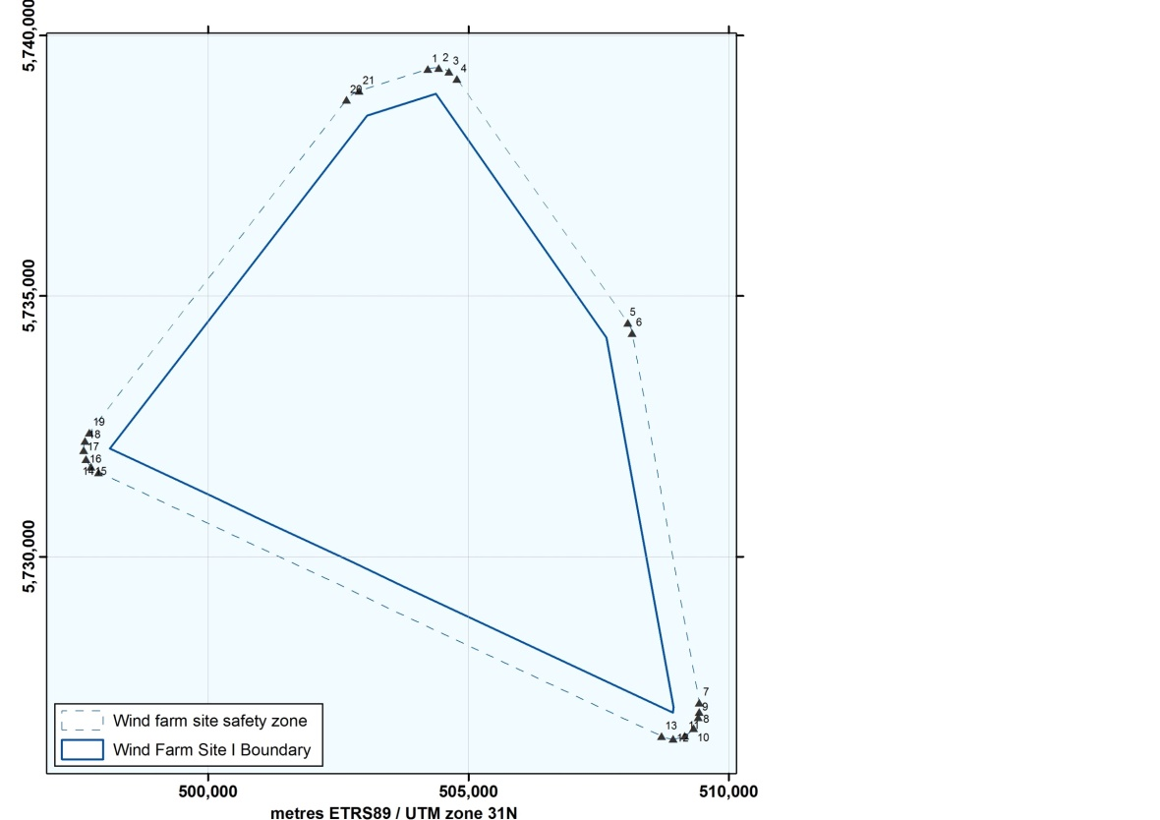
Figure 4 Safety zones around Borssele Wind Farm Site I

BWFS I | UTM
Safety zone | (ETRS89, zone 31)
Point No. | Easting | Northing
SZ_01 | 504,222.7 | 5,739,355.0
SZ_02 | 504,431.2 | 5,739,375.1
SZ_03 | 504,629.6 | 5,739,307.9
SZ_04 | 504,783.1 | 5,739,165.4
SZ_05 | 508,062.2 | 5,734,488.1
SZ_06 | 508,144.8 | 5,734,290.6
SZ_07 | 509,434.7 | 5,727,196.1
SZ_08 | 509,434.9 | 5,727,017.9
SZ_09 | 509,416.4 | 5,726,915.7
SZ_10 | 509,326.7 | 5,726,707.5
SZ_11 | 509,154.1 | 5,726,560.3
SZ_12 | 508,934.3 | 5,726,504.5
SZ_13 | 508,712.5 | 5,726,551.5
SZ_14 | 497,899.0 | 5,731,618.2
SZ_15 | 497,753.3 | 5,731,721.3
SZ_16 | 497,653.0 | 5,731,869.0
SZ_17 | 497,611.1 | 5,732,042.6
SZ_18 | 497,632.8 | 5,732,219.8
SZ_19 | 497,715.4 | 5,732,378.1
SZ_20 | 502,657.2 | 5,738,766.0
SZ_21 | 502,901.7 | 5,738,936.7
Table 4 Boundary points of the safety zones of Borssele Wind Farm Site I

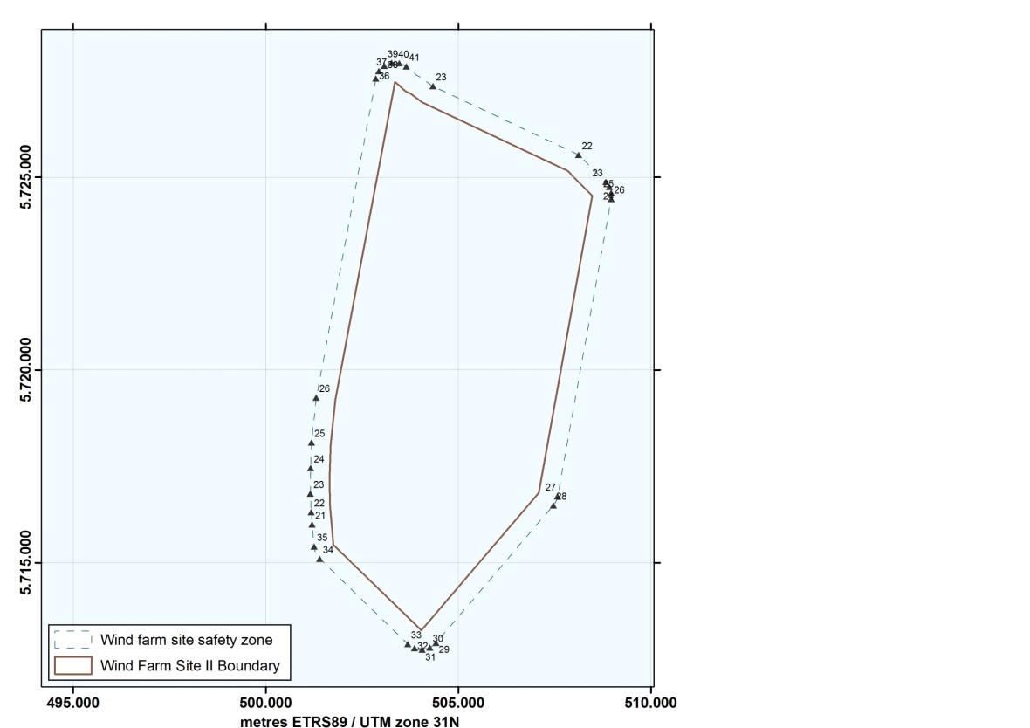
Figure 5 Safety zones around Borssele Wind Farm Sites II

BWFS II | UTM
Safety zone | (ETRS89, zone 31)
Point No. | Easting | Northing
SZ_22 | 508,125.5 | 5,725,580.2
SZ_23 | 508,830.6 | 5,724,873.6
SZ_24 | 508,923.9 | 5,724,743.9
SZ_25 | 508,971.5 | 5,724,591.5
SZ_26 | 508,968.7 | 5,724,431.7
SZ_27 | 507,579.1 | 5,716,723.0
SZ_28 | 507,467.1 | 5,716,486.8
SZ_29 | 504,419.6 | 5,712,921.2
SZ_30 | 504,259.4 | 5,712,797.0
SZ_31 | 504,063.1 | 5,712,746.6
SZ_32 | 503,862.9 | 5,712,778.4
SZ_33 | 503,691.7 | 5,712,886.9
SZ_34 | 501,405.4 | 5,715,101.4
SZ_35 | 501,255.0 | 5,715,418.9
CP_21 | 501,206.1 | 5,715,990.5
CP_22 | 501,181.0 | 5,716,307.4
CP_23 | 501,160.0 | 5,716,790.0
CP_24 | 501,167.6 | 5,717,455.3
CP_25 | 501,186.9 | 5,718,115.4
CP_26 | 501,314.5 | 5,719,280.2
SZ_36 | 502,860.6 | 5,727,560.3
SZ_37 | 502,936.8 | 5,727,746.8
SZ_38 | 503,080.2 | 5,727,888.0
SZ_39 | 503,267.7 | 5,727,961.2
SZ_40 | 503,468.8 | 5,727,954.5
SZ_41 | 503,651.0 | 5,727,869.1
SL_23 | 504,344.7 | 5,727,358.0

Table 5 Boundary points of the safety zones of Borssele Wind Farm Site II

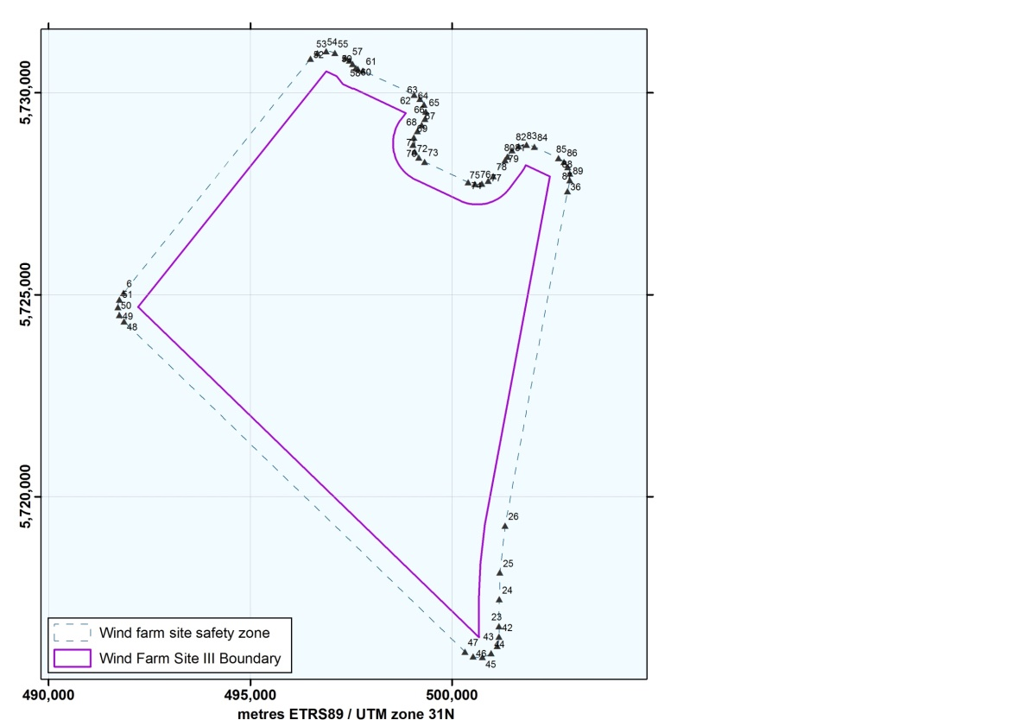
Figure 6 Safety zones around Borssele Wind Farm Sites III

BWFS III | UTM
Safety zone | (ETRS89, zone 31)
Point No. | Easting | Northing
SZ_42 | 501,166.0 | 5,716,526.7
SZ_43 | 501,117.0 | 5,716,297.4
SZ_44 | 500,969.0 | 5,716,115.6
SZ_45 | 500,754.3 | 5,716,021.3
SZ_46 | 500,520.2 | 5,716,035.2
SZ_47 | 500,318.3 | 5,716,154.3
SZ_48 | 491,870.8 | 5,724,336.3
SZ_49 | 491,759.8 | 5,724,496.8
SZ_50 | 491,718.7 | 5,724,687.5
SZ_51 | 491,753.8 | 5,724,879.4
CP_6 | 491,857.9 | 5,725,044.9
SZ_52 | 496,490.3 | 5,730,844.9
SZ_53 | 496,662.9 | 5,730,982.7
SZ_54 | 496,878.0 | 5,731,032.8
SZ_55 | 497,093.6 | 5,730,985.4
SZ_56 | 497,352.6 | 5,730,863.7
SZ_57 | 497,454.3 | 5,730,800.0
SZ_58 | 497,537.9 | 5,730,713.9
SZ_59 | 497,612.8 | 5,730,615.4
SZ_60 | 497,664.7 | 5,730,591.0
SZ_61 | 497,788.1 | 5,730,551.6
SZ_62 | 499,063.4 | 5,729,951.9
SZ_63 | 499,207.5 | 5,729,849.7
SZ_64 | 499,307.0 | 5,729,703.9
SZ_65 | 499,349.6 | 5,729,532.5
SZ_66 | 499,330.0 | 5,729,357.0
SZ_67 | 499,250.6 | 5,729,199.3
SZ_68 | 499,139.1 | 5,729,050.7
SZ_69 | 499,057.5 | 5,728,892.1
SZ_70 | 499,036.1 | 5,728,715.1
SZ_71 | 499,078.5 | 5,728,542.0
SZ_72 | 499,178.8 | 5,728,394.6
SZ_73 | 499,324.4 | 5,728,291.6
SZ_74 | 500,403.1 | 5,727,784.8
SZ_75 | 500,568.3 | 5,727,738.1
SZ_76 | 500,739.5 | 5,727,749.6
SZ_77 | 500,896.8 | 5,727,818.2
SZ_78 | 501,021.8 | 5,727,935.9
SZ_79 | 501,317.8 | 5,728,330.3
SZ_80 | 501,370.2 | 5,728,414.9
SZ_81 | 501,484.8 | 5,728,575.6
SZ_82 | 501,652.7 | 5,728,679.4
SZ_83 | 501,847.7 | 5,728,710.2
SZ_84 | 502,039.3 | 5,728,663.1
SZ_85 | 502,639.2 | 5,728,381.0
SZ_86 | 502,774.0 | 5,728,288.0
SZ_87 | 502,871.5 | 5,728,156.4
SZ_88 | 502,921.3 | 5,728,000.4
SZ_89 | 502,918.0 | 5,727,836.6
SZ_36 | 502,860.6 | 5,727,560.3
CP_26 | 501,314.5 | 5,719,280.2
CP_25 | 501,186.9 | 5,718,115.4
CP_24 | 501,167.6 | 5,717,455.3
CP_23 | 501,160.0 | 5,716,790.0
Table 6 Boundary points of the safety zones of Borssele Wind Farm Site III

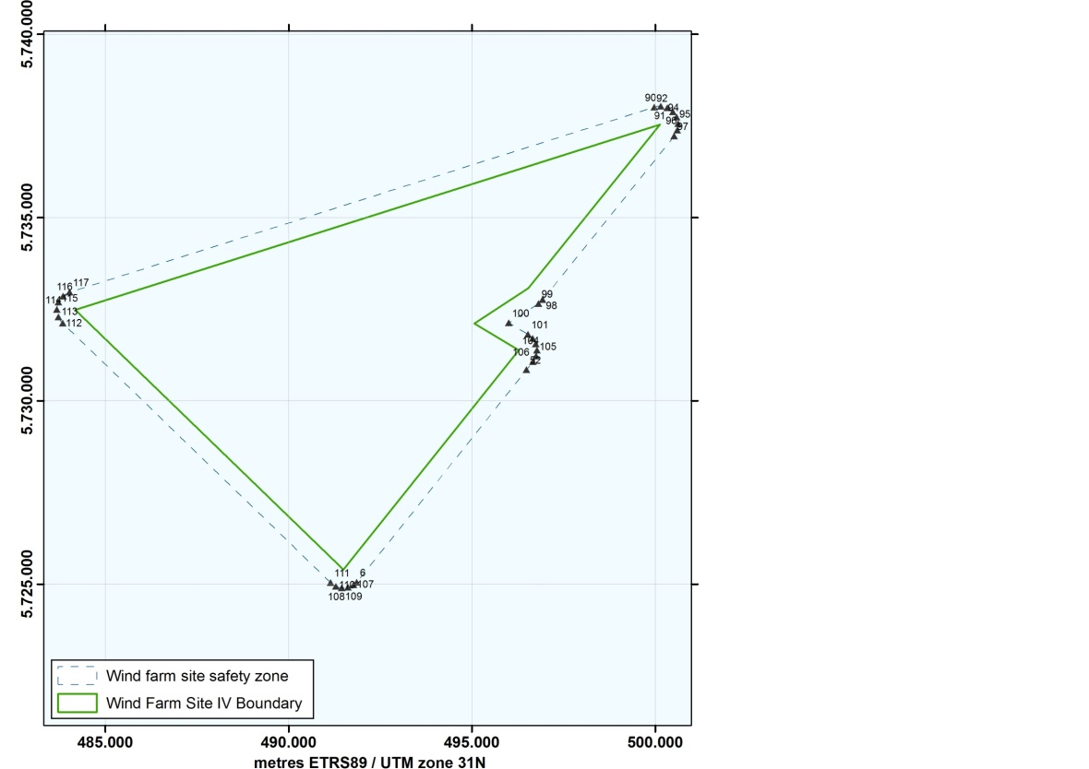
Figure 7 Safety zones around Borssele Wind Farm Sites IV

BWFS IV | UTM
Safety zone | (ETRS89, zone 31)
Point No. | Easting | Northing
SZ_90 | 499,979.0 | 5,738,011.1
SZ_91 | 500,159.1 | 5,738,033.6
SZ_92 | 500,335.3 | 5,737,990.3
SZ_93 | 500,484.5 | 5,737,887.0
SZ_94 | 500,587.0 | 5,737,737.3
SZ_95 | 500,629.2 | 5,737,560.8
SZ_96 | 500,605.8 | 5,737,380.8
SZ_97 | 500,519.6 | 5,737,221.1
SZ_98 | 496,931.1 | 5,732,757.7
SZ_99 | 496,815.8 | 5,732,652.9
SZ_100 | 496,008.9 | 5,732,123.5
SZ_101 | 496,534.1 | 5,731,809.0
SZ_102 | 496,662.8 | 5,731,698.4
SZ_103 | 496,747.1 | 5,731,551.1
SZ_104 | 496,777.2 | 5,731,384.1
SZ_105 | 496,749.8 | 5,731,216.7
SZ_106 | 496,668.0 | 5,731,068.0
SZ_52 | 496,490.3 | 5,730,844.9
CP_6 | 491,857.9 | 5,725,044.9
SZ_107 | 491,772.4 | 5,724,976.6
SZ_108 | 491,618.4 | 5,724,909.0
SZ_109 | 491,450.7 | 5,724,896.3
SZ_110 | 491,288.2 | 5,724,939.9
SZ_111 | 491,149.4 | 5,725,034.9
SZ_112 | 483,837.6 | 5,732,117.0
SZ_113 | 483,718.7 | 5,732,286.5
SZ_114 | 483,678.6 | 5,732,489.5
SZ_115 | 483,724.1 | 5,732,691.4
SZ_116 | 483,847.5 | 5,732,857.5
SZ_117 | 484,027.6 | 5,732,959.4

Table 7 Boundary points of the safety zones of Borssele Wind Farm Site IV

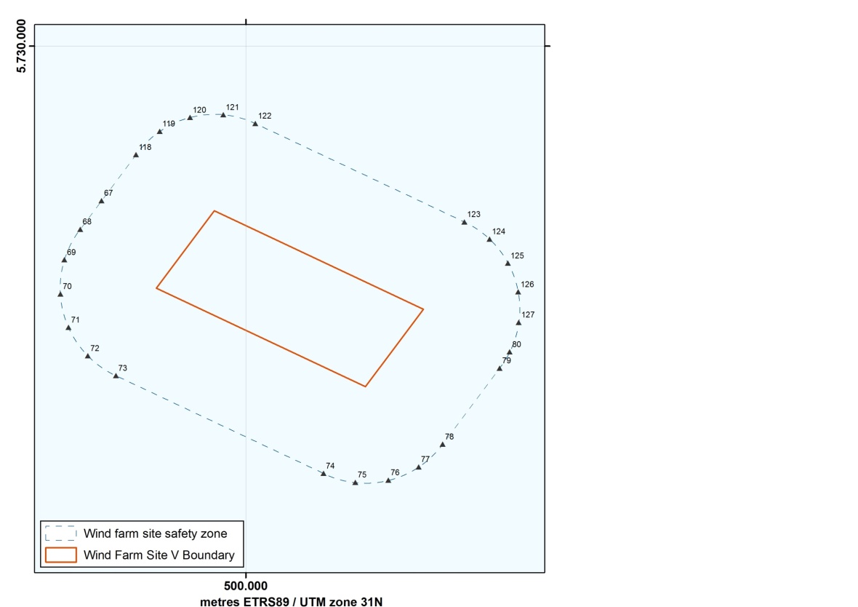
Figure 8 Safety zones around Borssele Wind Farm Sites V
BWFS V | UTM
Safety zone | (ETRS89, zone 31)
Point No. | Easting | Northing
SZ_118 | 499,429.2 | 5,729,437.2
SZ_119 | 499,552.6 | 5,729,558.4
SZ_120 | 499,709.8 | 5,729,630.3
SZ_121 | 499,882.1 | 5,729,644.4
SZ_122 | 500,048.9 | 5,729,599.0
SZ_123 | 501,134.8 | 5,729,088.4
SZ_124 | 501,265.2 | 5,728,999.6
SZ_125 | 501,361.5 | 5,728,874.5
SZ_126 | 501,413.9 | 5,728,725.6
SZ_127 | 501,417.4 | 5,728,567.8
SZ_80 | 501,370.2 | 5,728,414.9
SZ_79 | 501,317.8 | 5,728,330.3
SZ_78 | 501,021.8 | 5,727,935.9
SZ_77 | 500,896.8 | 5,727,818.2
SZ_76 | 500,739.5 | 5,727,749.6
SZ_75 | 500,568.3 | 5,727,738.1
SZ_74 | 500,403.1 | 5,727,784.8
SZ_73 | 499,324.4 | 5,728,291.6
SZ_72 | 499,178.8 | 5,728,394.6
SZ_71 | 499,078.5 | 5,728,542.0
SZ_70 | 499,036.1 | 5,728,715.1
SZ_69 | 499,057.5 | 5,728,892.1
SZ_68 | 499,139.1 | 5,729,050.7
SZ_67 | 499,250.6 | 5,729,199.3
Table 8 Boundary points of the safety zones of Borssele Wind Farm Site V

Infrastructure

Cables and pipelines

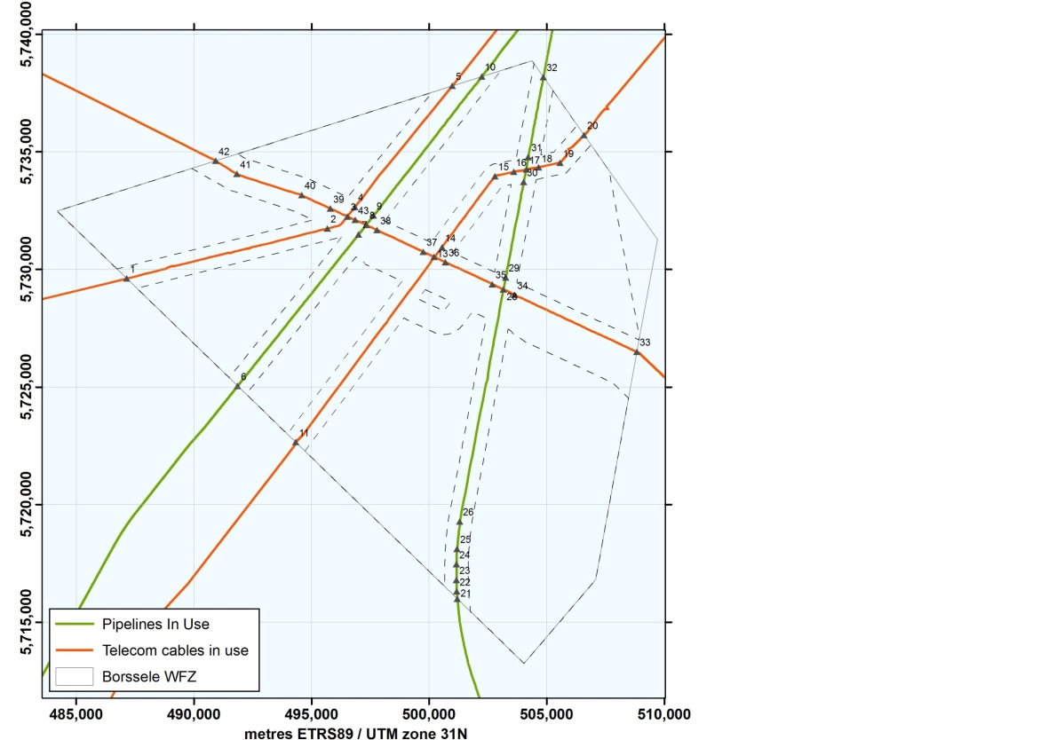
Figure 9 Active cables and pipelines in the Borssele Wind Farm Zone

TAT-14 | UTM
 | (ETRS89, zone 31)
Point No. | Easting | Northing
CP_1 | 487,143.1 | 5,729,611.4
CP_2 | 495,679.0 | 5,731,738.2
CP_3 | 496,524.3 | 5,732,250.9
CP_4 | 496,847.1 | 5,732,654.0
CP_5 | 500,990.2 | 5,737,806.9
Table 9.1 Coordinates TAT-14

SeaMeWe 3 | UTM
 | (ETRS89, zone 31)
Point No. | Easting | Northing
CP_11 | 494,329.2 | 5,722,651.2
CP_13 | 500,215.7 | 5,730,531.7
CP_14 | 500,549.5 | 5,730,936.7
CP_15 | 502,805.0 | 5,733,965.0
CP_16 | 503,597.7 | 5,734,150.5
CP_17 | 504,128.0 | 5,734,250.9
CP_18 | 504,652.5 | 5,734,345.4
CP_19 | 505,570.0 | 5,734,530.0
CP_20 | 506,591.9 | 5,735,714.4
Table 9.2 Coordinates SeaMeWe 3

Farland | UTM
North | (ETRS89, zone 31)
Point No. | Easting | Northing
CP_33 | 508,832.6 | 5,726,495.4
CP_34 | 503,626.9 | 5,728,917.6
CP_28 | 503,162.6 | 5,729,151.1
CP_35 | 502,694.9 | 5,729,368.1
CP_36 | 500,695.7 | 5,730,308.0
CP_13 | 500,215.7 | 5,730,531.7
CP_37 | 499,761.4 | 5,730,750.1
CP_38 | 497,788.4 | 5,731,668.5
CP_8 | 497,325.2 | 5,731,891.1
CP_43 | 496,853.8 | 5,732,105.5
CP_3 | 496,524.3 | 5,732,250.9
CP_39 | 495,804.1 | 5,732,587.1
CP_40 | 494,583.4 | 5,733,161.0
CP_41 | 491,831.0 | 5,734,057.0
CP_42 | 490,924.9 | 5,734,619.3
Table 9.3 Coordinates Farland North

Franpipe | UTM
 | (ETRS89, zone 31)
Point No. | Easting | Northing
CP_6 | 491,857.9 | 5,725,044.9
CP_7 | 497,002.5 | 5,731,488.1
CP_8 | 497,325.2 | 5,731,891.1
CP_9 | 497,647.5 | 5,732,290.3
CP_10 | 502,208.1 | 5,738,192.6
Table 9.4 Coordinates Franpipe

Zeepipe | UTM
 | (ETRS89, zone 31)
Point No. | Easting | Northing
CP_21 | 501,206.1 | 5,715,990.5
CP_22 | 501,181.0 | 5,716,307.4
CP_23 | 501,160.0 | 5,716,790.0
CP_24 | 501,167.6 | 5,717,455.3
CP_25 | 501,186.9 | 5,718,115.4
CP_26 | 501,314.5 | 5,719,280.2
CP_28 | 503,162.6 | 5,729,151.1
CP_29 | 503,259.3 | 5,729,658.4
CP_30 | 504,018.9 | 5,733,713.0
CP_17 | 504,128.0 | 5,734,250.9
CP_31 | 504,214.8 | 5,734,778.9
CP_32 | 504,861.9 | 5,738,182.1
Table 9.5 Coordinates Zeepipe

Infrastructure - TenneT

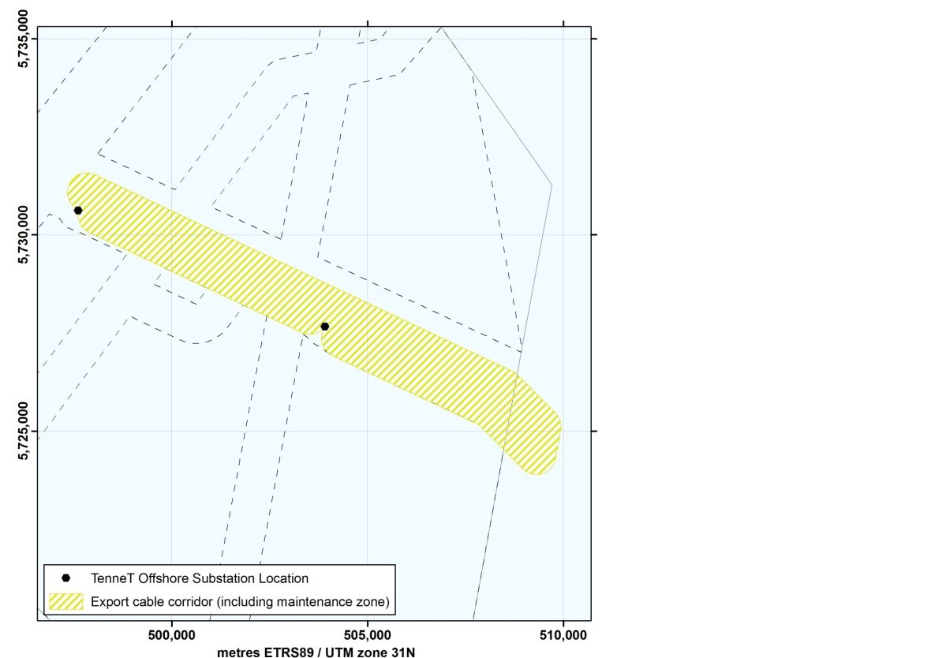
Figure 10 TenneT Platforms Alpha and Beta and export cable route
(including maintenance zone)

 | UTM
 | (ETRS89, zone 31)
Platform | Easting | Northing
Alpha | 503,919.0 | 5,727,666.0
Beta | 497,620.7 | 5,730,622.0
Table 10 Position points TenneT platforms

Infield Cable Entry Zones

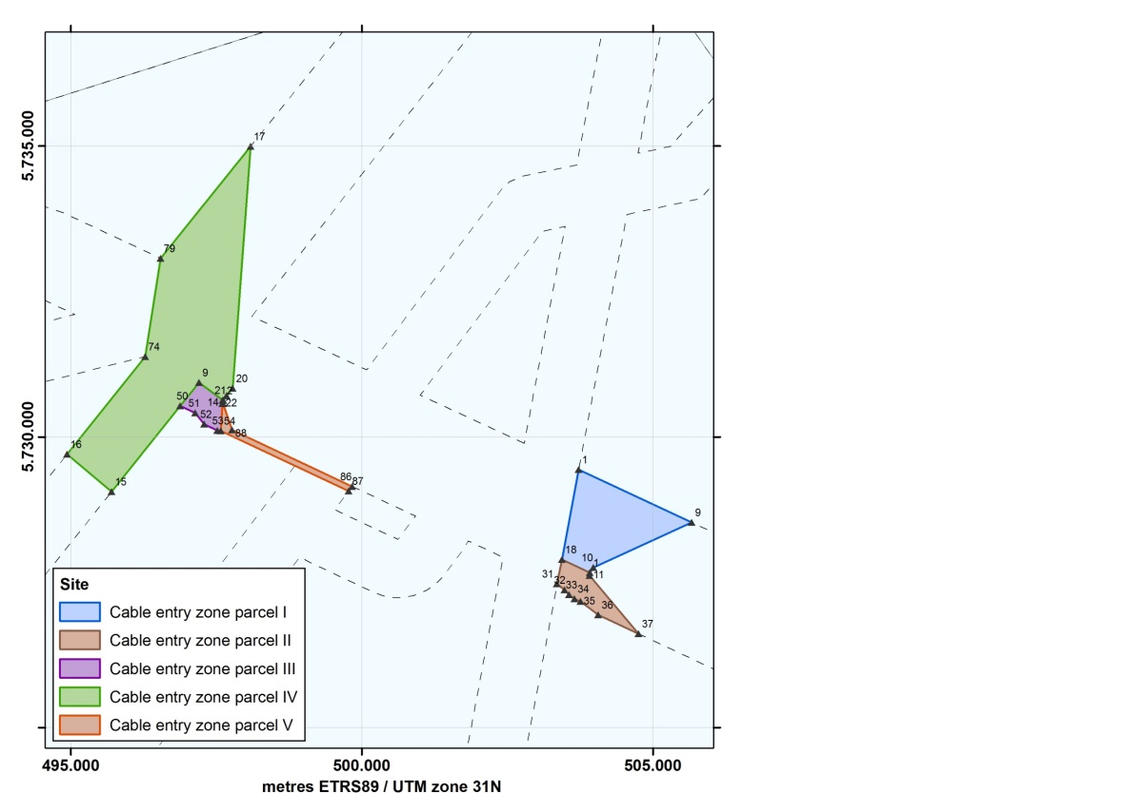
Figure 11 The infield cable entry zones for the TenneT infrastructure in the Borssele Wind Farm Zone

BWFS I | UTM
Cable entry zone | (ETRS89, zone 31)
Point No. | Easting | Northing
P_1 | 503,726.3 | 5,729,436.4
T_9 | 505,669.1 | 5,728,527.4
T_10 | 503,977.5 | 5,727,748.8
T_1 | 503,919.0 | 5,727,665.3
T_18 | 503,438.1 | 5,727,891.2
Table 11.1 Coordinates infield cable entry BWFS I

BWFS II | UTM
Cable entry zone | (ETRS89, zone 31)
Point No. | Easting | Northing
P_31 | 503,352.1 | 5,727,468.4
P_32 | 503,486.1 | 5,727,368.4
P_33 | 503,561.0 | 5,727,281.4
P_34 | 503,653.0 | 5,727,212.7
P_35 | 503,757.8 | 5,727,165.7
P_36 | 504,063.2 | 5,726,937.9
P_37 | 504,755.8 | 5,726,612.2
T_11 | 503,914.4 | 5,727,612.4
T_1 | 503,919.0 | 5,727,665.3
T_18 | 503,438.1 | 5,727,891.2

Table 11.2 Coordinates infield cable entry BWFS II

BWFS III | UTM
Cable entry zone | (ETRS89, zone 31)
Point No. | Easting | Northing
P_50 | 496,881.0 | 5,730,532.8
P_51 | 497,139.9 | 5,730,411.2
P_52 | 497,289.1 | 5,730,215.2
P_53 | 497,518.6 | 5,730,107.2
P_54 | 497,575.3 | 5,730,099.1
T_22 | 497,603.4 | 5,730,569.9
T_21 | 497,609.5 | 5,730,630.6
SL_9 | 497,202.2 | 5,730,934.4
Table 11.3 Coordinates infield cable entry BWFS III

BWFS IV | UTM
Cable entry zone | (ETRS89, zone 31)
Point No. | Easting | Northing
P_50 | 496,881.0 | 5,730,532.8
T_15 | 495,703.3 | 5,729,058.3
T_16 | 494,935.0 | 5,729,700.0
P_74 | 496,277.2 | 5,731,380.0
P_79 | 496,541.5 | 5,733,070.9
T_17 | 498,088.1 | 5,734,994.8
T_20 | 497,781.3 | 5,730,835.8
T_13 | 497,678.4 | 5,730,705.1
T_2 | 497,620.7 | 5,730,622.2
SL_9 | 497,202.2 | 5,730,934.4
Table 11.4 Coordinates infield cable entry BWFS IV

BWFS V | UTM
Cable entry zone | (ETRS89, zone 31)
Point No. | Easting | Northing
T_2 | 497,620.7 | 5,730,622.2
T_14 | 497,615.4 | 5,730,568.7
P_88 | 497,769.0 | 5,730,118.6
P_86 | 499,836.2 | 5,729,146.6
P_87 | 499,774.9 | 5,729,064.9
P_54 | 497,575.3 | 5,730,099.1
T_22 | 497,603.4 | 5,730,569.9
T_21 | 497,609.5 | 5,730,630.6
Table 11.5 Coordinates infield cable entry BWFS V

Shipping Corridor

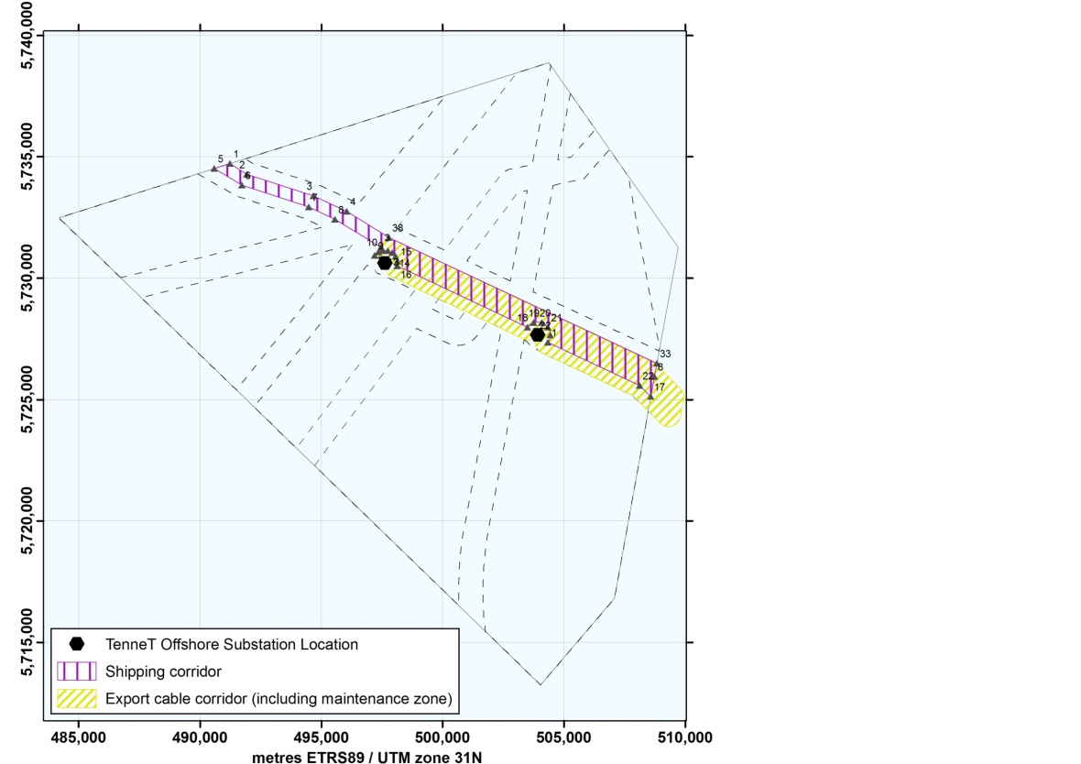
Figure 12 The shipping corridor through the Borssele Wind Farm Zone

Shipping | UTM
corridor | (ETRS89, zone 31)
Point No. | Easting | Northing
SL_1 | 491,235.2 | 5,734,717.5
SL_2 | 491,936.7 | 5,734,283.6
SL_3 | 494,677.5 | 5,733,392.6
SL_4 | 496,051.9 | 5,732,749.7
CP_38 | 497,788.4 | 5,731,668.5
CP_33 | 508,832.6 | 5,726,495.4
T_8 | 508,733.7 | 5,725,946.4
SL_17 | 508,584.7 | 5,725,120.0
SZ_22 | 508,125.5 | 5,725,580.2
SL_23 | 504,344.7 | 5,727,358.0
SL_22 | 504,444.0 | 5,727,665.7
SL_21 | 504,344.3 | 5,727,973.2
SL_20 | 504,083.3 | 5,728,164.0
SL_19 | 503,760.0 | 5,728,165.7
SL_18 | 503,497.0 | 5,727,977.6
SL_16 | 498,131.4 | 5,730,500.7
SL_15 | 498,139.5 | 5,730,702.5
SL_14 | 498,069.4 | 5,730,894.8
SL_13 | 497,931.1 | 5,731,045.6
SL_12 | 497,745.6 | 5,731,132.1
SL_11 | 497,541.2 | 5,731,141.1
SL_10 | 497,348.8 | 5,731,071.3
SL_9 | 497,202.2 | 5,730,934.4
T_3 | 497,466.3 | 5,731,268.0
SL_8 | 495,559.3 | 5,732,426.4
SL_7 | 494,481.4 | 5,732,932.6
SL_6 | 491,722.7 | 5,733,831.7
SL_5 | 490,590.5 | 5,734,513.4
Table 12 Position points defining the shipping corridor

Reference documents
- SDB_20160226_RVO_MPK.MPK

