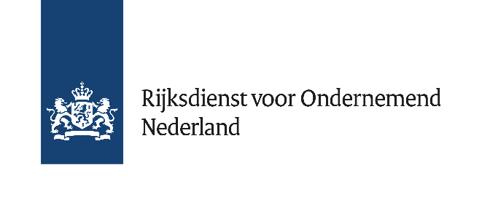

Market consultation for users of RVO Ecology data for Offshore Wind Farm Development

General information on market consultation
This market consultation is performed by the Netherlands Enterprise Agency (RVO) and aims to understand the end user position with regards to ecological studies in the site study package for offshore wind (as published on Offshorewind RVO). The results will be used to update the strategy on ecological studies, and possibly expand the site study package.
Please provide your answers in writing to WOZ@rvo.nl. RVO may contact you to discuss your answers further in person (or via Teams), please indicate if you prefer not to be contacted by RVO.
Answers given to this questionnaire will be treated confidentially. After the market consultation, RVO will share an updated strategy, with no reference to consulted participants.
Introduction
The Netherlands Enterprise Agency (RVO) delivers site characterisation studies as preparation for the permit tender of Dutch Offshore Wind Farm Zones (WFZ’s). RVO site characterisation studies aim to reduce uncertainty and risk for wind farm developers in their bid preparation, by providing accurate information and data on site conditions. Until now, the research was mainly focused on integrating Soil and Wind & Water (metocean) conditions in the wind farm design. However, the ecology of the North Sea is a topic gathering increased attention: it forms a key scoring criterion in some wind farm tenders and also it poses a risk for the construction and maintenance phase of wind farms. Several programs are run by the Dutch Government to increase knowledge about the ecology in the North Sea in relation to wind farms (see figure 1).
Therefore, RVO would like to contribute with pre-wind farm tender site investigations to obtain more detailed information on ecological conditions at future Wind Farm Sites to reduce risks and limit the impact of wind farms.
- Program | Aim
WOZEP | To expand knowledge on the effect of offshore wind on protected species, to get more detailed insight in cumulative ecological effects (KEC)
MWTL | To monitor water (quality), on- and offshore
MONS | To determine whether and how changing use of the North Sea (including offshore wind development) may impact ecological capacity
RVO Site studies | Help wind farm developers by supporting above programs with pre-wind farm tender investigations
Figure 1. Current ecology measurement programs by the Dutch Government

In IJmuiden Ver Gamma and Nederwiek I WFZ’s the first ecological pilot study has been executed. The focus of this study was benthic ecology by means of boxcore analysis and eDNA.
IJmuiden Ver Soil – On this page of our website offshorewind.rvo.nl you can find the widget ‘Ecology IJmuiden Ver Gamma’ with links to the results, report, webinar and presentation on Ecology in IJmuiden Ver WFZ.
Nederwiek - Soil – On this page of our website offshorewind.rvo.nl you can find the widget ‘Ecology Nederwiek I’ with links to the results and the report on Ecology in Nederwiek I WFZ.
RVO is currently starting a new campaign in Search Area 6/7 with FPODs on metocean buoys to survey marine mammals. Also, in this area microphones (birds: Song Meter SM4 Acoustic Recorder, bats: SM4BAT-FS Ultrasonic Recorder) will be placed on buoys to collect data on birds and bats.

Subject | Description | Application of data in wind farms (not exhaustive)
Benthos | - Boxcores  - eDNA | - Nature enhancement (artificial reefs, nature inclusive scour protection)
Marine mammals | - FPODs on metocean buoys (currently only search area 6/7) | - Noise mitigation (during OWF installation)
Water quality | - Salinity  - Temperature  - Turbidity  - Marine growth | - Wind Turbine design
Birds & Bats | - Microphones on metocean buoys (currently only search area 6/7, planned for 2025) | - Curtailment  - Bird corridors  - Black blade  - Increased height of lowest tip point position
Figure 2. Current ecological research by RVO site studies

RVO is interested in the market actor’s viewpoints and needs concerning ecological investigations prior to the permit tender of a WFS. We would like to know the market actor’s opinion on our past and current studies and strategy. What is needed, in terms of ecological site investigations, to set up a good wind farm tender and reduce risks?
- What do you consider as the biggest risks concerning ecology and offshore wind?

- What is your opinion about the ecology studies RVO has done so far/is currently executing:

  - Benthic studies by means of boxcores?
  - Benthic and fish studies by means of eDNA?
  - Measuring bird en bat presence (results not yet available)?
  - Measuring marine mammal presence (results not yet available)?
Please try to be specific about the methods, techniques, data formats and time span.
- Do these studies meet your data requirements regarding ecology?
  - If not, why?
  - Do you (intend to) perform ecological investigations yourself?

- What needs to be added to the ecological site study package to reduce risks for wind farm developers? Please specify per species group (benthos, birds, bats, marine mammals, fish)
  - What will the data be used for?
  - Could you elaborate on methods, techniques, data formats and time span?
  - Are there specifics we should take into account? For example time of year, time of day, delivery time before tender?

- Do you have examples of similar studies we could look at?

Planning
The questionnaires are sent to market parties in week 50-51/2024. RVO requests answers in writing to be sent back by week 6/2025. If applicable, afterwards RVO will send out invitation for a meeting. The updated ecology strategy will be shared later in Q1-2/2025.

